Student Name
Date

Images: A Vacation in Paradise

- Image Web Site: http://earthobservatory.nasa.gov/NaturalHazards/shownh.php3?img_id=12643
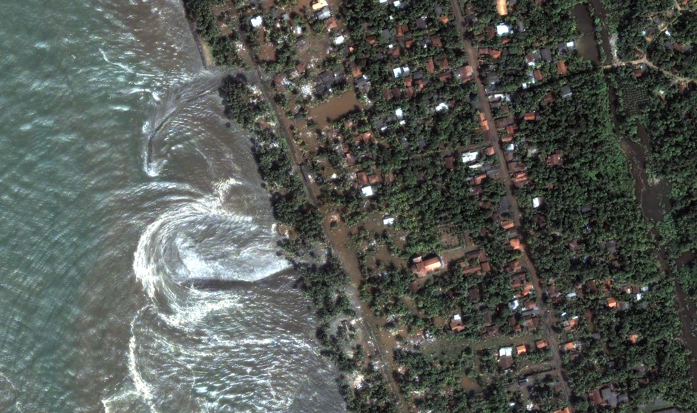
Image provided by DigitalGlobe

- Image Web Site: http://www.sxc.hu/photo/866398
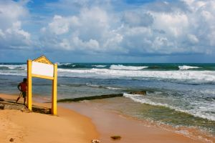

- Image Web Site: http://www.sxc.hu/photo/843417
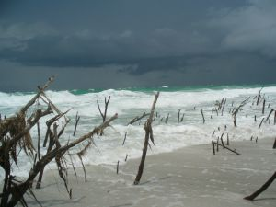

- Image Web Site: http://www.sxc.hu/photo/311255
