Student Name
Date

Media Citations for Global Warming PowerPoint

Climate Change
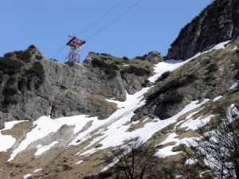

http://www.sxc.hu/photo/335236
Many of the world’s freshwater glaciers are shrinking, as warming temperatures melt them away. Some have disappeared all together. This image was selected to show an example of how global warming affects the Earth.

Partly Bleached Coral Reef
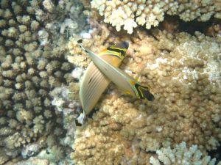

http://www.sxc.hu/photo/728528
A partly bleached coral reef is white next to healthy coral. Rising ocean temperatures, one of the many effects of global warming, are threatening coral reefs around the world. This image was selected to show an example of how global warming affects the marine life.

Changing of Migration Patterns
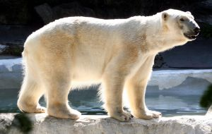

http://www.sxc.hu/photo/797985
A polar bear walks across rocky ground. The bears depend on sea ice as a platform from which they can hunt seals, their main prey. This image was selected to show an example of how global warming can affect the migration patterns of the animal kingdom.

Video on Global Warming
http://www.nwf.org/wildlifeandglobalwarming/globalwarmingandwildlife.cfm
The video clip provides a summary of global warming and its affects on humans, sea life and animal kingdom.

