Creating a Database Form
You can create a form by selecting Design View from the Insert menu or Database toolbar. You create a form in design view by selecting fields from a list and adding them to a grid. Neither the form itself nor any data is displayed in design view.

Electronic forms have two parts—controls and labels. Controls accept information from users and display information from the database. Labels tell people who use the form what each control does. Most controls are bound to fields in the database. Several kinds of controls provide ways to enter and display different kinds of data. Some common form controls include:

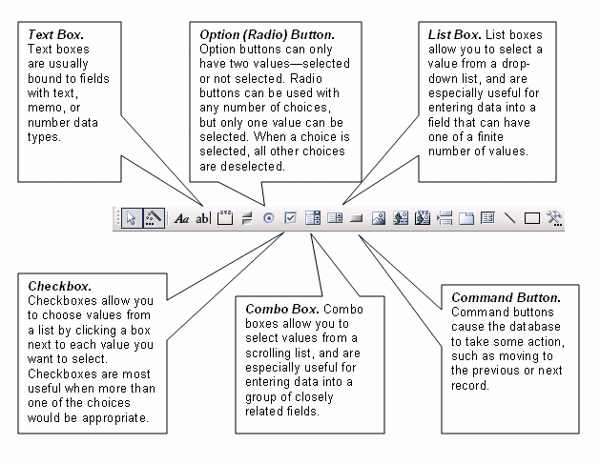

The properties of a control determine everything from the field to which the control is bound to the font in which the value is displayed. You must set the properties of every label and control when you design a form. Some controls have more than 50 properties!

Even though many properties can usually be left at their default values, creating a form in design view requires a lot of time and expertise. If you have that expertise, design view gives you complete and precise control of a form. If you do not need complete and precise control, you can save a lot of time by using a form wizard.

Form Wizard
Most database applications provide a form wizard and toolbar to make creating forms easy. You can create a form by selecting the Form Wizard from the Insert menu or Database toolbar. A form wizard in a database application is one of the greatest time-saving wizards in any application.

Form wizards in various database applications usually have some minor differences. In most database applications, creating a form involves the following five basic steps:

- Select Tables. Select the tables that contain the data you want to enter.

- Select Fields. Select the fields from each table that you want to include in the form. Click > to add the fields to your form. Click >> if you want to add all of the fields in a table. Click the Next button.

- Choose Layout. Choose the basic layout for your form. You may be able to lay out the form in columns, in a table, or as a datasheet. Click the Next button.

- Format Labels. You can usually choose a format for field labels from a number of basic designs. Choose a design that is easy to read. Click the Next button.

- Create the Form. The wizard usually opens the form by default. However, you may choose to continue to refine the form in design view. When you have made all your selections, click the Finish button to create the form.

AutoForm
Most database applications can automatically create basic forms based on a table. AutoForms can be very efficient and effective way to enter data into a table. You can usually choose AutoForm from your database application’s Insert menu when you have a table selected in the database window.

