Student Name
Date

Multimedia Files for Immigration Reform Solution

Picture | Web Site |  | Copyright Status
Reason for Use on My Web Site
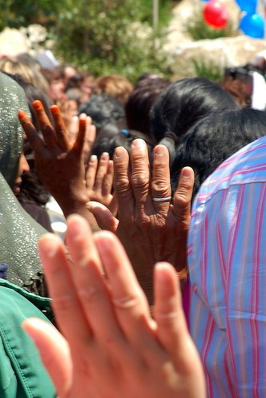 | From http://www.flickr.com/photos/distra/182002115/ on May 25, 2007  Saved as Taking_oath.jpg. |  | Permission granted
This picture show immigrants taking the oath of citizenship at a naturalization ceremony in Seattle, WA.
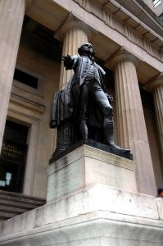  “The bosom of America is open to receive not only the Opulent & respectable Stranger, but the oppressed & persecuted of all Nations & Religions; whom we shall wellcome to a participation of all our rights & privileges.”  George Washington Address to Irish Immigrants, December 2, 1793 | Image from http://www.sxc.hu/photo/348667 - added quote  Saved as GW_Quote.jpg. |  | Copyright free
The quote in this photo is by George Washington and shows approval early in Unites States history for immigration.
 | From http://www.sxc.hu/photo/866633  Saved as Immigration_Children.jpg. |  | Royalty-free image
This image shows cousins who are separated by their immigration status. Many US immigration laws make it difficult for families to remain together.
From http://www.youtube.com/watch?v=aAaBgMmSrJo on May 25, 2007 | From http://www.youtube.com/watch?v=aAaBgMmSrJo on May 25, 2007  <object width="425" height="350"><param name="movie" value="http://www.youtube.com/v/aAaBgMmSrJo"></param><param name="wmode" value="transparent"></param><embed src="http://www.youtube.com/v/aAaBgMmSrJo" type="application/x-shockwave-flash" wmode="transparent" width="425" height="350"></embed></object>  (Media will open in a separate window.) |  | © 2006 Mercury Radio Arts and CNN. All rights reserved.  Just use link
This video from the Mercury Radio Arts and CNN take a humorous look at the history of illegal immigration in the United States. The history starts in 1846 with the war between the United States and Mexico and continues to the modern day proposals for immigration reform.
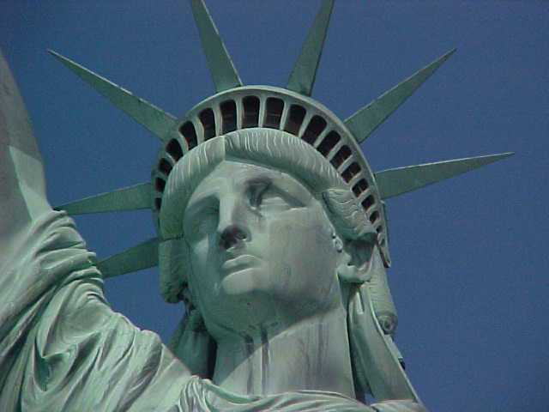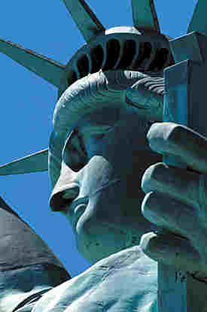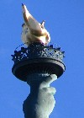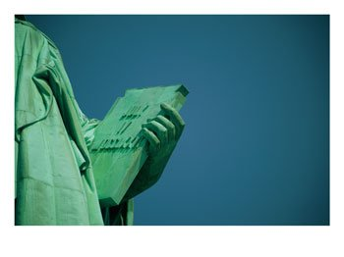   | From http://www.nps.gov/stli/, on May 30, 2007  This is a site from the government of the United States, so there is no copyright. |  | No copyright.
Pictures of Statue of Liberty for the web site banner.
 |  | From http://www.sxc.hu/photo/518967  Saved as immigration.jpg. | Royalty- free image
Picture of new US citizen after naturalization ceremony.
 |  | From http://www.sxc.hu/photo/813650  Saved as Graduation.jpg. | No copyright.
Picture of college graduation; good picture for talented and skilled section of essay.

