Adding an External Style Sheet to a Web Page
You can create an external style sheet with a text editor by setting the values of properties for each element and class you want to format. For example, you can copy the internal style sheet you created to format the table layout and paste it into a new plain text file. Then, you can save the text file with a .css extension.

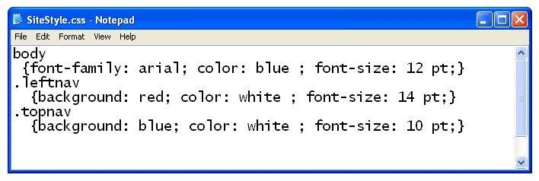

Once you have created an external style sheet, you must link your HTML document to the style sheet. You do this by adding a hypertext reference in your HTML document’s head < head>< /head> section that points to the CSS document.

