Adding an Internal Style Sheet to a Web Page
You can create an internal style sheet with the style element and a text editor. First, you add the style < style>< /style> element between the document head element’s start < head> tag and end < /head> tag. Then, you set values for the properties of any elements or classes you want to format.

In some cases, you may want to format only certain instances of an element. You can use the class attribute in the document head to define styles that you want to use only in certain instances of an element. You define a class by a period preceded by a name you create and then setting values for its style properties inside curly brackets.

A generic example of defining a style for a class is:

.class1 {property1: value1; property2: value2}

The following example would define a class for a left navigation bar with green, 10-point Arial text:

.leftnav {font-family: arial, helvetica, sans-serif; font-size 10 pt; color: green}

When you want to use the style defined for a class of a specific element, you use the class attribute and the name you created, such as < p class=“class1”>. Classes save time because the class name stands for all the formatting properties you defined in the document head.

Creating an Internal Style Sheet
Suppose you want to create an internal style sheet for the HTML table layout from the previous activity. You could follow these steps:

- Set values for the font, color, and size of all text in the body of the HTML document.
- Define classes to format the left navigation and top navigation in the layout.
- Add the leftnav class inside the table data start < td> tag of the cell containing left navigation
- Add the rightnav class inside the table data start < td> tag of the cell containing right navigation.
- Save the plain text file with an .htm or .html extension.

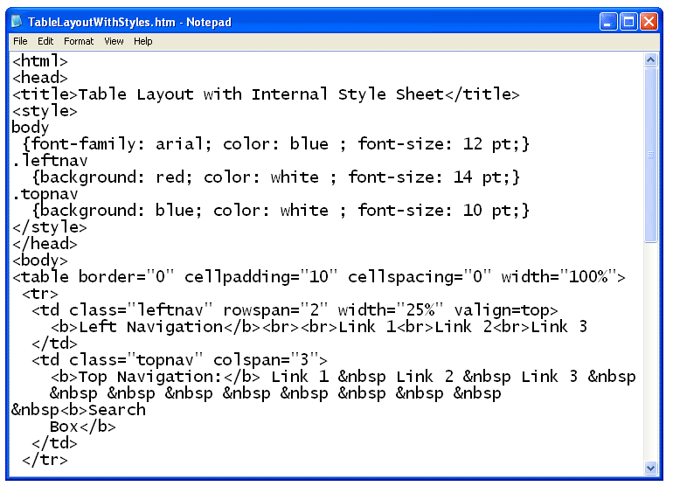

When you open the file with a Web browser, the HTML document is formatted in the styles you specified.

