Creating and Formatting a Basic Web Page
You can create and format a basic Web page with a few HTML tags and a text editor. Add a start <> tag and an end </> tag for each of the four main HTML document elements to a plain text file. You can consistently format an HTML document with the style, span, and div elements and a text editor. You add the style element to the start tag of any other HTML elements you want to format. After you add styles to your Web page, save your plain text file with an .htm or .html extension.

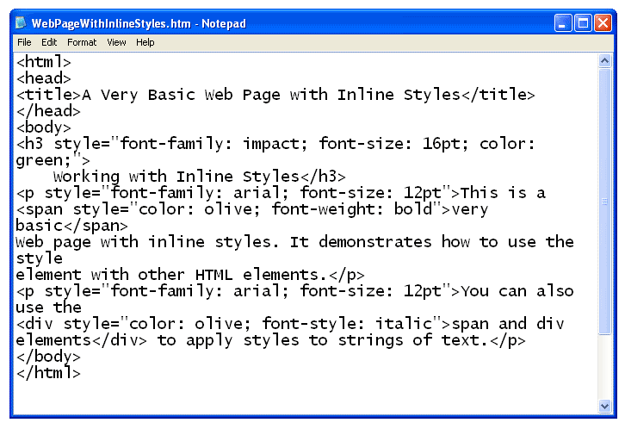

When you open the plain text file with a web browser, the text is displayed as an HTML document. Notice that the HTML tags themselves are not displayed by the browser. The title is displayed in the blue title bar at the top of the browser window. The text that was entered in the body element of the file is displayed inside the browser window and formatted in the styles you specified.

Notice that the < span>< /span> element does not cause a line break, but the div element causes line breaks before the start < div> tag and after the end < /div> tag. Also, notice that the div element ended the style defined for the paragraph. Starting another paragraph with the same style after the div element would continue the paragraph style.

