Embedding Audio and Video in a Web Page
You can add audio and video to a Web page with the embed element and a text editor. You simply add the < embed> tag with the source of the media and any other needed information defined in src and other attributes. Then, you save the plain text file with an .htm or .html extension.

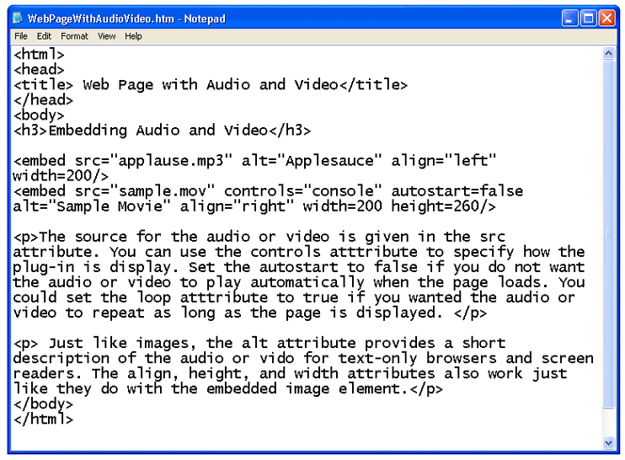

When you open the file with a web browser, the plain text file is displayed as an HTML document with hypermedia. Notice that the < embed> tags themselves are not displayed in the browser window.

