Embedding Images in a Web Page
You can add graphics to a Web page with the embedded image element and a text editor. You simply add the < img> tag with the source of the graphic and any other needed information defined by src and other attributes. Then, you save the plain text file with an .htm or .html extension.

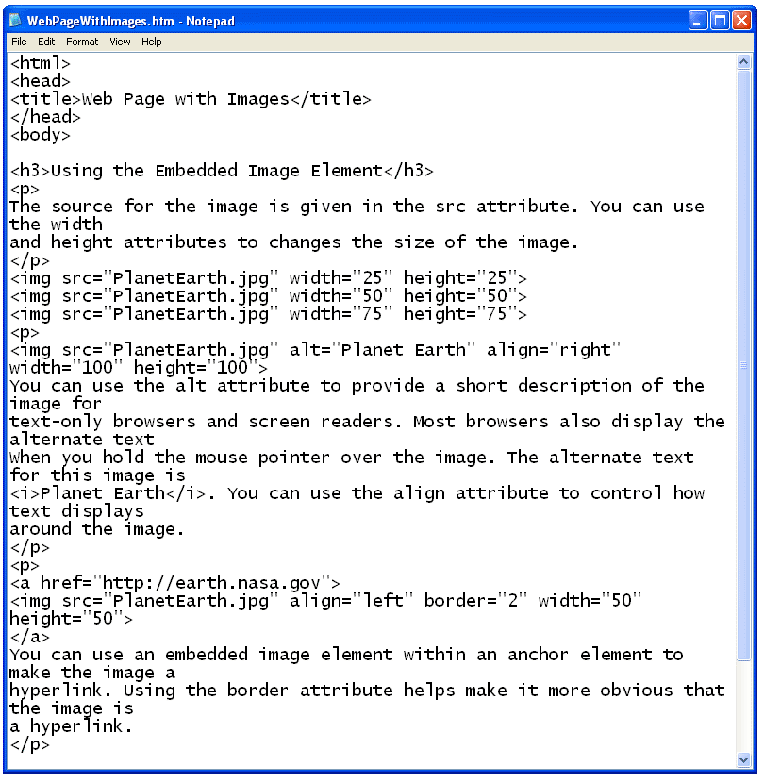

When you open the file with a web browser, the plain text file is displayed as an HTML document with graphics. Notice that the < img> tags themselves are not displayed in the browser window.

