Formatting Cells and Rows in an HTML Table
You can create more complex tables by setting values for some attributes of the table row, table header, and table data cell elements. In most cases, these attributes are needed to create a Web page layout with an HTML table.

Open the HTML document in a text editor and add the attributes you want to set. Then, save the plain text file with an .htm or .html extension. The following example uses table data attributes to create spaces for a generic Web site architecture.

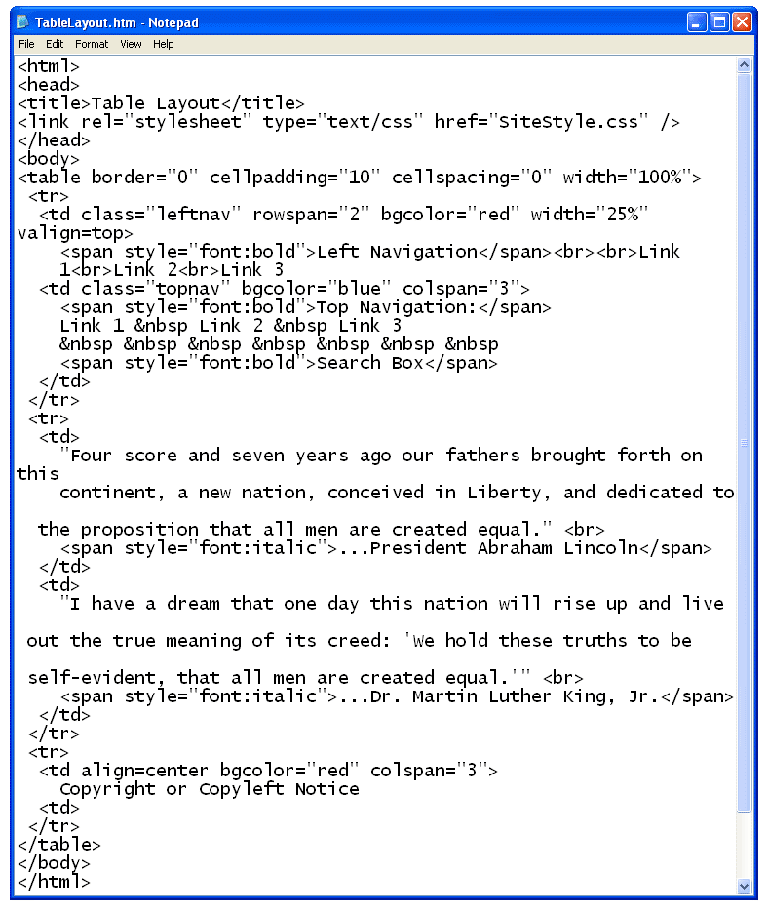

When you open the example file in a Web browser or refresh an open browser window, the table is displayed as a generic Web page that includes the content from the previous tables. The best way to learn how use attributes of the associated table elements is to change them to various settings and view the changes in a browser.

