Budget Experiment Handout

Go to: http://www.kowaldesign.com/budget/money.html. The first activity is to actually allocate the federal budget. You'll answer the question: Where Does Your Money Go? You can change the percentages according to how you believe they should be allocated. Follow the procedures below:
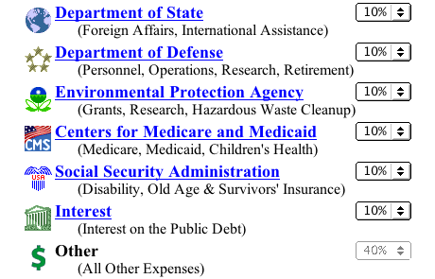
- Use the pull down menus to select the
percentage that you believe or want to
be allocated to each category.

- When you've finished making changes,

click on the link:

- The Budget Explorer will then give you feedback on your budget. If you were testing how well you knew the real allocations, see how you closely you got. If you were choosing percentages based on what you wanted the amounts to be, use the feedback to see what areas of the budget you'll be trying to increase or decrease when it's your turn to adjust the actual budget amounts. After you've read (and printed or saved) the feedback, click on the next link:


- On this click you'll have the actual figures from the Federal Budget. Scroll down and click on “Department of the Treasury” and then "Internal Revenue Service" to expand the listing in that category.
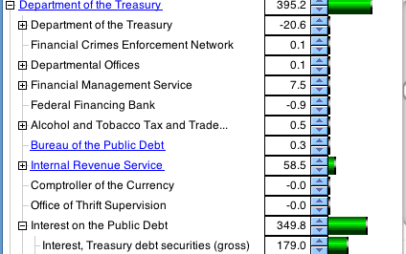

  - What amount is set aside for interest on the public debt? What is interest?
  - What is the unit? dollars? thousands of dollars, millions? billions, trillions?
  - What benefit do you think Americans get from this large expenditure?

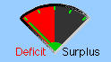
- Watch what happens to the Deficit / Surplus dial if you reduce the interest level a little with the toggle down arrow.
Watch what happens to the Deficit / Surplus dial if you reduce the interest level to "0".

