Molecular Genetics Quiz
PLEASE DO NOT WRITE ON THIS COPY OF THE QUIZ. WRITE ALL ANSWERS ON THE ANSWER SHEET!
1. DNA stands for __(a) nucleic acid and RNA stands for (b) nucleic acid.
2. The sugar of RNA is __(a) and the sugar of DNA is (b) .
3. DNA is __(a) stranded and RNA is (b) stranded,
4. RNA has __(a) as a nitrogen base instead of (b) which is found in DNA.
5. DNA replication is considered to be a process _______________.
6. Purines are ringed nitrogen bases.
7. Pyrimidines are ringed nitrogen bases.
8. Guanine and adenine are examples of __________.
9. Uracil, cytosine, and thymine are examples of __________.
10. Label the various parts of the DNA molecule below.
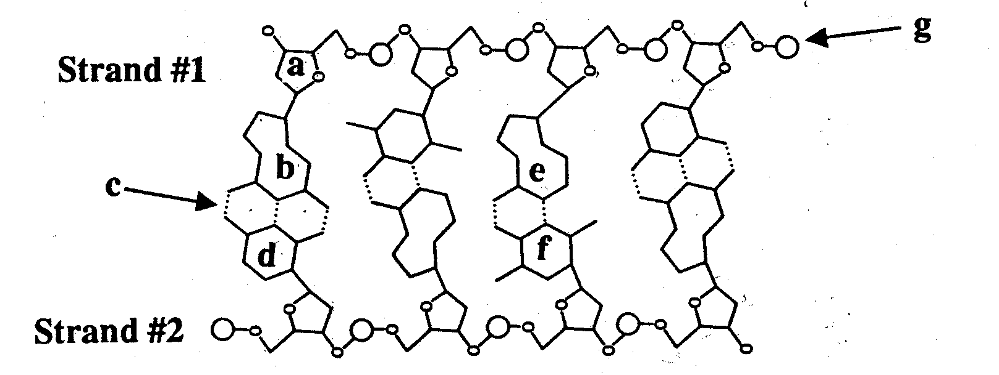

11. Strand #1 runs in what direction (3' → 5', 3' ← 5', 5' → 3', or 5' ← 3')?
12. Strand #2 runs in what direction (3' → 5', 3' ← 5', 5' → 3', or 5' ← 3')?
13. The two strands of DNA are said to be ___________ to each other.
14. List the full names of the three types of RNA (don't use abbreviations like rRNA).
15. What is the relationship between DNA and chromosomes?
16. Complete the mRNA strand, tRNA strand, and the code.
17. Which type of RNA copies DNA?
18. Which type of RNA has an amino acid attached to it?
19. Which type of RNA assembles ribosomes?
20. The first amino acid of every protein is ________________.
21. The first major step of protein synthesis is __(a) and the second step is called (b) .
22. The steps to translation in order are __(a) , (b) , and (c) .
23. The first codon of every protein is __(a) and it found on a (b) RNA.
24. The first anti-codon of every protein is __(a) and it found on a (b) RNA.
25. The structure of a DNA molecule can be described as a .

Name:
Grade: ____/80 Period:
Review: Yes / No (20 pts) Date:
Molecular Genetics Quiz
Answer Sheet
1.(a) _____________________________ 17. _______________________________
(b) _____________________________ 18. _______________________________
2.(a) _____________________________ 19. _______________________________
(b) _____________________________ 20. _______________________________
3.(a) _____________________________ 21.(a) _____________________________
(b) _____________________________ (b) _____________________________
4.(a) _____________________________ 22.(a) _____________________________
(b) _____________________________ (b) _____________________________
5. _______________________________ (c) _____________________________
6. _______________________________ 23.(a) _____________________________
7. _______________________________ (b) _____________________________
8. _______________________________ 24.(a) _____________________________
9. _______________________________ (b) _____________________________
10.(a) ______________________________ 25. _______________________________
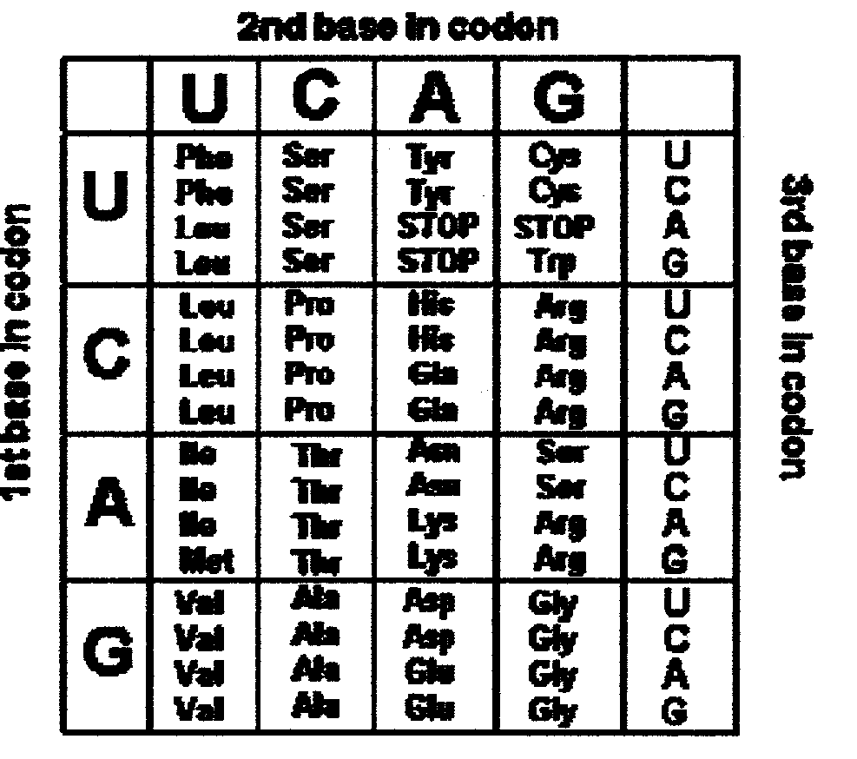
(b) ______________________________
(c) ______________________________
(d) ______________________________
(e) ______________________________
(f) ______________________________
(g) ______________________________
11. ________________________________
12. ________________________________
13. ________________________________
14.(a) ______________________________
(b) ______________________________
(c) ______________________________
15. _______________________________
- DNA: TAC/TGG/AAC/GTT/CAG/ACT
mRNA: / / / / /
tRNA: / / / / /
a.a. seq: / / / / /

