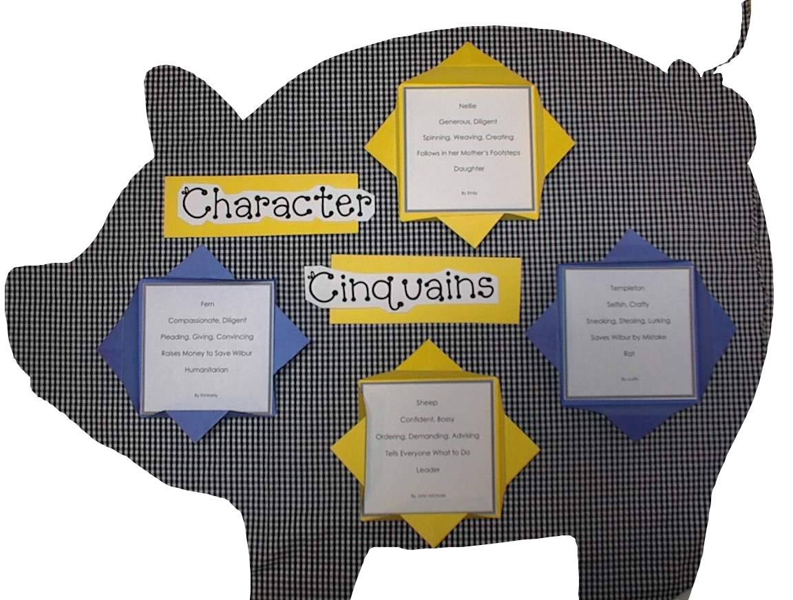
Character Cinquain
Poetry Frames

1. Begin with a 9”X12” piece of construction paper laying horizontally.
2. Take the bottom left corner and fold diagonally to meet the top edge.

3. Cut at edge of newly formed triangle (figure 2) to form a square.

4. Open the square and fold all four corners into the center.

5. Fold each point back to edge.

