What We Think Really Happened

WANTED: SALLY, SAMANTHA & GEORGE

Sally, Samantha, and George committed the crime. They broke into Ms. Miller’s classroom on the night of February 24th and stole nine chemicals. All evidence points to these three guilty parties, as you can see from our map.

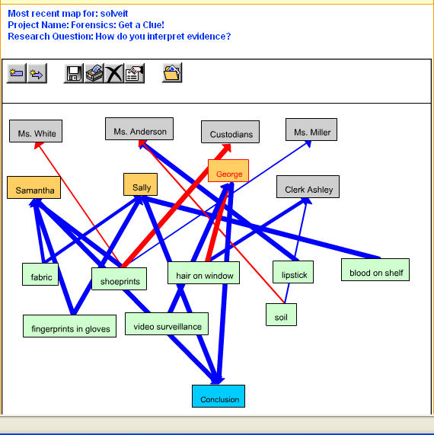

We did an analysis of the granule size, color, mineral content, and pH of the soil found on the shoeprints in the back room and the shoeprints of the suspects. The results of this test revealed that Sally, Samantha, and Ashley’s soil at their homes most closely matched the soil found at the scene of the crime. Based on other evidence and the interview, we later ruled out Ashley as a suspect. Although George did not leave a shoeprint, other evidence points to his involvement in the crime.

We believe that the suspects were wearing white latex gloves. Two pairs of latex gloves were found in a trash can at Sally’s house. We lifted the fingerprints and when we compared them to the suspects, we found that they matched Sally and Samantha’s fingerprints. No surprise there. Also, upon searching Sally’s house with a search warrant, we found a crowbar in her garage. Although it was hidden with her dad’s other tools, it was found to have traces of paint. We tested the paint chip and found that it matched the paint from the storage room door. More evidence pointing to their guilt!

A luminal test detected blood in the storage room. Based on our blood drop volume lab, we found that the approximate blood loss was .80 mL and the type is AB for the blood found on the shelf. We also did an angle of impact test and we think that when climbing the ladder to reach the chemicals, someone picked up a glass bottle, accidentally dropped it, and cut themselves on a piece of glass. We think the blood was caused by an accident and not a violent act relating to the crime. We believe that it is Sally’s blood. She has a cut on her hand and has AB blood type.

We also analyzed the hair that was found at the crime scene. The hair on the window was found to be dyed blonde hair. It seems to match Samantha’s hair and not Sally’s because Sally has natural blonde hair and Samantha dyes hers. The fiber test results also point to Samantha. We compared the fiber found at the scene of the crime to other fibers by comparing the fiber’s response to flame. We found that the fiber at the crime scene was cotton with blue marker on it. When we searched Sally’s house, we found a white cotton shirt with blue marker in her laundry basket. Samantha had a marker fight with Lucy earlier in the day. Further investigation revealed this to be Samantha’s shirt. It seems that when Samantha was escaping through the window, her shirt caught on the window ledge.

The video tape from the surveillance shows three people who match the physical description of Sally, Samantha, and George. This makes sense because they are all friends. The videotape showed the male (George) breaking into the principal’s office. So, we think that George hacked into the principal’s computer. Also, George claims that he was with Bob, but Bob said that he was only with his parents that night.

Here’s what we think happened. Sally, Samantha, and George hid somewhere in the school – maybe in Ms. Miller’s room after the custodian cleaned it or maybe in the bathroom. Then, after the custodian left, they broke into Ms. Miller’s storage room with a crowbar. They stole the crowbar from the custodian’s room. When they got into the storage room they took a bunch of chemicals because they wanted to make an explosive just for fun. While the girls were taking the chemicals, George was breaking into the principal’s office to get into his computer and change his behavior and absence record. Somehow, he set off the alarm. When the girls heard the alarm, they quickly escaped through Ms. Miller’s window. Samantha tore her shirt while they were escaping and they spilled some chemicals.

