The War to End All Wars
Volume 1, Issue 1 | 11/30/2005
Special points of interest:  - Serbians assassinate Austria-Hungary’s heir to the throne  - Mobilization of troops  - Almost all of Europe is engulfed in war  - U.S. enter World War I  Inside this issue: | Germany in World War I  By: Student A  The whole world is wondering what is going to happen; many nations are forming alliances and massing military. Imperialism, militarism, and nationalism are some of the causes of the soon to be war. Alliances with other countries also played a part in the pre-war. Germany was involved in all these. First imperialism, Germany, along with many other European countries, felt that by acquiring more land, they would spread the wealth and glory of the nation. Much of this land was in Africa. Land was diminished as many countries occupied the continent of Africa. Because of so many countries getting land next to another country’s, many border disputes broke out between the different nationalities; caused much conflict in Africa, and hatred between the two counties owning that land. Militarism was a big part in the break out of the war. An arms race increased the hostility between many European countries. Armies and navies began to expand rapidly as nations competed with other nations to have the largest and best military in Europe or even the world. Germany’s army doubled in size from 1870 to 1914. Germany was very competitive in navy expansion, especially with Great Britain. Nationalism also played a role before the war. As many countries made treaties with others to back them up, tensions between the Triple Entente and the Triple Alliance became very tight. As troop movements began, many countries became scared that they were going to be attacked, or their ally was going to be attacked, thus causing them to move troops, and creating even more fear. Germany was one of the first to begin troop movements, causing other countries to mobilize their troops, and eventually the war broke out on June 28, 1914, when Archduke Francis Ferdinand, heir to the Austria- Hungarian throne, was assassinated in Sarajevo, Bosnia, by a Serbian nationalist belonging to an organization known as the Black Hand. The war had begun.  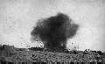  German artillery shell exploding near British lines.
  Russia in World War I | 2
  British Role in World War I | 2
  Serbian Assassination | 2
  Austria -Hungary | 3
  United States Enters World War I | 3
  Letter to Editor | 4
  France in World War I | 4

PAGE 2 | THE WAR TO END ALL WARS |  | VOLUME 1, ISSUE 1
Russia in World War I
By: Student B  It was July 28, 1914 when Austria-Hungary declared war on Serbia when they turned down the Ultimatum they were issued, which said that the assassins had to be dealt with and it put an end to Serbia's sovereignty. They were issued this because they were outraged by the assassination of their Arch duke Franz Ferdinand. Austria-Hungry knew that Serbia would turn down the Ultimatum; they just wanted a reason to justify a declaration of war on Serbia. But they were worried that Russia would come to the aid of Serbia so they made sure that Germany would back them if things went wrong. This is what brought Russia into this war because of their loyalty to Serbia they entered the war to help protect Serbia.  Now we have reached the Russian revolution. After the loss of many Russian troops, |  | many Russians began to lose faith in this war. It was March 3, 1918 when Russia dropped out of the war and gave up control of many territories like  Finland, Poland, Ukraine, and Baltic Provinces. After the Russians dropped out of the war they were still losing troops when a commander, Entente led an invasion of Russia. This invasion was said to "punish" Russia for dropping out.  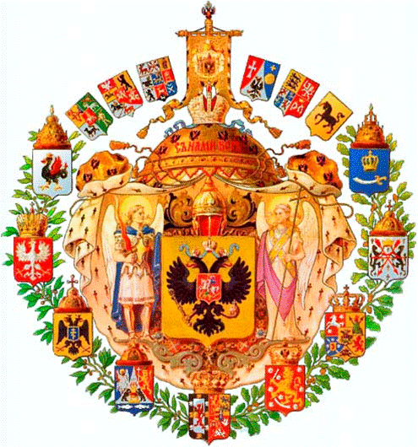  Coat of Arms for the Russian Empire. Painted by  Commander Valery Yegorov

British Role in World War I
By: Student C  The British were one of the world greatest powers. They thought that if they were to maintain naval superiority they would have to have a navy 2 and a half times the size of the second largest navy. The British Empire was the world’s first global power and the largest human population. 470-570 million people. About a quarter of the world’s population. | When the Germans Attacked Belgium, it made the British to declare war on Germany. Since Russia and France was allied by an agreement that said they would protect Belgium. Since the Germans attacked the city Britain was obligated to defend it. When Britain declared war many of her colonies and domains offered military and finical support. These domains included: Australia, Canada, India, |  | New Zealand and the Union of South Africa.  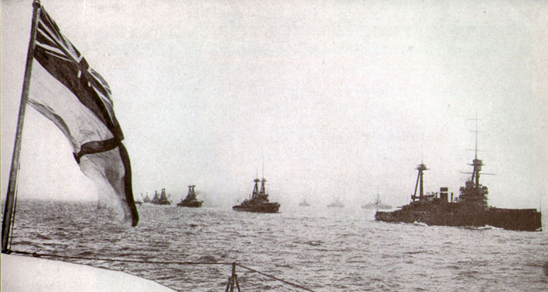  British ships sailing out to sea.
Serbian Assassination
By: Student B  On June 28, 1914 the heir to the Austrian throne, Archduke Francis Ferdinand and his wife Sophie, were assassinated in the Bosnian capital. They were touring the city of Sarajevo. The reason that they were touring was to celebrate the anniversary of the 1389 battle of Kosovo where Serbians were defeated by Ottoman Turks. The reason that he was assassinated | was because he was trying to convert the Austro-Hungarian Monarchy to a Triple monarchy by including Serbia. The assassins were young Bosnians with Serb background. When Serbia heard of the murder they sent their condolences to the Austrian government. Still the Austrian press spread false rumors to mislead the public to believe that Serbia was behind the whole thing. |  | After the news of the false rumors reached the Serbian the said that they will do justice to those who played a role in the assassinations. The Austrian government did not ask the Serbian government for help so the Serbian thought that they were planning some action against them. Serbians considered that their interests require peace and tranquility.

Volume 1, Issue 1 | The War to End All Wars | Page 3

Austria-Hungary
By: Student C  The reason why Austria-Hungary went into war with the other countries was because of a futile assassination of there Archduke. The assassination was July 28, 1914 when Ferdinand was arriving at the town hall in Sarajevo. The assassinator was a nationalist. Austria-Hungary issued an ultimatum that would bring the assassins to justice. His fall to the Serbian Black Hand is one of the major events that caused the great world war.  Serbia had long Slavic ties with Russia so Russia declared war on Austria. Then Germany declared war on Russia and Serbia on August 1 and teamed up with Austria Hungary. A war that was supposed to be a limited war was turned into a war that ended all wars. These events fueled the outbreak of a major world | war know as world war one.  The three countries that came together to fight was known as the triple alliance. They fought the other countries known as the triple entente who where Britain, France, and Russia. Italy was the other country that came together to fight with Austria-Hungary and Germany.  The country of Italy betrayed the other two countries and joined the triple entente to fight. The war ended when on November 3, when Italy, France, and Great Britain smashed Austria-Hungary and caused Austria to sign an armistice. | 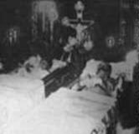  The Archduke and Duchess lie dead in Sarajevo.

United States Enters World War I
By: Student B  It was February 3, 1917 when current president, Woodrow Wilson, declared that the United States would sever all their ties with Germany. Wilson made this decision when Germany decided to resume unrestricted submarine warfare (unrestricted submarine warfare is when a submarine assaults a merchant ship with no warning). Along with Germany the United States broke relations with a few other Latin American Nations. After ties were severed this wasn’t | enough for Wilson, he proposed that we declare war on Germany. He also proposed war against Austria-Hungry if they didn’t renounce their loyalty to the Germans. On April 16, 1917 the United States declared war on the Germans. When Austria-Hungry kept their loyalty to Germany the US declared war on them in December of 1917. | In the summer of 1918 US troops were sent to Europe to stand and fight in the war. But through out the war the US was short on many necessities like weapons and airplanes. There were many casualties due to the fact that the general John Pershing was in control of the frontal assaults and he was very reluctant to remove his troops causing many US casualties. But in the end Germany was defeated by the hand of the US and its allies.

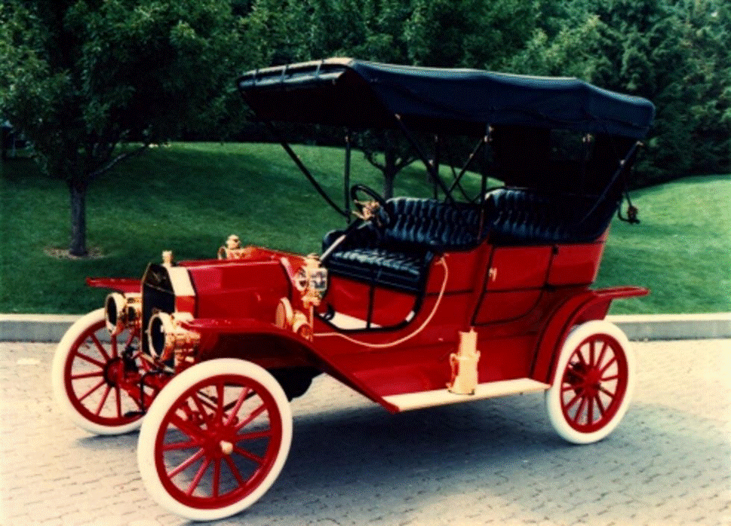 |  | Dear Editor:  I am a reporter in Europe; I am investigating the event and causes of the “War that Will End All Wars.” I am come to conclusion of who will win, and why. I think that Germany and its allies will win this war. I think Germany and its allies will win because of their strong militaries.  Germany has one of the strongest armies and navies. They competed in an arms race and doubled their army between 1870 and 1914. The navy of Germany also greatly improved, as they went into a competition with Great Britain. The allies of Germany also have strong militaries.  Germany and many of their allies also have a lot of land. This can have both advantages and disadvantages. Some advantages are that they can use more people to fight in the war. A disadvantage is that they will have to defend a lot of land if they don’t want to lose that land. Another disadvantage is if they are occupying territory and many of the people in that territory may not want to fight for that country.  Overall I think that the strong armies of navies of Germany and its allies will overpower the countries against them, allowing them to win this soon to come war.  Sincerely,  Student D  Student
This is the new Model T Ford. Come and see it is a great buy
Only $650

Up to 45 mile per hour
A Pure LUXURY car

France in World War I
By: Student D  France had many parts in the beginning of World War I. They were actively involved in the affairs of other countries and the arms race that was a cause of the war. They participated in the imperialism that was influenced and participated in many countries in Europe. France also had many alliances, which also cause the war of the “War that Will End All Wars.”  France played a big part in the pre-war. France tried to acquire more land; most of this was in the continent of Africa. As was many countries in Europe. As many countries were occupying countries, border disputes were common between the different nationalities. This created a lot of hostility between the European nations, because of these border disputes. | France also played a part in the arms race, between 1870 and 1914, the army of France doubled. They also tried to increase their navy, to compete with the great naval power of that time, Great Britain and Germany. As France increased their navies and armies, it put pressure on the other countries to also increase their armies to compete with the power of France.  France passed many treaties to become allies in the war. France was part of the Triple Entente, which consisted of Great Britain, France, and Russia. This treaty was used to counter the treaty between the Triple Alliance, which was Germany, Austria-Hungary, and Italy. This put Europe into two armed camps. |  | When Russia was threatened with war, France strengthened their backing with Russia. France began to mobilize as Germany moved their troops to support Austria-Hungary. Soon, all of Europe was encountered in the war.  