Probing Questions

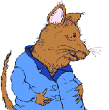

Use these questions to help elicit answers from students so that they may justify their answers.

If you were Doctor DeSoto, would you treat the fox? Why or why not?

- What could you do differently to assure yourself that the fox would not harm you and your family?
- Give me an example from another book that you have read or your own personal experience to justify your answer.
- What changes would you have made in treating the fox?
- Would the fox’s appearance affect your decision to treat him?
- What would your criteria for treating dangerous animals be?
- How can you tell if someone is a safe person (stranger/danger)?
- Do you think that dressing nicely was part of fox’s plan?
- Would you treat other large animals? Why or why not?
- Under what circumstances would you treat other large animals?
- Would you ever treat a tiger or elephant even if it was an emergency?
- Would it matter if the animal was a baby animal?
- What lesson is learned from this story?

