Timeline
A timeline is a simple way to show an assessment plan and check that a variety of assessment methods occur throughout the learning cycle.
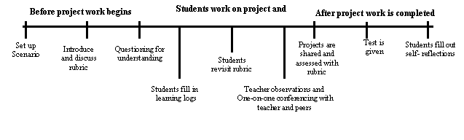
Venn Diagram
A Venn Diagram is another way to visually represent how and when a variety of assessments can occur throughout the learning cycle. It also shows how the same method is used at various times over the course of a unit of study.
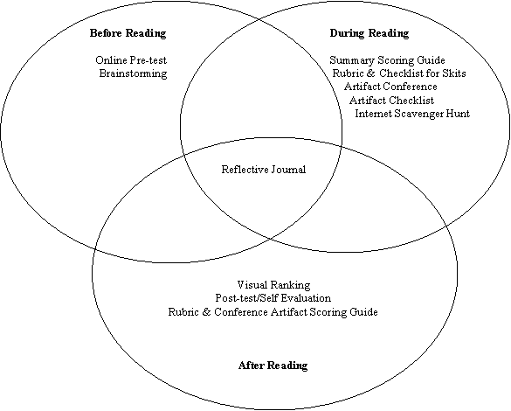
Table
A table provides a format for describing in detail the processes, purposes, and methods for assessment throughout the learning cycle. The following example is taken from the National Energy Plan Unit Plan within the Visual Ranking Tool.

Assessment | Process and Purpose of Assessment
Questioning/ Brainstorming | Use questioning and brainstorming to determine how much students know about energy resources prior to the start of the unit and to draw connections to students’ personal lives.
Project Overview and Checklist | Students use the project checklist to understand where they are in the unit and where they are going, as well as to self-assess their progress while working on the various components of the project. They revisit the checklist throughout the unit to help monitor their progress and check due dates.
Research Worksheets | Students use the State Energy Information, Energy Plan Comparison, and Energy Plan Choices worksheets to help guide and assess their research of energy policies, usage, and resources.
Project Journal | Students are prompted at the end of each project step to create journal entries in response to prompts. During conferences review the project journal entries and provide feedback and clarify misunderstandings. Students use the journals to record new learnings and reflect on their thinking. Review journal entries at the end of the unit to assess understanding.
Teacher Conference | Meet with each team at least once during the project to assess the students’ quality of research and understanding of content. The conference is also used to provide feedback on current work, clarify misunderstandings, and assist in locating other research resources, if necessary.
Visual Ranking Comments | Read the students’ comments within the Visual Ranking projects to assess comprehension and ability to provide sound reasoning for their selections.
Anecdotal Notes | Periodically take notes during individual and group work. These notes support, checking progress and adjusting instruction. Refer back to these notes when conducting the final assessment.
Presentation Outline | Review students’ presentation outlines and provide feedback, suggestions, and corrections before they begin working on their multimedia presentations.
Presentation Scoring Guide | Students use the scoring guide to self-assess and provide constructive feedback to peers prior to presentation completion. Use the scoring guide to assess verbal communications skills, as well as quality of content, design and research, following the final project presentations.

Assessment Timeline
A timeline shows types and sequence of (formal and informal) assessments during the unit. Timeline should reflect assessments at the beginning, middle and end of a unit. A table below the timeline describes how the assessments are conducted; how the assessment informs the teacher and student (the purpose), and who participates in rating or recording the assessment (student, teacher, parent, or peer.)

The following Assessment Plan example is taken from The Great Bean Race Unit Plan within Designing Effective Projects. In this unit, students study plants and conduct investigations of ideal growth conditions before growing the tallest beans possible. They keep a science journal and plant log and create a newsletter that documents results of the different activities in the seven week unit.

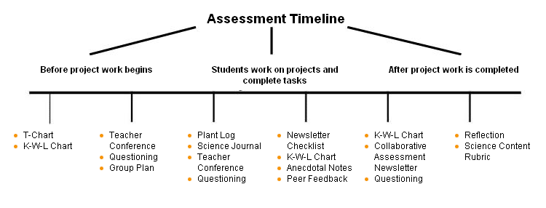

Assessment | Process and Purpose of Assessment
T-Chart | Students create a T-chart to compare and contrast fact from fiction. Use the information to draw out prior knowledge and gauge readiness for a plant study. The T-chart is posted for students to revisit what is fact or fiction.
K-W-L | Students develop classroom and individual Know-Wonder-Learn charts about plants. Students use these to access prior understanding, brainstorm ideas, think about questions to research, and reflect on their learning. Use the KWL initially to gauge readiness and interests and then during the unit to promote metacognition of learning progress as students revisit them and reflect.
Questioning | Use questioning strategies to monitor student progress, probe for understanding, and engage students in higher-order thinking. Circulate during group and individual work time as well as during conferences. Also return to Curriculum-Framing Questions throughout the project to analyze student understanding.
Group Plan | Students synthesize their new learning in small groups and plan conditions for light, soil, and water to grow the tallest bean plant. Review the plan to assess scientific understanding of plant growth and prepare feedback, clarify misunderstandings, or provide additional lessons, if necessary. Students review and discuss plan at end of investigation.
Conferences | Schedule individual conferences to assess the students’ scientific understanding and the writing process and allow for feedback, clarify misunderstandings, or provide additional lessons if necessary. Pre-planned questions and notes provide documentation for project assessment.
Anecdotal Notes | In this informal assessment, notes from observations and interactions with individuals and groups and from the conferences provide documentation for final assessment.
Plant Log | The log is provided for students to record daily growth and temperature and graph the changes over the growing period. Use the log during conferences to monitor the progress of data collection and prompt questions. Review the log at the end of the unit.
Science Journal | Students make observations and keep notes in their science journal about the growth of their plants. Students complete specific observations and reflections prompted by the teacher at key times during the unit. Review during conferences to provide feedback, clarify misunderstandings, and provide additional lessons if necessary. Also review at the end of the unit to assess scientific understanding.
Newsletter Checklist | Students use the newsletter checklist to self-assess their progress while working on the newsletter.
Collaborative Assessment- Newsletter | Students assess how well they worked as a group. Use this assessment to assess the group process and the final newsletter product.
Peer Feedback | Students review each others’ writing and give structured feedback. Use to help monitor group process.
Reflection | Students analyze all groups' bean plant growth data and come to a conclusion about the best growing conditions for plants. Use to assess science concept and process understanding.
Science Content Rubric | Use the science journal, plant log, group plan, reflection, observation notes, and newsletter to assess science concepts and process development using the rubric as a guide. The rubric allows students to self- assess their progress. Also, use it to conduct a final assessment.

