Learn About Sequencing Activities
Sequencing activities help students to arrange information in a logical order, making it easier to track information over time.
Chain-of-Events
The use of a chain-of-events graphic organizer is a valuable way to:
- Organize steps in a procedure
- Trace plot development in a story or novel
- Document actions of a character
- Record the important stages of an event
Chain-of-Events for Where the Wild Things Are by Maurice Sendak
This is a sample graphic organizer a student might create.
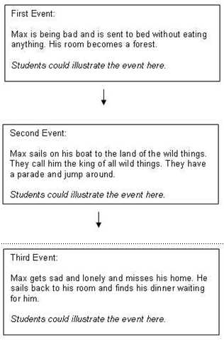
Timelines
Like a chain-of-events organizer, timelines help students place events and people in chronological order. Throughout a lesson or unit, students can add to the timeline, use it as a reference and a benchmark to make sense of dates and events and to see patterns in history. By sequencing important events, students can make connections to past and current content. Individual and class timelines can be effective ways to represent events and time periods.
Space Exploration Timeline
This is a sample timeline a student might create.
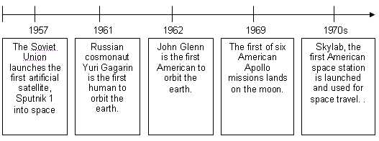
Storyboard Planners
Storyboard planners are helpful ways to construct ideas and organize information before creating a product. Students can create storyboards, using multimedia technology or paper and pencil. These storyboards can be used as a pre-writing or brainstorming activity before students create a final product. The storyboards can be checked by a peer or teacher to make sure the student is on-track and provide feedback before getting to work.
This is a sample storyboard a student might use.
This storyboard is from the Unit Plan, African Adventure Safari from Designing Effective Projects.
