Designing Effective Projects: Sequencing Activities
Storyboards

Web Site Storyboard Example

This is a sample storyboard a student might use.
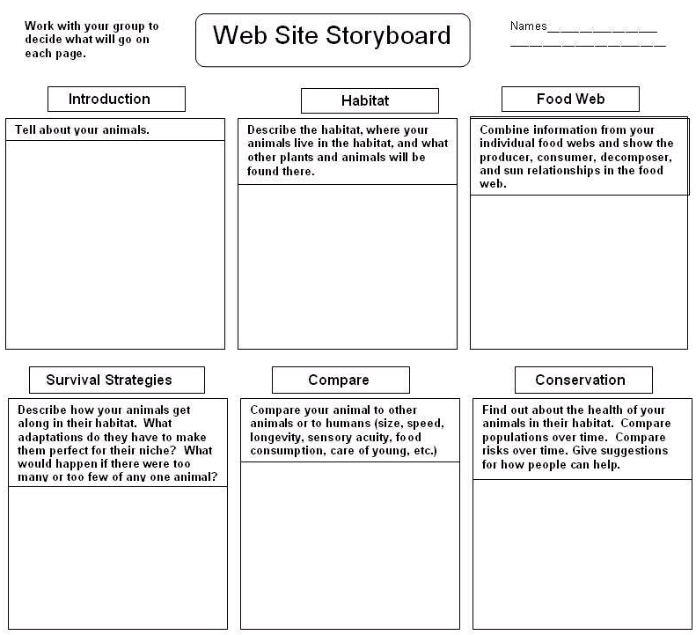

This storyboard is from the Unit Plan, African Adventure Safari.

