Designing Effective Projects: Sequencing Activities
Timelines

Example of a Timeline Organizer

Philippine History Timeline
This is a sample timeline a student might create.

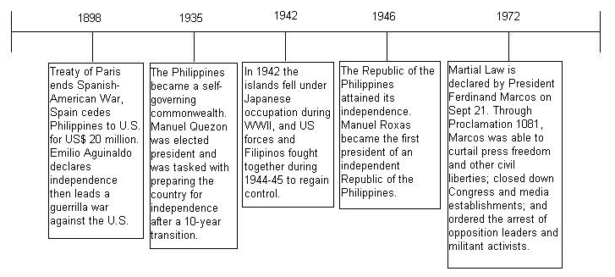

Resources:

The CIA World Factbook
https://www.cia.gov/library/publications/the-world-factbook/geos/rp.html

History of the Philippines
http://en.wikipedia.org/wiki/History_of_the_Philippines

Note: An extension idea is to have students create a slideshow presentation where each student is assigned a date, types out the event, illustrates it using a draw program or clip art and the slides are compiled into one presentation.

