Assessing Projects: Gauging Student Needs
Classification Charts

Sorting and Categorizing Information
With classification charts, students organize information visually to compare related ideas.
Venn Diagrams
Venn Diagrams are used across the curriculum and with any grade level to compare information. A Venn Diagram is made up of two or more overlapping circles. The similarities between topics are listed in the intersection of the two circles. The differences are listed in the remaining sections. From simple two-circle Venn Diagrams to four-circle Venn Diagrams, students construct visual representations of their learning. Students use the diagrams to organize information as an aid for developing multimedia presentations, reports, essays, or oral presentations. Teachers can use Venn Diagrams as a way to assess student learning or as a quick, informal means to check for student understanding.
Venn Diagram Example
This sample Venn Diagram is from the Unit Plan, Where in the World is Cinderella? in Designing Effective Projects.
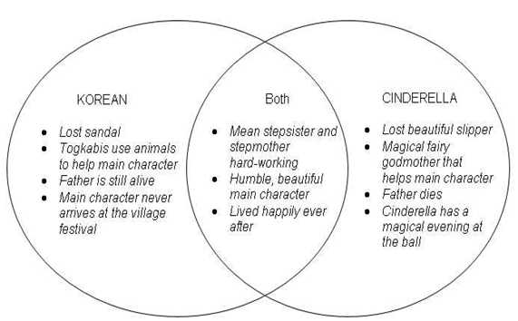
T-Charts
Another type of classification chart is a T-chart. With T-charts, students can clarify concepts or ideas by comparing and contrasting them visually by listing and examining two facets of a topic. They can, for example, list pros and cons, advantages and disadvantages, facts and opinions, strengths and weaknesses, or problems and solutions. Like the Venn Diagram, the T-chart can be used to organize learning for a report, presentation, or essay.
T-Chart Example
This is an example T-chart inspired by the Unit Plan, Destination America: Our Hope, Our Future in Designing Effective Projects.
Destination America: Our Hope, Our Future
Compare Ellis Island immigrants to Angel Island immigrants using the T-Chart below.
 | Ellis Island | Angel Island
Where are the immigrants from? | Mostly European countries (Italy, Poland, Ireland, England) | Mostly from Asian countries (China, Japan, Korea, India, Philippines)
Where is the island located? | East coast – across the Atlantic Ocean in New York Harbor West coast | West Coast –– across the Pacific Ocean in San Francisco Bay
Reasons immigrants came to America: | Religious and political persecution, crop famine, loss of jobs, overpopulation, free expression, personal opportunity and government incentives in America | Poverty, limited job opportunities in homeland, war, high taxes, the hope to have a better life in America
Nickname: | Gateway to America | Guardian of the Western Gate
When was island open for immigrants? | Opened for immigrants between 1892 to 1924 | Immigrants and emigrants between 1910 and 1940
Why were the islands built? | To regulate immigration into America – a stopping point to America | Designed to control the flow of Chinese immigrants with the passage of the Chinese Exclusion Act of 1882. Process and detain Chinese and other Asian immigrants.
How many people passed through the gates? | Over 22 million immigrants passed through the doors to American through Ellis Island | Estimated 1 million people entered and left the country. 175,000 Chinese150,000 Japanese
What did the immigrants have to do when they got there? | Medical examinations and full physicals for everyone by 1917. If a problem was curable, they were sent to the island hospital. If not, they were sent back home. | Humiliating and barbaric medical examinations performed. Interrogation sessions took place.
What were the conditions like? | The Statue of Liberty greeted the immigrants and welcomed them to America. The conditions were crowded. | Harsh prison-like conditions while awaiting the demanding hearing process to prove their status as legal immigrants
How long did they stay? | Process took 3-5 hour with the interviews. Some stayed for months waiting for family members or other reasons. | Some stayed over night, while others stayed for months. Chinese immigrants stayed an average of 2-3 weeks. While waiting for their immigration status, many of the immigrants etched poems of depression and fear on the walls of the barracks.
How were they granted permission to stay? | Prove they could be in America legally. Prove their country of origin, where they expected to live and work in America. Anyone with a criminal record or suspected of being an indentured servant was rejected. By 1921 a literacy test had to be passed and a passport or visa had to be shown. Had to have at least 20 dollars to be allowed to enter America. Their money was exchanged on the island. | Prove their identity by matching details of their lives with the answers of their relative in the United States. Often had to wait months while their case was being investigated.

