Designing Effective Projects: Cooperative Learning
Reciprocal Teaching
Reciprocal Teaching Strategy
Reciprocal teaching (Palincsar, 1984) is a cooperative grouping strategy that calls on students to become “the teacher” and work as a group to bring meaning to text. Teachers and students engage in dialogue regarding segments of text. The dialogue is structured by using four strategies:
- Summarizing
- Question generating
- Clarifying
- Predicting
It is important that each of the above strategies has been taught and practiced before reciprocal teaching takes place. The stages of reciprocal teaching are easy to set up.
Stages of Reciprocal Teaching Set-Up
The teacher hands out a passage of text to each student in the group. Each student reads the passage and writes summarizing, clarifying, or predicting questions related to what they’ve read. The “teacher” of the group, asks one of the questions. The “teacher” is the lead group member who starts off the questioning. One group member responds, using the text to support their answer. The student, who answers the question, then asks a question and the process repeats.
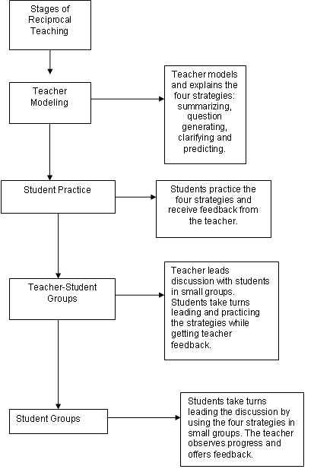
Adapted from: http://condor.admin.ccny.cuny.edu/~yq6048/*
References
Palincsar, A.S. & Brown, A. L. (1984). Reciprocal teaching of comprehension-fostering and comprehension-monitoring activities. Cognition and Instruction, 1(2), 117-175.

