Using the Essentials Course Wiki
A wiki is a "type of website that allows the visitors themselves to easily add, remove, and otherwise edit and change some available content… This ease of interaction and operation makes a wiki an effective tool for collaborative authoring." (Wikipedia, 2006)
We use this wiki during the Pedagogical Practices discussions to share ideas and strategies for teaching in a student-centered, project-based classroom.
Click on the links in the left navigation pane to access directions for completing each Pedagogical Practices discussion. Click on the + button to expand each section. If you need help using the wiki at any time, click on the Wiki Help link for directions.
Use the "Back to. . ." button at the bottom of each Wiki page to return to the last page you visited before entering the Course Wiki.

Understanding the Wiki Editing Tabs
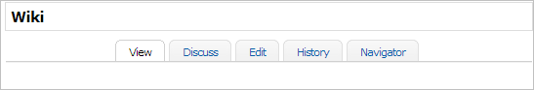

The Wiki has it’s own editing features within the subset of tab navigation.
- View: Allows users to view the currently published wiki page.
- Discuss: Users can discuss the content for the wiki page. Note: include your name if you leave a comment so others may ask you questions if needed.
- Edit: Allows participants to contribute to the wiki content, by adding a new page, linking to files and/or resources, and making content edits.
- History: participants can view the timeline of when the page was created and any subsequent edits.
  - Note: Be cautious when exploring this option as you can accidentally delete another user’s work.
- Navigator: Explains the navigation relationships- where did the page link originate from.

Using the HTML Editor to Format the Wiki Content
The HTML editor will allow you to format your responses without having to know HTML. Mouse over each item to identify the feature, a few useful features are noted in the image below.

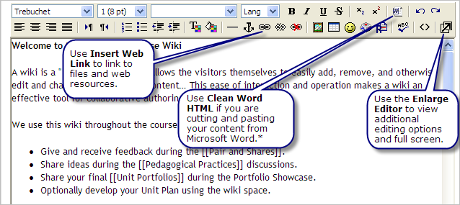

Full Screen Editor
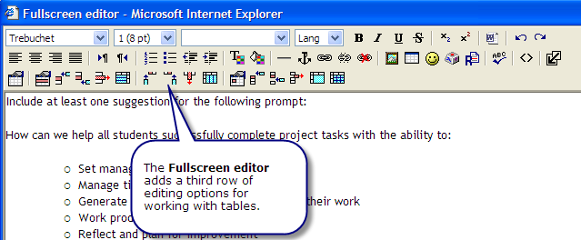

Working with Tables
Many of the Pedagogical Practices ask you to collaborate and share information using a table structure in the wiki. When adding content to a table you should use the Full screen editor.

Creating a table
- In the Full screen editor select Insert Table.
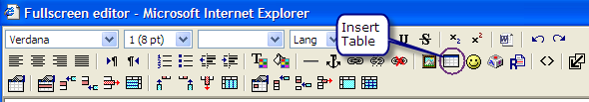
- The Insert Table window opens. Adjust the table properties such as number of rows and columns. When finished adjusting the setting select OK.
Note: If you wish to have each row of the table display on the wiki page then you need to enter a space in each cell of the table.

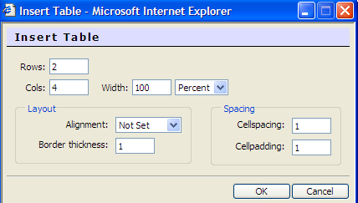
- Enter text into each cell. Note: you can not cut and paste a row or column from a table in Microsoft Word*. Text needs to be entered one cell at a time.
- Close Full screen editor.
- Save Changes.

Editing a table
- Navigate and select edit on the wiki page with the table you will work in.
- Select the Full screen editor, this allows you to see the Table Editing Features.
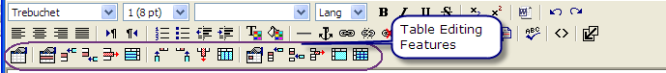
- Enter text into each cell. Note: you can not cut and paste a row or column from a table in Microsoft Word*. Text needs to be entered one cell at a time.
- Mouse over the Table Editing Features to understand the options available, such as insert a row or column, or changing the table’s properties.
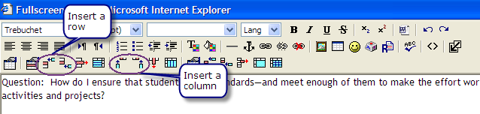
- Close Full screen editor.
- Save Changes.

Linking to a Web page in the Wiki
As you share and collaborate in your groups you may choose to share resources in support of your Pedagogical Practices. The following directions will allow you to quickly link a web resource to your wiki page.
- Go to the page that you would like to link your resource to.
- Click Edit, and type the name of the URL that you would like to link to in your wiki space.
- Select the text and then select the link button, the one that looks like two interlocking chains
- Insert Link feature opens. Enter the URL of the page you are linking to.
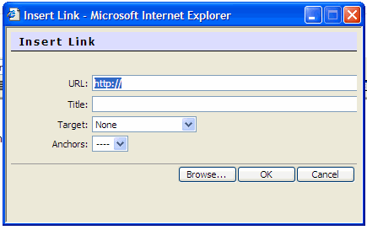
- In the Target drop-down select New window, so your link will open in a new window.

Note: the default is None, it is important to select New window so you do not accidentally navigate away from the course.

- Click OK to save your link.
- Don’t forget to Save your wiki page.

Linking Resources in the Wiki
If you are going to upload and link files to your wiki page, it is helpful to create a folder structure for your files. The very first time you link to a resource file in the wiki, you can create your folder.
- Go to the wiki page that you would like to link your resource to.
- Click Edit, type in the name of the file or resource that you would like to link to in your wiki space.
- Highlight the text and select the link button, the one that looks like two interlocking chains
- Insert Link feature opens, Click Browse to find the resource
- Before you upload a file for the first time you need to create a folder for your resource. Click Create Folder and type your name in the space provided
- To upload your resource into your folder, click the folder, click Browse, find the file on your computer, select the file and click open.
- Click upload, and confirmation that file was successfully uploaded will appear.
- Click on the resource you uploaded and the file URL will appear in Insert Link window.
- In the target drop-down select New window, so your link will open in a new window.

Note: the default is None, it is important to select New window so you do not accidentally navigate away from the course.

- Click OK to save your link.
- Don’t forget to Save your wiki page.

Using the Wiki Search Feature
You may want to revisit a wiki entry that was created by another user but you can not recall where you had seen that entry. The Wiki search will allow you to find the wiki pages that contain the item that you are searching for.
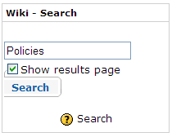
Click in the search field and enter the text you wish to find. Click Search.
Seach will break the information up by page names with the search information and content pages that contain the search item.
Results will show below the search button or on a full page, if you mark Show results page. The images reflect a search on Policies.
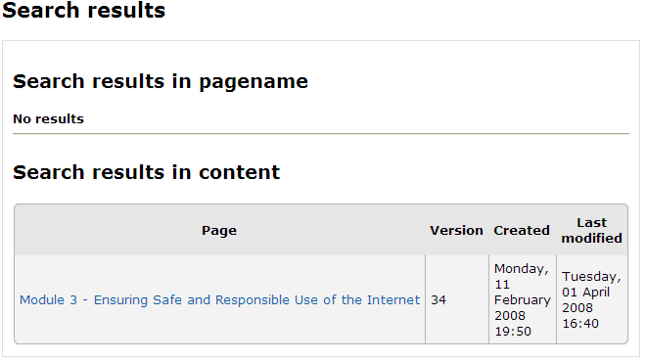
Creating a New Wiki Page
Many of the wiki pages are set up for you to use. The following directions will guide you on how to add additional pages.
- Go to the page that you would like to link your new page from.
- Click Edit
- Surround your desired page name in double brackets and you will create a new page.
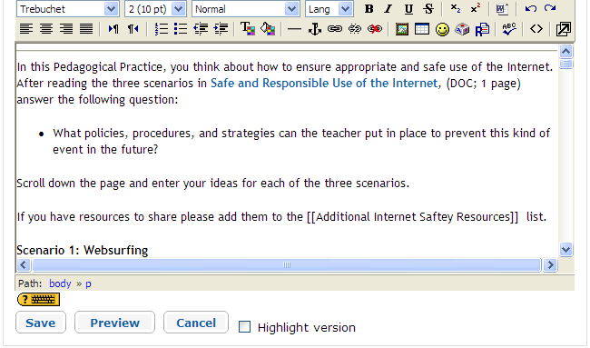
- Upon saving, a new page is created and appears in the course navigation.
- Select the question mark (?) next to the file name to edit the page.

