Intel® Teach Course Management Tool
Quick Reference Guide – Local Education Agency (LEA)

URL: http://coursemanagement.intel.com
Additional information is included in the CMT User Guide
Please email any questions to your ITA or email teacher.training@intel.com
To find your ITA’s contact information click on Personal Profile in the left navigation, then click on My ITA

LEA Guidelines (PDF) describes your role, benefits, and responsibilities.

The Course Management Tool supports your implementation of the program: adding Master Instructor (MI) candidates, finding classes and assigning MIs, and supporting MIs with their delivery to participants.

Common Functions for your role include:

Identifying Master Instructor (MI) candidates and adding them to the tool
Master Teachers (MTs), selected by the Local Education Agency (LEA), are experienced in integrating technology into curriculum. In addition, MTs must be competent in using a word processing application, e-mail, and Internet navigation. MTs undergo comprehensive instruction and curriculum review by certified Senior Trainers (STs). Upon successful completion of the instruction for Master Teachers, MTs then recruit and deliver professional development to Participant Teachers (PTs) in their area. For more information, please refer to the Master Teacher Guidelines (PDF).

To add your MT Candidates, click on Admin Tools > User > Add User
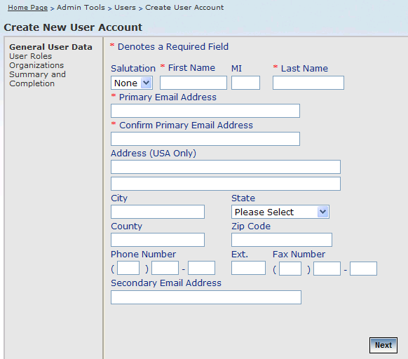
Required Fields are designated with an asterisk (*). Fill in the remaining fields only if you are certain of their accuracy: when the MT logs in for the first time, they will be prompted to fill in the remaining fields. Click Next to progress to the User Role. You may add Master Instructor candidates or LEA users for your LEA only. When you complete the Add User wizard, a system-generated message will be sent to the user, using the Primary Email Address you entered, providing their login ID. A second email to the user will provide their password.

The candidate is now ready to be assigned to a roster, to attend a Master Level class in your area.

Senior Instructors (SIs) also have the ability to add a last minute MI attendee to their roster if the MI candidate is in the system: this is one reason it’s essential the LEA add candidates into the CMT.

NOTE: if you are an LEA and MI, check that you have the MI role. To add the role, click Admin > Users > Search Users (enter your last name). Click Edit next to your name and click Next to find the User Roles page. Check the box next to Master Instructor. Now you should be able to add yourself to rosters for courses you wish to attend (Classes > Search Classes).

Searching for classes in your area and assigning MIs to the Class Roster
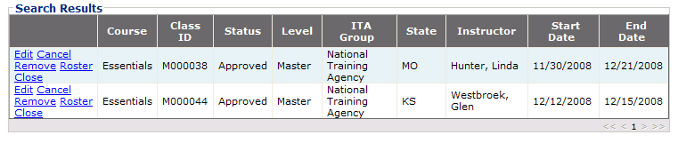
To find a class, click Classes > Search classes > narrow by Course, Master Level, and any other criteria you wish. Click the Search button. Click “Roster” next to a course to add candidates. Select your LEA, and any candidates you have should appear available.

Support MIs to ensure they meet their commitment to train 10 PTs
Upon successfully completing a course, the Master Instructor is certified to deliver that class at the “Participant Level” and order materials accordingly.

The tool does not help Master Teachers recruit participant teachers: your ITA is a great resource for recruitment materials, or you can visit www.intel.com/education/teach/us for information.

The Course Management Tool does not store Participant Teacher’s information, so there are no rosters for any Participant Level course except Essentials Online (this information is required to set up the online learning environment). A link is provided on the schedule page (classes > schedule a class) for the Essentials Online Course roster.

A quick follow up call or email to remind the MT to close their class in the Course Management Tool is very helpful. It’s very important that Master Teachers close their classes. Intel sends communications to MTs who have not met their commitment to train 10 PTs within a year of their MT course end date. If your MTs trained their PTs but did not close their class, they are included in these communications and may be de-activated (preventing their access to schedule and order). You are able to run reports to determine which classes are open / approved and have passed their end date but have not closed.

Monitor Activity in your LEA
You control your MIs’ authorization status. An MI must be both Certified and Authorized to schedule a course and order materials. If you no longer wish for a particular MI to deliver a course to participants, simply “de-authorize” them by un-checking their authorization box (Admin Tools > User > Search User > find the certification and authorization link next to their name. Your ITA also has this ability.

You can keep your MIs up to date through curriculum updates. The Intel® Teach Course Updates site, http://teachonline.intel.com/courseupdates/, keeps MTs current on the courses they are certified to deliver. For the very latest version of each course, you’ll find an overview, MT resources and CD resources.
Note: Registration is open. Follow instructions on the landing page: you will register and enroll in each course.
Common uses for the Course Updates site:
- To prepare to deliver a newer version of curriculum than they were certified on
- To access the most up-to-date resources (Senior and Master level training resources and CD resources are provided for trainers to download prior to delivering a course.

Reports are available for you to track activity in your LEA only. Click Reports and select the report you’d like to run. You may narrow down results using the filters provided, and you may include all optional columns or reduce the number returned. Click Export to Excel to save the report to your system or for the ability to edit the report.

Please remember: additional detail is available in the CMT User Guide
Email any questions to your ITA or email teacher.training@intel.com

