Intel® Teach Course Management Tool
Quick Reference Guide – Master Instructor (MI)

URL: http://coursemanagement.intel.com
Additional information is included in the CMT User Guide
Please email any questions to your LEA, ITA, or email teacher.training@intel.com
To find your LEA’s contact information, click on Personal Profile in the left navigation, then click on My LEA
To find your ITA’s contact information click on Personal Profile in the left navigation, then click on My ITA

Master Teacher Guidelines (PDF) describes your role, benefits, and responsibilities.

The Course Management Tool supports your participation in the program, allowing you to schedule “Participant Level” classes, order materials, and close your classes to count the Participant Teachers you’ve trained.

Common Functions for your role include:

Schedule a Participant Level Course

Click on Classes > Schedule Class
Please read the notes at the top of the page – they may apply to you.
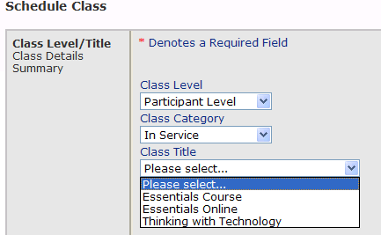
- Select the Class Level first (MIs deliver Participant Level classes).
- Select the Category then Class Title.
You will see an error message if you select a class you are not certified and authorized to deliver. If you receive an error, please check your profile (Personal Profile, My Profile, click the My Certifications link at the bottom of the page)

The Course Management Tool does not store Participant Teacher’s information, so there are no rosters for any Participant Level course except Essentials Online (this information is required to set up the online learning environment). A link is provided on the schedule page (classes > schedule a class) for the Essentials Online Course roster.

Order Materials

Ordering materials is a second, separate step after you schedule a class. Please be sure to order after you know how many Participant Teachers you’ll deliver to, and at least 14 days prior to a course.

There are two ways to order:
- When you log in, at the bottom of the “Welcome Page”, you’ll find your personal dashboard with your upcoming courses.
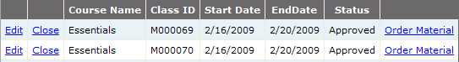
Find the class you’re ready to order for and click the Order Materials link in the right column.
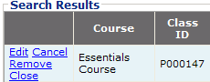
- Click Classes > Search Classes in the left navigation: in the search results, find the class you’re ready to order for and click Edit.

On the page, click the “Order/View Materials” link in the center of the page. Enter the information and click Submit to place your order.

Close Your Classes
It’s very important that you close your class. Intel sends communications to MTs who have not met their commitment to train 10 PTs within a year of their MT course end date. If you train your PTs but do not close the class, you’ll be included in these communications and may be de-activated (preventing your access to schedule and order).

- From the dashboard on the Home page, click “Close” next to the “Edit” link.
- From the search results (click Classes > Search Classes) click “Close

Enter the # of PTs trained and click “Close Class”.
Closing your class also enables the evaluation link for your participants: if you do not close your class, they will not be able to complete the evaluation.

Note: if you team teach, each MT should set up a class and close the class to get credit. Total teachers trained should be the true total: divide the numbers as you like. One MT can place the order, but please explain the situation in both classes’ notes field.

Recruiting Participant Teachers
The tool does not help you recruit participant teachers, we wish it could! Your ITA is a great resource for recruitment materials, or you can visit www.intel.com/education/teach/us for information.

You can stay up to date through curriculum upgrades. The Intel® Teach Course Updates site, http://teachonline.intel.com/courseupdates/, contains an overview, MT resources and CD resources for the latest version of each course.
Note: Registration is open. Follow instructions on the landing page: you will register and enroll in each course.
Common uses for the Course Updates Site:
- To prepare to deliver a newer version of curriculum than you were certified on
- To access the most up-to-date resources (Senior and Master level training resources and CD resources are provided for trainers to download prior to delivering a course.

Please remember: additional detail is available in the CMT User Guide
Email any questions to your LEA, ITA, or email teacher.training@intel.com

