How to Schedule a Participant Level Class (facilitated by a Master Instructor) and Order Materials

Login to the Intel® Teach Course Management Tool at http://coursemanagement.intel.com

Schedule a Class

Participant Level: Typically, the Master Instructor schedules the class, with support from their LEA or ITA.

Click Classes > Schedule a Class >
- Class Level (Participant Level will be selected = Master Instructor delivers to participants)

Select:
- Class Category (In-Service, Leadership, or Pre-Service)
- Class Title (You may only schedule classes for which you, as a Master Instructor, are certified and authorized to deliver. If the ITA or LEA is scheduling, they may only assign a certified and authorized MI. Otherwise, you receive this notice:

Complete course details and Click> Schedule Class

If you are a Master Teacher scheduling an Essentials Online Course, email this Roster to teacher.training@intel.com.

Order Materials
Note: Your materials will be shipped 30 days before the course start date. If your class starts in less than 30 days, your materials shipment should arrive in 10 business days.
(!) Please order materials at least 10 days prior to your course whenever possible. We will make every effort to accommodate rush orders, but there is a risk the order will not reach you in time.

After you schedule a class:
- Click Classes > Search Classes
- Enter Search Criteria or Class ID
- Click Edit next to your class.
- Click the Order/View Material link in the middle of the page.
- Enter the shipping contact and address specifically for this course (this should not be a post office box).
- Quantity is carried over from the expected # of attendees entered when the class was scheduled.
  - You may edit expected attendees in the class description page or you may edit each item in your order (please note that some items are ordered as a pack).
- Do not order more than one item per attendee.
    - If you have materials remaining from a past class, please use them! Reduce the number of that item by the number you have on hand.
- Click Submit (“Back” will clear the information you entered)

If the order is successfully placed:
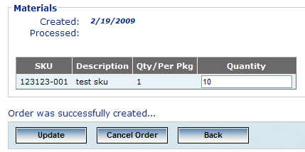
The “Created” date will appear with the date you place the order.
“Processed” date will not appear until 30 days prior to the course start date if you order early.

You’ll also see a note at the bottom of the page “Order was successfully created…”

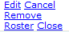
Upon completion of your class, don’t forget to close your class: Search for your class, and click Close. Enter the number of Participant Teachers who completed the class in the box for # trained and click Close Class.

