18-349
Embedded Systems
(Lab-2)

Memory Mapped I/O
+
Flash Programming
+
Whack-A-Mole Game

Table of Contents
1 Introduction 1
2 Development Environment 2
3 Part I: Device Drivers 3
3.1 Requirements 3
3.2 Keypad Demo 3
3.3 Terminal-Display Demo 3
3.4 Timer Demo 3
3.5 Seven-Segment Display Demo 3
3.6 What to Turn In 3
4 Part II: X-Board Flash Programming Utility 4
5 Part III: Whack-A-Mole Game 5
5.1 Introduction 5
5.2 Setup 5
5.3 Select playing level 5
5.4 Game Play 5
5.5 Game Completion 6
5.6 Quitting your program 7
6 What to Turn In 8
7 Appendix 1: Some hardware details 9
8 Appendix II: APIs for Flash Programming - 1 12
9 Appendix III: APIs for Flash Programming - 2 21
10 Appendix IV: Using the Flash Libraries 26
11 Appendix V: flashType structure 27
12 Appendix VI: FooterType structure 28
13 Appendix VII: ImageInfo structure 29
14 18-349 Project 2 Grading Sheet 30

Introduction
This lab introduces Memory Mapped I/O, interrupts and the 80200 Big Endian Evaluation Board. In the first part of the lab, you will write software drivers that control various I/O devices such as the timer, the Serial Port (Keypad input and Console Output), and the seven segment LED. In the second part of the lab, you will write code to create a utility for accessing the non-volatile memory (Flash memory) . In the third part, you will use the drivers(created in part-1) and flash programming concepts as part of a the Whack-A-mole game.
Schedule

Date | Description | What To Turn In
Part 1  Due: | Serial Port (Keypad input and Console Output), and the seven segment LED | Submit your commented code to handin dirs.
Part 2  Due: | Your own X-Board Flash Utility | Bring hard-copies to demo,  Turn in commented code to handin dirs  NO report is required for this lab.
Part 3  Due: | Flash Programming and Whack-A-Mole Game | Bring hard-copies to demo,  Turn in commented code to handin dirs  NO report is required for this lab.

Development Environment
You will be using the ARM Developer Suite (ADS) version 1.2 for your development work. You may use the 1.1 or 1.2 evaluation versions on your personal machines but the final demo will be on ADS v1.2 in the HH1307 lab.
- You will be using the X-Board for this lab.

Part I: Device Drivers

Requirements
Before building the game, there are several pieces of software that you’ll need for controlling the I/O devices on the 80200 BRH board. For the first part of the lab, you’ll write most of these software components, called device drivers, and short wrapper programs that call the device drivers. The device drivers should control the simple seven-segment LED, the keypad, the terminal-display and the timer.
Part 1 of the lab consists of four ‘short’ programs. The following components are required in Part 1.

Keypad Demo
Display the number entered on the keypad on the seven segment display. You should poll the keypad in this program.

Terminal-Display Demo
Output all the text printed on the button that is pressed on the PORT serial keypad. The text should be displayed on the terminal-display that is connected to the second serial port. (NOT the debug display window in AXD).
You should use a program such as Hyperterminal (provided with Windows) for this purpose. Hyperterminal should be configured to use the second serial port on the host (NOT the one that is connected to Serial Port 1 on the Board. This port is for use by the Angel Debug Monitor). You should configure Hyperterminal as follows
- 1200 bps
- 8 bits
- No Parity
- 1 stop bit
- No Flow Control

Timer Demo
Repeat the 7-segment LED counts up program, but this time use the timer to keep track of time. The timer should be polled by your program and should not generate interrupts.

Seven-Segment Display Demo
A program that initializes the 7-segment LED display to “0” and then starts counting up, incrementing the 7-segment LED approximately every second. Be prepared to explain how you approximated the timing of one second. You cannot use the timer for this portion of the lab. You can, however, use the timer to help you develop your code.

What to Turn In
For part 1, you will demo your code for the TAs. You can sign up for a demo later online. At the demo, bring a hardcopy of the fully-commented source code with you so that the TAs can look at the code and provide feedback.
You will need to get this part of the lab working in order for the game to work. We recommend that you finish part 1 as soon as you can and start working on parts 2 and 3.

Part II: X-Board Flash Programming Utility
In this lab, you will create your own Flash Programming Utility for the X-Board. We will provide APIs for you to access the Flash Memory on the 80200 Board. On loading your utility, you must
- Detect the number of flash devices on the board.
- Print out the following information about each of the devices:
- Base Address of the Device
- No of Blocks that the device uses
- Size of each block
- Set the non-bootable flash device as the active one. (This is IMPORTANT)
- Make a footer list (an array which contains information about the currently active flash).
- Display a prompt to the user where he/she can enter commands (mini-shell/command-parser). You can use the debug console in AXD for this shell.

At the prompt, you should accept, parse and generate output for the following (case-insensitive) commands

Command | Description
Help | Displays help information about the available commands (something like this table)
list | Lists out all the images that are on the currently active flash
read <Image#> <FileName> | Reads the Image specified from the flash and copies it to a file on the Host Computer
Board | Prints out the Board Number of the Current Board. The board number is to be obtained by searching through the Flash memory for the following string “ Angel Debug Monitor Running on Board ” followed by some spaces and a one or two digit number (this is the board number) followed by an end of string delimiter (‘\0’).

An extensive listing of the APIs provided as part of the Flash Libraries is available in the Appendix.

Part III: Whack-A-Mole Game
The goal of this lab is to develop the software for the Whack-A-Mole game. Whack-A-Mole is modeled after the arcade game, which goes by the same name. In the arcade version, the player uses a large mallet to ‘whack’ any mole that pops its head up through several holes in the game board. In our version of the game, the player will uses the 80200 Keypad keys to whack any mole that lights up on the Terminal-display.

Introduction
The Whack A Mole game will run continuously once the program has been initialized. The game can be split into four parts:
- Setup
- Select playing level
- Game play
- Displaying the score

Setup
Before a game begins, the game must be in the starting state. In this state
- The 7-segment LED Display is the number board number modulo 10 (you must determine this by reading the contents of the flash like you did in part 2 ). IMPORTANT: Do not hard-code this to be the board number on which you run the program. The machine on which you demo the code may have a different number.
- The terminal-display is clear.
After the user presses the 0 key on the keypad, the game will enter the level select mode.

Select playing level
The playing level represents the level-of-difficultly in the game (0 = easy, 9 = difficult). To select a playing level, the player uses the keypad to enter a single digit, from 0-9, representing the desired level. Once a level has been selected, the game is ready to begin and the 7-segment LEDs should display the number “3”. They should then begin counting down from three to zero; when zero is reached, the game begins.

Game Play
7 | 8 | 9
4 | 5 | 6
1 | 2 | 3

Keypad Keys

+---+---+---+ +---+---+---+
| X | | | | | | X |
+---+---+---+ +---+---+---+
Terminal Display | X | | | | | | | Terminal Display
(moles 7, 4 and 2 showing) +---+---+---+ +---+---+---+ (moles 9 and 3 showing)
| | X | | | | | X |
+---+---+---+ +---+---+---+

During game play, Xs in the terminal-display will turn on and off to represent moles with their heads sticking in and out of their holes. When the X shows, the mole’s head is sticking out and can be whacked by pressing the corresponding key on the keypad. If the player manages to flip the switch before the X goes off, the ‘mole’ is ‘whacked’ and the player receives 1 point. Play continues until 100 moles have made their appearance.
Moles should randomly pop their heads up as the game progresses. The amount of time the mole pops its head up for and the maximum number of moles popped up at any given time depends on the difficulty level. The Table below lists these values based on the level the player selects.
Mole Characteristics Based on Playing Level
Level | Range of Time Mole Appears For (seconds) | Maximum Number of Moles
0 | 2 - 4 | 2
1 | 2 - 4 | 3
2 | 2 - 4 | 4
3 | 2 - 4 | 5
4 | 2 - 2.5 | 3
5 | 2 - 2.5 | 4
6 | 2 - 2.5 | 5
7 | 1 - 2 | 4
8 | 1 - 2 | 5
9 | 0.5 - 1.5 | 6

Every half second there is a 50% chance that a mole will get bored and pop its head up to look around. If there are already too many moles popped up, the other moles will not want to feel crowded and keep their heads in their holes until a mole has gone back down. As soon as a mole is ‘whacked’, it goes back down in its hole looking for aspirin and cannot be wacked until it pops up again (that would be cruelty to animals).
The actual hole a mole pops up from is random and should be uniformly distributed. This does not mean that each hole should have exactly the same number of moles; just that an unweighted random number generator should be used. The standard C rand function should work well. Likewise, the amount of time each mole appears for should also be uniformly distributed.
During game play you should show (on the terminal-display) the total number of moles the player has ‘whacked’ so far and the total number of moles that have appeared so far.

Game Completion
After 100 moles have popped up, the game ends and the player’s score should be shown again in the terminal-display along with the level of the game. Additionally, you should turn your creative skill loose when displaying the score. The higher the score, the flashier the display should be.
After the score has been displayed, the game should wait until the player presses any key on the keypad. If the user presses the ‘0’ key, then the game should exit and your code should quit running (this means return from main). If the user presses any other key then they want to go back for more; in this case the game should restart from the Setup section.

Quitting your program
In general, it is good coding practice to return the system to the state you found it in. When your code exits, it should disable the timer interrupt and restore the original timer interrupt handler. If you successfully restore the machine state, then you should be able to rerun your program from the debugger.

What to Turn In
Your source code should be documented well.

Appendix 1: Some hardware details
Seven Segment LED
A 7-segment display is provided on the X-Board for indication of any desired state of the system. With the exception of the decimal point segment, this display is controlled by the BRH firmware. The decimal point segment is used as a ‘power-on’ indictor and is connected to the 3.3V rail. Please refer to the header file “brh.h” for the detailed LED Character Map. The LED is mapped in memory at the location 0x20200000.

Timer
The X-Board contains two identical 32-bit timers (timer A and timer B) capable of interrupting the 80200. These timers use the 33.3 MHz peripheral bus clock as their time base, making them capable of 128 seconds maximum timing interval. Each timer consists of a down counter which reloads with a software programmable value upon underflow if set for continuous operation. The timer can also be programmed for “one shot” operation where it will stop counting and disable itself once reaching the count of zero. Upon counter underflow (going from 0 to the preload value), an interrupt is generated which can be routed to either the nFIQ or nIRQ input of the 80200 via the interrupt controller. The interrupt will be held active until explicitly cleared by the 80200.

Both the reload value and the current timer value can be read by the 80200. The timer value is guaranteed to return a stable value if the register is read as a complete word. Reading the timer value as bytes or ½ words is allowed but the timer, if enabled, will continue accumulating between the individual reads, making the values incoherent in time.

Because the timer does not issue the interrupt until at the time of underflow, the desired count value must have 1 count subtracted before being written to the preload register. For example, if a 0.1 ms periodic timer is desired, 3333 counts are required. Therefore, the value 3332 must be written into the preload register so that an interrupt is issued every 3333 counts or 0.1 ms. The same is true when the timer is programmed for “one-shot” mode. The only difference between the modes is that in the one-shot case, the timer is not reloaded with the preload value. Any 32 bit value is a valid preload value, except for the value of 0. If 0 is written into the preload register, the result is undefined. A timer control register is provided to control several features of the timer. The timer/counter can be disabled by clearing the timer enable bit in the timer control register.

Timer Status/Control Register – Timer A: 0x21000300
Timer Status/Control Register – Timer B: 0x21000320

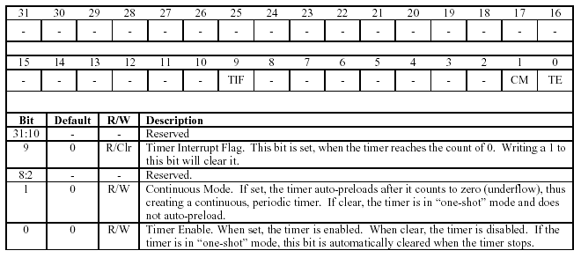

Timer Preload Register – Timer A: 0x21000304
Timer Preload Register – Timer B: 0x21000324

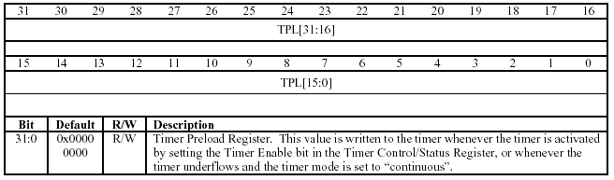

Timer Current Value Register – Timer A: 0x21000308
Timer Current Value Register – Timer B: 0x21000328

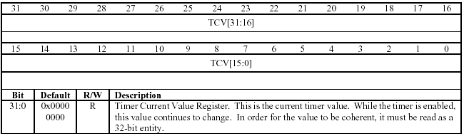

You can get the Timer to work in One-shot mode in the following way:
- Create a “start_timer” function which would be called once before you start and does the following:

void start_timer() {
//Stop the timer by loading the “status-control register” with TMR_STOP.
timer_struct->stat_cntrl = TMR_STOP;

//Set preload to highest value possible to get longest possible time.
timer_struct->preload = MAX_PRELOAD;

//Clear any possible underflow interrupts and enable timer A in one-shot mode.
timer_struct->stat_cntrl = TMR_INTR_CLEAR | TMR_ENABLE;
}

- Create a function “double dtime(void )” which returns the number of seconds since start_timer() was called. The easiest way to use this is to call start_timer() during initialization, then call dtime() at the start of the benchmark to record the start time. At the end of the benchmark, call dtime() to record the end time. Then subtract end time from start time to get the duration time. dtime() would not use interrupts, so it can only time up to 128 secs. You will need to figure out how to time a duration greater than that. Please refer to the header file “brh.h” for the various structure definitions.

double dtime(void) {
volatile unsigned int counts;

counts = MAX_PRELOAD – timer_struct->value;

//Check for underflow and report error if true
if (timer_struct->stat_cntrl & TMR_INT){
printf("\nERROR: Timer Underflowed!!\n");
}

//return number of seconds (counts times the timer rate of 30ns)
}

Serial Port

Two asynchronous serial ports are provided on the X-Board. A dual UART (TI 16C752) containing two duplicate 16C550 devices is connected to the peripheral bus. In addition to data lines TX and RX, handshake lines CTS and RTS are provided. Two standard 9-pin ‘D’ female connectors are provided for cable attachment and are pinned-out matching the standard PC serial port (i.e. connection to a PC should be made via a “straight through” cable). The PORT serial keypad has been modified to work on the X-Board and will not work on connecting to the COM port of your usual computer. (This was essential because the keypad has no power source of its own and needs to get power from the serial port on the X-Board. Unlike a normal computer, the serial port on the X-Board is a 9-pin female and the only way it can supply power to the keypad is via the RTS pin.)

You will need to write a pseudo-serial driver for the Serial Port -2 (Please note that the Serial Port -1 is reserved for use by the Angel debug monitor) The APIs necessary for you to implement this driver are provided as part of a library “serial_lib.a”. You will need to get this driver working for the keypad and the terminal display demos.

SERIAL API | API Function | Comments
void init_serial() | Initializes the serial device library. | Must be called before you do anything with the serial port-2.
void printChar(char ch) | Used to write out characters to the UART. | Used to print characters on the terminal display.
int getKeyPressed(void) | Used to capture input via the PORT serial keypad. | Detects numeric input on the keypad. (The ‘FN’ key returns 100 when pressed and can be used for exit operations).
void end_serial() | Performs exit operations on the serial port-2 | Must be called to end the serial port-2 operations.

Important Note: The serial port-2 has a small bug. Except for the first key press of any run, each key press returns two values – one: the value of the last key pressed and second: the value of the current key pressed. You will need to make sure your pseudo-driver gets around this bug (otherwise your Whack-A-Mole game would not work correctly)

Appendix II: APIs for Flash Programming - 1
About the flash library
The X-Board contains a large area of flash memory (4 MB). This space is used to store many programs and associated data in a block structure. The flash library divides the large flash memory structure into discrete blocks. An image can contain any number of blocks, but it must conform to the flash library definition. Figure 7-1 shows the standard flash library image storage layout.
Figure 7-1 Flash library image storage layout
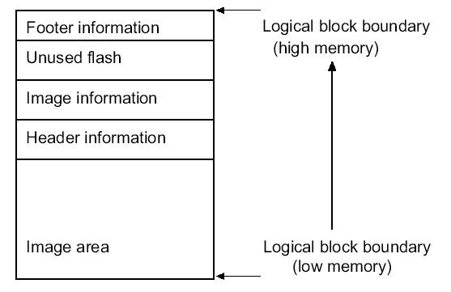
The following list describes the areas contained in Figure 7-1:

Image area
All of the code and read-only data segments of the image.

Header information
Any file header information from the downloaded file is placed after the image. (Not all images have header information.)

Image information
Added by the flash library code for image identification and code operations.

Unused flash
The footer must be at the end of the block of flash memory. The memory between the end of the image information and the footer is unused. If there is no room in the block containing the image for the footer, the
footer will be placed at the end of the next block.

Footer information
A five-word information block containing:
• the address of the information block for this image
• the base address of the data (the start might be at the beginning of a previous block rather than at the start of this block)
• a unique 32-bit value to aid in fast searching
• the image type (that is, a block, an image, a SIB(System Information Block), or data)
• a checksum for the footer information (over the first four words only).

Accessing flash
Primary routines are supplied as part of the Flash Libraries “flash_lib.a” and “ActivateFlash.a” that allow access to on-board flash and allow an application to:
• check that there is actually flash at a given location
• set a part of the flash as active
• read a word

Flash library functions
This section documents the functions in the flash library. All the type definitions are contained in “flash_lib.h”.

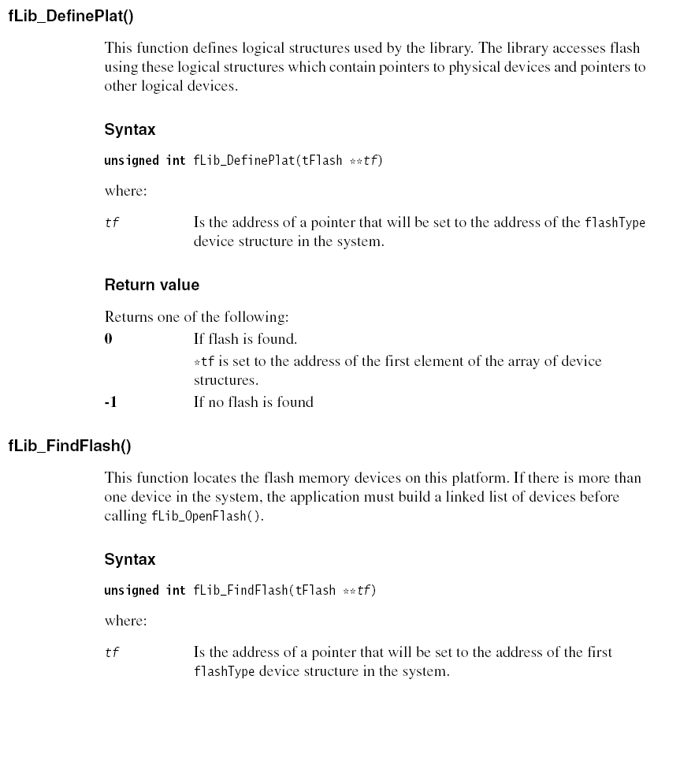
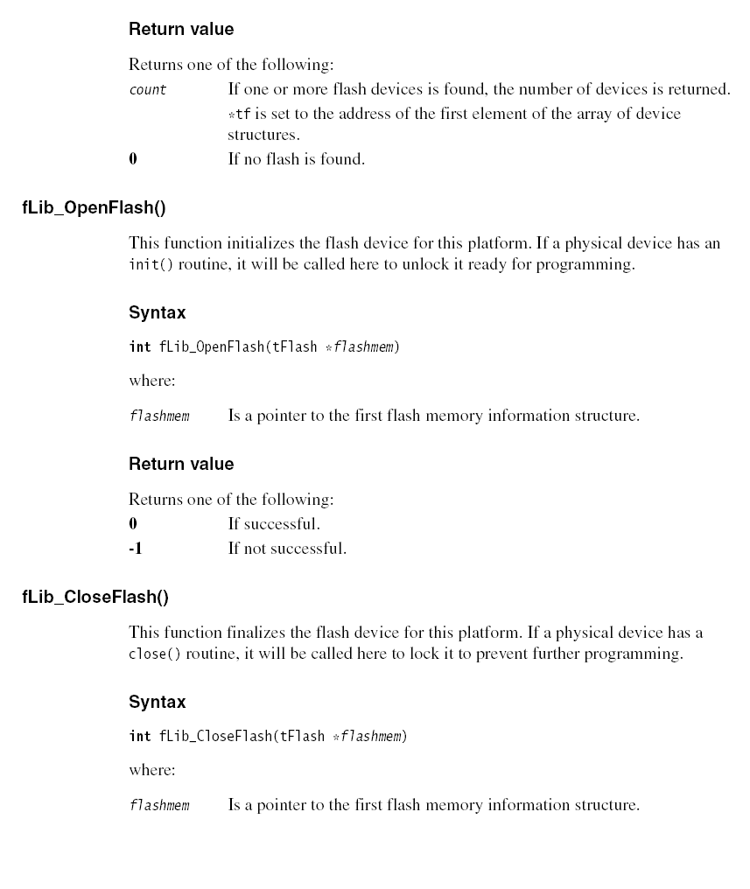

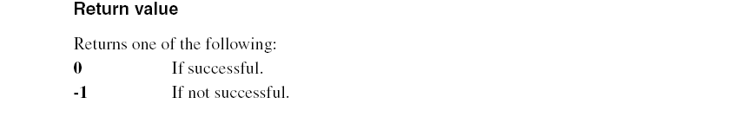

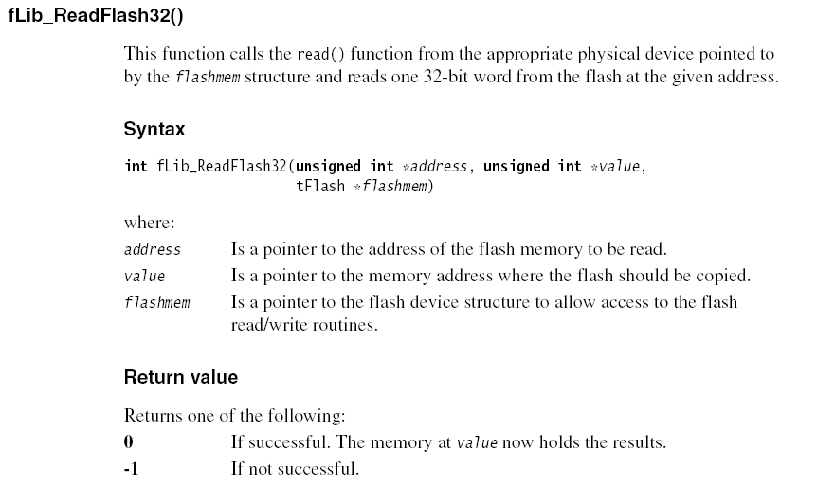

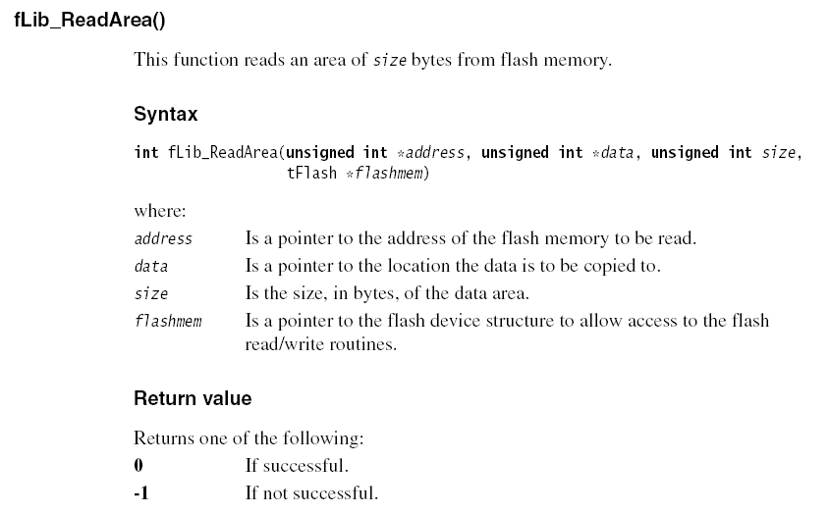

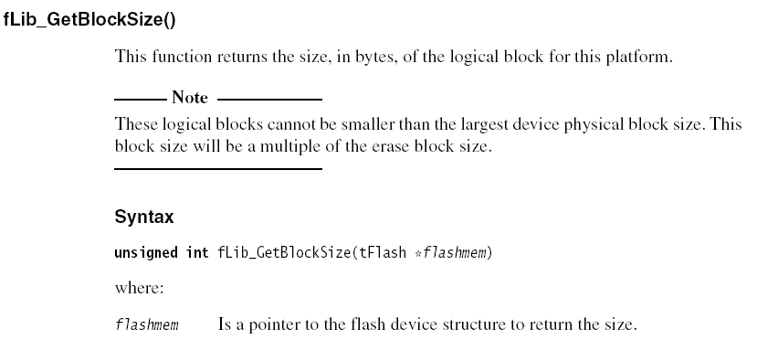
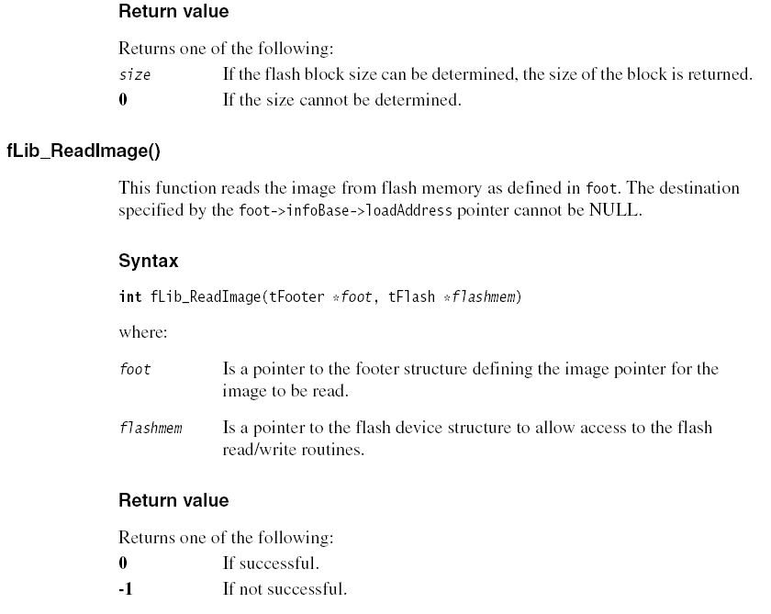

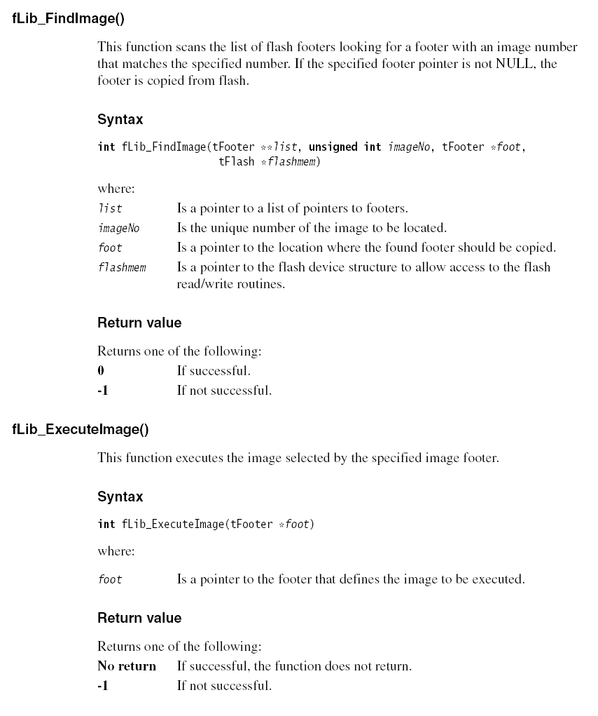

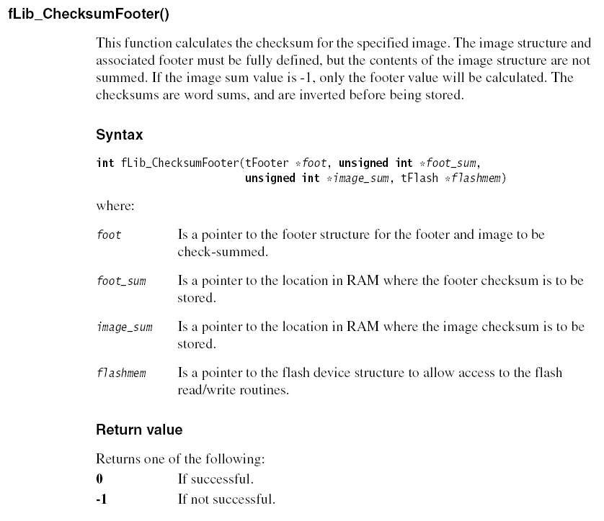

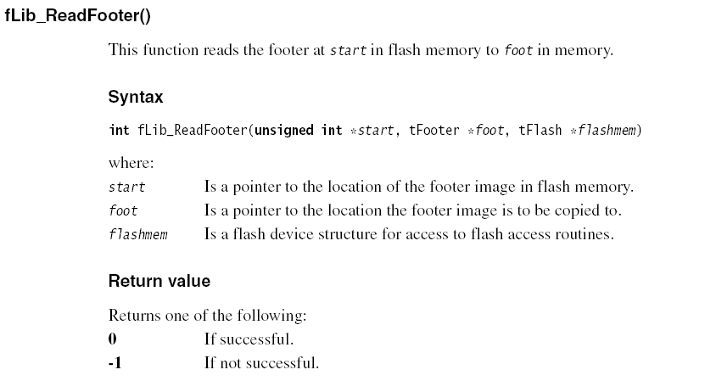
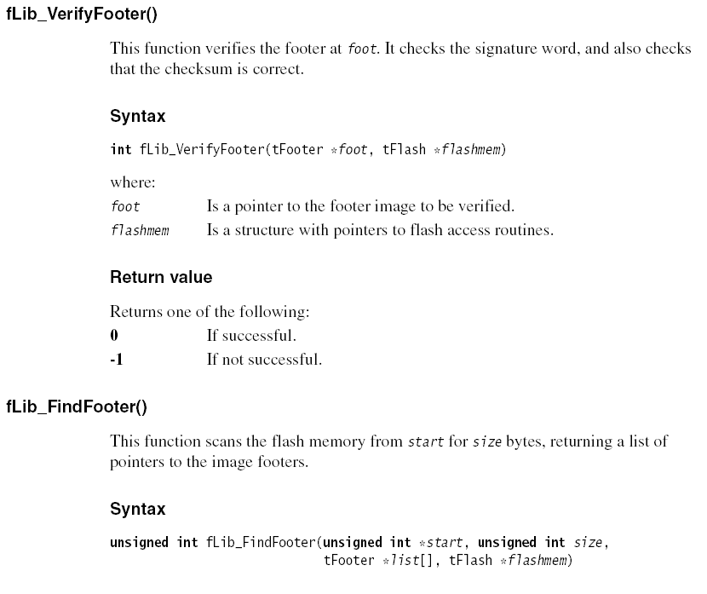

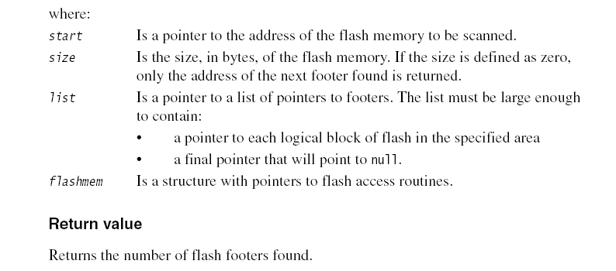

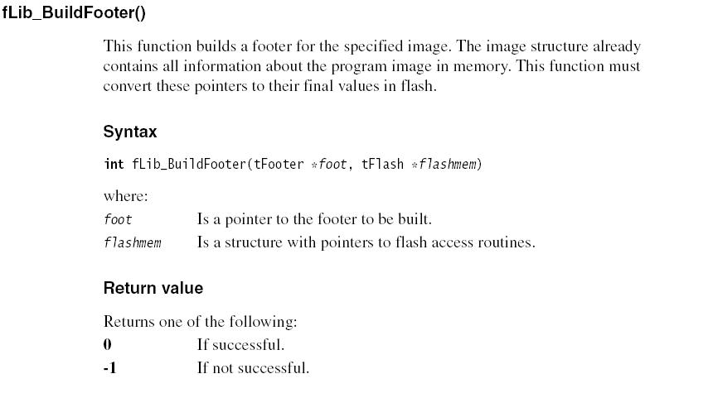

Additionally, the 2nd Flash library “ActivateFlash.a” contains the following API

void set_active_device(tFlash * initial_dev, unsigned32 num)

where:
initial_dev Is the flash device to be marked as “Active”
num Is the number of flash devices detected in the system.

IMPORTANT: This API is to be used to set the APPlication part of the Flash Memory as the default device. Under no circumstances should you set the BOOT portion of the Flash Memory as the default flash device as this may cause serious damage to the X-Board.

Appendix III: APIs for Flash Programming - 2
File processing functions (also part of “flash_lib.a”)

This section documents the set of file processing function calls. All definitions are contained in “flash_lib.h”.

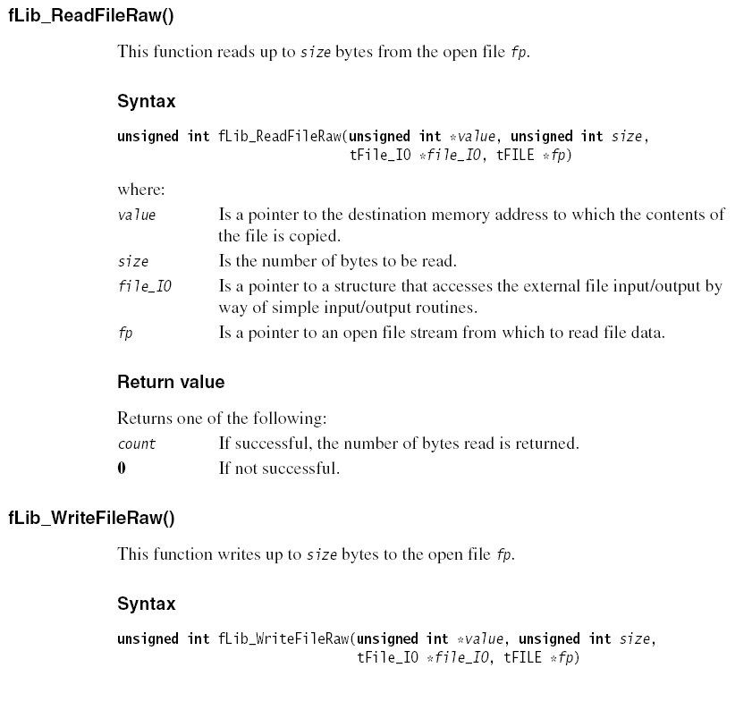

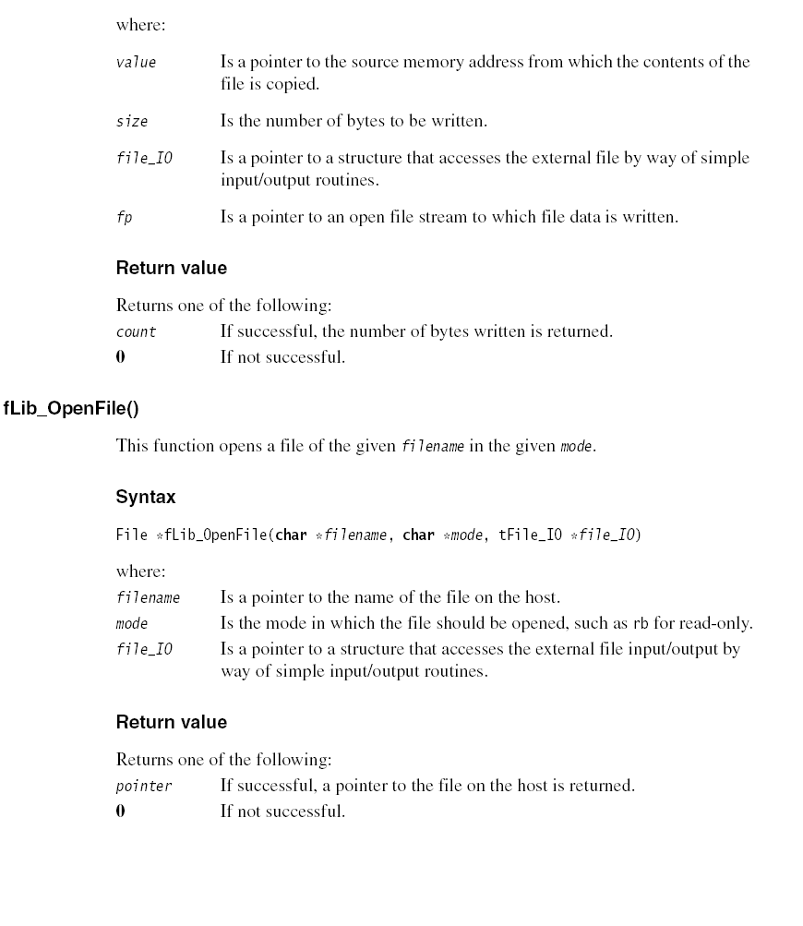

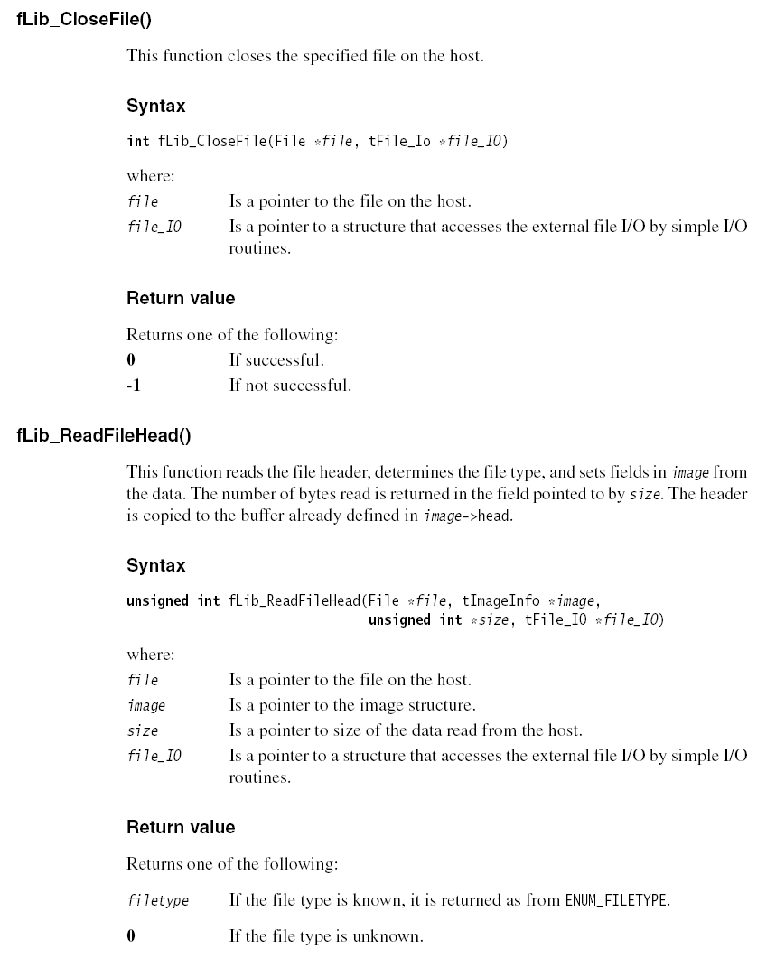

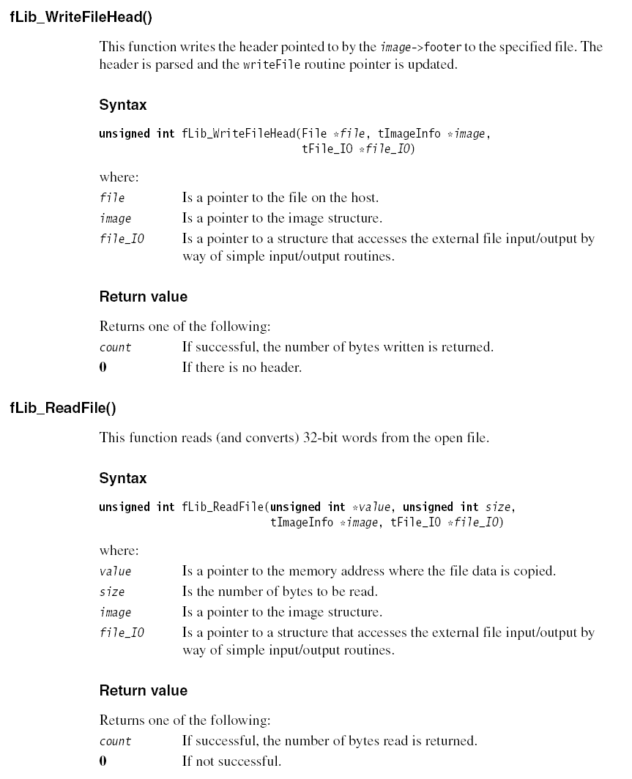

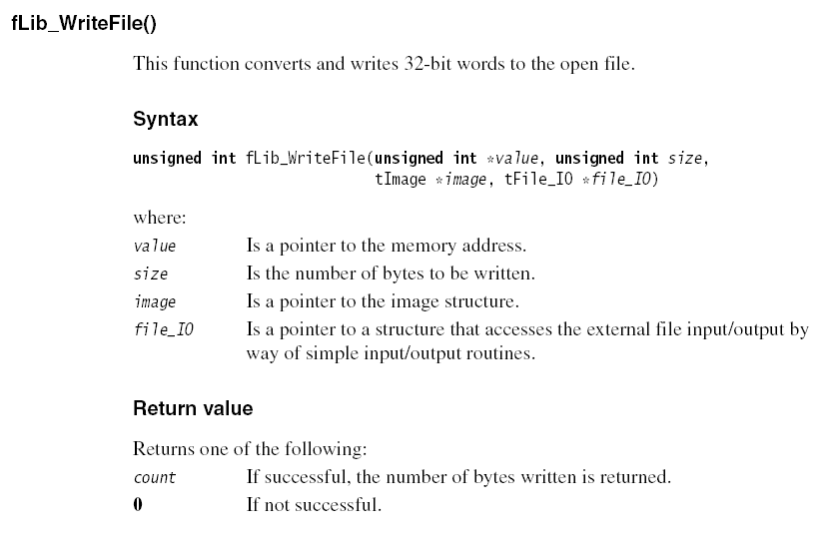

Appendix IV: Using the Flash Libraries
Here are a few tips which can help you get started with using the Flash Libraries

Starting up and finding the flash

When your Flash Utility starts on the X-Board, the application must:
1. Define and locate the flash.
2. Verify that it is supported.
3. Set the non-BOOT portion (i.e. the APPLICATION) of the flash as “active”.
4. Scan for any images that have already been programmed.

Fig 9-1 shows the functions that perform these operations.

Figure 9-1
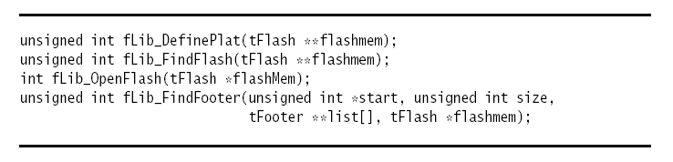
Please Remember: Before you go about making a footer list for the flash devices (by using the fLib_FindFooter(…)), make sure you have set the non-BOOT part (i.e. the APPLICATION part) of the Flash Memory as the active device using the following API:

void set_active_device(tFlash * initial_dev, unsigned32 num)

Reading an image from flash and writing it to a file on the host

Figure 9-2 shows the functions that perform these operations.

Figure 9-2
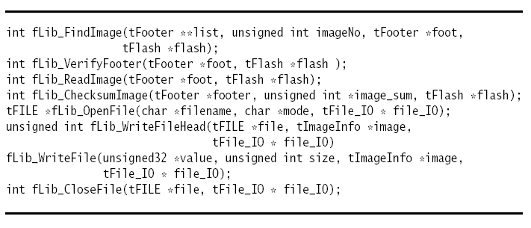

Appendix V: flashType structure

The flash library uses a logical representation of the flash space. This involves one or more logical devices. XScale uses two types:

Boot Flash
This is an area that contains applications that the user would not normally wish to overwrite, such as the boot- monitor, Angel debug client, or system self-tests.

Application Flash
This area is where the user keeps applications and data. (You will be playing around with this part of the flash.)

Table 7.2 Logical Structure Routines
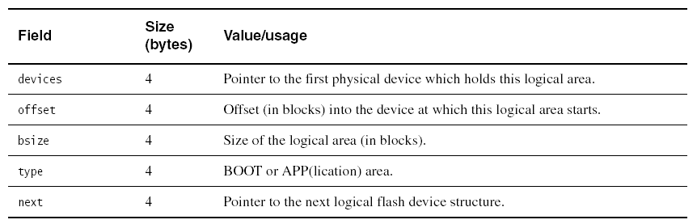

The library defines a C structure, shown in Figure 7-3, for the logical flash definition so that all offsets from the first word are abstracted.
Figure 7-3 flashType structure
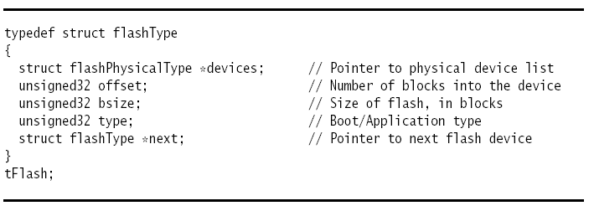

Appendix VI: FooterType structure

The footer structure is a five-word device that contains a pointer to a more detailed structure that, if required, defines the image. Table 7-4 shows the format for the footer. The image base address is the start of the first block containing data for this image. If the image is less than one logical block in length, this pointer will be set to the start of the current block.

Table 7-4 Footer Format
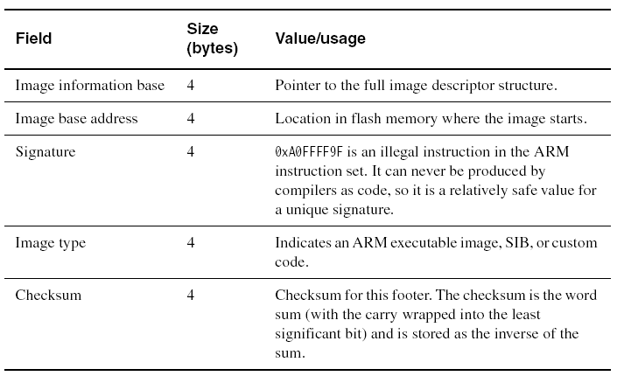
The library defines a C structure for the footer so that all offsets from the first word are abstracted. Figure 7-5 shows this structure.
Figure 7-5 FooterType Structure
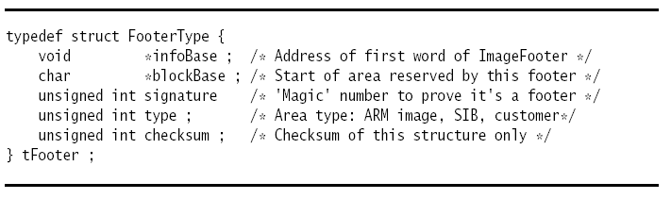

Appendix VII: ImageInfo structure

This structure replicates much of the information contained in the header of file formats such as Executable and Linkable Format (ELF) in a form that is accessible to the file-independent routines. The image data structure contains information about any file header stored in the image space to allow reconstruction of the file, if required. The image information block is situated immediately after the full image, and any header information is stripped from the input file and stored with the image. The checksum is calculated from the full image, any header information, and the image information block. Figure 7-6 shows the ImageInfoType structure.

Figure 7-6 ImageInfoType Structure

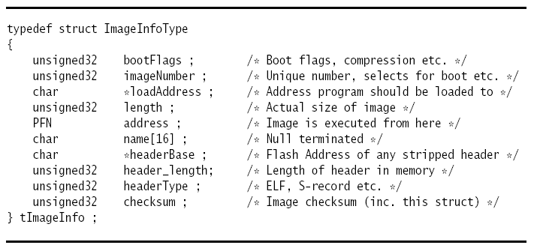

18-349 Project 2 Grading Sheet

Name
Date
Part 1 (18) | Keypad Demo | /6
Part 1 (18) | Terminal-Display Demo | /4
Part 1 (18) | Timer Demo | /6
Part 1 (18) | Seven Segment Demo | /2
Part 2 (37) | Detecting Flash Devices / Printing flash information | /4
Part 2 (37) | Non-boot Flash activation | /4
Part 2 (37) | Flash Footer List generation | /4
Part 2 (37) | Mini-Shell / Command-Parser | /25
Part 3 (40) | Setup | /5
Part 3 (40) | Select Game Level | /5
Part 3 (40) | Game Play | /20
Part 3 (40) | Display Score | /5
Part 3 (40) | Game Exit | /5
Coding Style (5) |  | /5
Total |  | /100
Comments

