Lecture 3

Semiconductor physics

We’ll have about a two-week crash course in this – just enough to learn some terminology.

1. Basic semiconductor properties

A. Electrical conductivity (or resistivity) – intermediate between a metal and insulator.

See Handout 2: conductivity scale

Most of the variation comes from changes in the number of charge carriers (electrons and “holes,” which we’ll learn about later).

Introduction of specially-chosen impurities into a semiconductor can change this carrier concentration enormously.

See Handout 2: relation between resistivity and impurity conc.

B. Crystallinity – semiconductors with the best electrical properties are perfectly crystalline. This does not mean regular shiny faces!

Crystal def: a practically infinite repetition in space of identical structural units. Crystal is described by two components:

• Lattice: a mathematical abstraction. It is a set of points (not
atoms or molecules) described by:

r’ = r + ua + vb + wc u, v, w = integers
a, b, c = translat’n vectors

Structure look identical from every point on lattice.
• Basis: an atom or group of atoms (1000s or more, as in proteins) associated with each lattice point

Thus,
lattice + basis = crystal structure

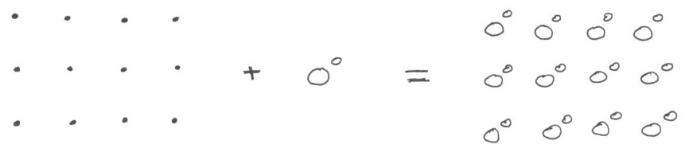

Holes in the structure or atoms out of their place are defects (e.g., vacancy, interstitial, substitutional) that usually degrade electrical properties.

2. Electronic structure

The crystallinity of semiconductors determines the energy levels that are available in the solid to be filled, and how they are spaced.

Let’s see how this works by imagining the solid as a huge molecule with about 10²² atoms making analogies, first with atoms and then with small molecules.

* Atoms: have 4 principal quantum numbers

• Principal quantum number n
• Angular momentum “ “ l
• Magnetic ” “ m
• Spin “ “ s
The Pauli Exclusion Principle determines how the energy levels are filled. No two e⁻ can have the exact same set of quantum numbers

We fill orbitals in the order 1s², 2s², 2p⁶, 3s², 3p⁶, 3d¹⁰, etc.

* Molecules: atomic orbitals combine to give molecular orbitals, some extending over entire molecule:

Show Handout 1: picture of CO MO’s
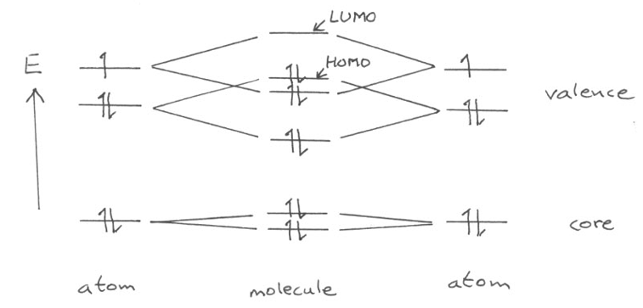
Each MO can be assigned its own unique set of quantum numbers, filled again according to the Pauli Exclusion principal.

Since the number of orbitals and e– is small, they are widely spaced and we can examine each orbital individually.

Spacing is usually of order 1 eV (23 kcal/mol), while room temperature corresponds to a thermal energy kT of only 1/40 eV. Thus, there is very little promotion of e⁻ between levels.

* Solids: atomic orbitals: atomic orbitals from 10²² atoms now combine to give huge orbitals that extend over entire solid!
Metal:
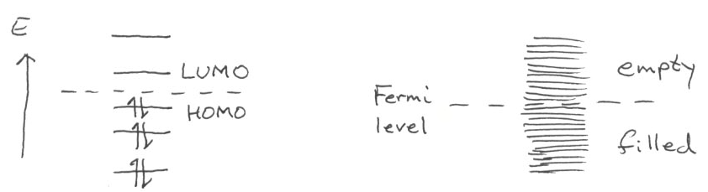
small molecule metal

At 0°K, all the lowest levels are filled. At room temp, a small molecule has occupation statistics that look almost like 0°K. Energy level spacing is of mostly order 10⁻²³ eV, which is tiny compared with kT. even at 1°K, since kT for 1°K ∼ 10⁻⁴ eV >> 10⁻²³ eV.

So there is a lot of promotion to higher levels, and we need to be concerned with occupation statistics of these levels:

Fermi-Dirac statistics: give probability that a state will be occupied.

f(E) = [ exp((E – μ)/kT) + 1 ] ^{–1} μ ≡ chemical potential

≡ E where f(E) = 1/2

Show Handout 1: f(E) as a function of T

Definition: Fermi energy E_{F} = energy of the topmost filled state at 0°K

= μ at 0°K

corresponds to HOMO in small molecule

A source of confusion: “Fermi level” is only defined at 0°K, but is often used interchangably with “chemical potential” even at higher T. This is not precise usage, but is usually pretty accurate, since μ starts to change a lot only at very high (> 1000K) temperatures.

• Metal: All levels near Fermi level are closely spaced. Since the “molecular orbitals” in metals extend over the entire solid, a partly filled orbital allows e– to go anywhere → good electrical conduction.

• Semiconductors: There are certain forbidden regions of energies: vestiges of large spacing in smaller molecules… called the bandgap.

Semiconductor:
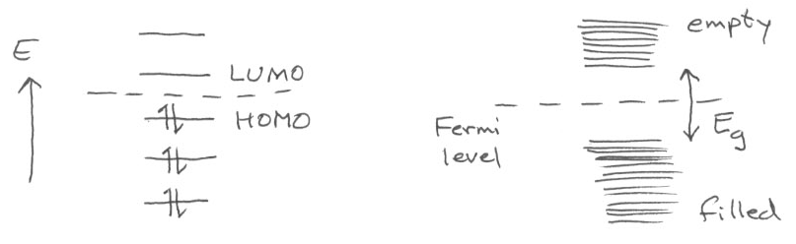
small molecule semiconductor

Bandgap energy E_{g} is a material property. Show Handout 1: bandgap energies

At 0°K, E_{F} for a pure semiconductor lies in the middle of the bandgap. Valence band is completely full (bonding orbitals) and valence band is completely empty (antibonding orbitals).

At T > 0°K, there is some promotion of e–, but since E_{g} is so large, the number of electrons in the conduction band remains very small. Since conductivity ∝ carrier conc., the conductivity is modest and T-dependent.

Lecture End ––––

