Lecture 4

Hand out HOMEWORK 1: (If HW is due on Tuesdays)

Quantitative description of semiconductor conductivity

We want to understand why the conductivity σ (or resistivity ρ) of a semiconductor varies strongly with T and impurity concentration.

Basic equation for current density j (A/cm²):

j = q N v q = electron charge (1.6×10^{–19} C)

N = number of charges / volume

v = velocity (cm/s)

N and v are the things that matter most

1. N: In a semiconductor there are two “kinds” of charge carriers

• e– in the conduction band, density n (cm^{–3}). Most of these sit at the bottom of the conduction band at energy E_{C}.

We can estimate their concentration from an approximation to the Fermi distribution. We saw that

f(E) = [ exp((E – μ)/kT) + 1 ] ^{–1}

Here, we let E = E_{C} and (according to conventional notation) μ = E_{F}. Since E_{C} – E_{F} ∼ 0.5 eV in Si >> kT ∼ 0.025 eV at 300K, we have

exp((E – μ)/kT) >> 1
so that
f(E_{C}) ≈ exp(–(E_{C} – E_{F})/kT)
Thus, n ∝ exp(–(E_{C} – E_{F})/kT)

(A true equality requires the “density of states.”)

• “holes” in the valence band, density p (cm^{–3})

Holes are empty states in the valence band whose motion represents the collective motion of all the remaining e– in the valence band. These collective motions act like a single positive charge.

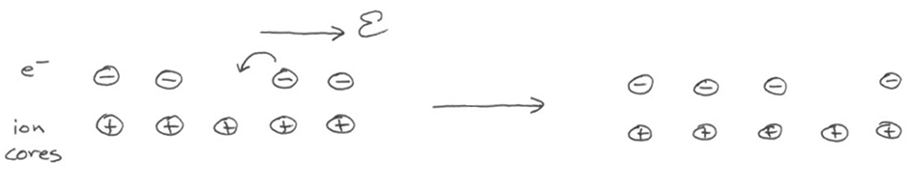
A crude (and inaccurate) model:

An argument similar to that for e– shows that

p ∝ exp(–(E_{F} – E_{V})/kT)

where E_{V} = the top of the valence band.

A. Intrinsic semiconductors

In an intrinsic semiconductor with no added impurity, every e⁻ promotion leaves behind one hole, so

n_{i} = p_{i}

Thus we see that N = n_{i} + p_{i} = 2n_{i} varies exponentially with T.

B. Doped semiconductors

We can artificially vary the number of e– or holes by adding impurities that are rich or deficient in valence e–.

Example: a. In Si, add a Group V element (P, As, Sb) that has 5
valence e– but only needs to form 4 bonds. The extra e–
stays very loosely bonded to the impurity with a bond
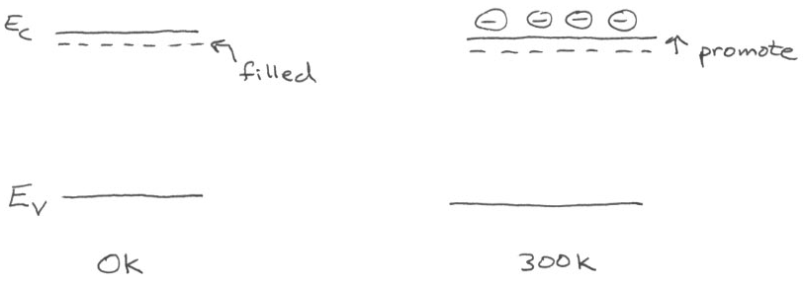
strength of only 0.04 – 0.05 eV.

At 300K, most of these e⁻ are “donated” into the
conduction band. Let the donor conc. be N_{D}. Then

E_{F} – E_{F,i} = kT ln (N_{D} / n_{i}) (E_{F} moves up)

b. Add a Group III element (B, Ga, In) that has 3 valence
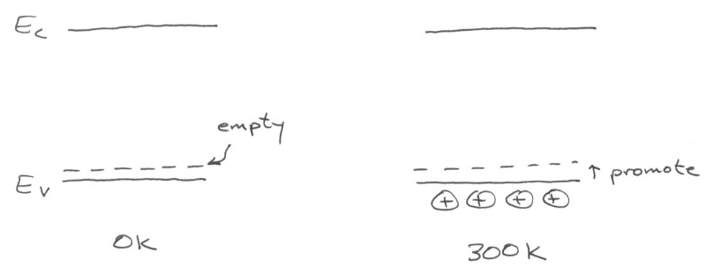
e⁻ but wants to form 4 bonds. An acceptor level forms in
the bandgap 0.04 – 0.05 eV above the valence band.

At 300K, these levels easily accept e⁻ out of the valence
band, leaving holes. Let the acceptor conc. be N_{A}. Then

E_{F,i} – E_{F} = kT ln (N_{A} / n_{i}) (E_{F} moves down)

In both examples, we use ppb quantities so the overall
band structure of the solid doesn’t change.

It turns out that there is a “Law of Mass Action” governing n and p.
We can see this from our expressions for n and p in intrinsic material:

np ∝ exp(–(E_{C} – E_{F})/kT) exp(–(E_{F} – E_{V})/kT)

= exp(–(E_{C} – E_{V})/kT) = exp(–E_{g}/kT) Since E_{C} – E_{V} = E_{g}

More quantitatively,

np = N_{C}N_{V}(–E_{g}/kT) where N_{C} = 2.80×10¹⁹ cm⁻³ is the effective
density of states in the conduction band

N_{V} = 1.04×10¹⁹ cm⁻³ is the effective
density of states in the valence band

(Both for Si at 300K)

With E_{g} = 1.11 eV, we get n_{i} = p_{i} = 8.15×10⁹ cm⁻³ at 300K

But the Law of Mass Action holds even when there is doping. Typical levels are 10¹⁴ cm⁻³ or more, so N_{D} (or N_{A}) >> n_{i} (or p_{i}). Then

• n-doping: n = N_{D} = N_{C}exp(–(E_{C} – E_{F})/kT) and p = n_{i}² / N_{D}

• p-doping: p = N_{A} = N_{V}exp(–(E_{F} – E_{V})/kT) and n = n_{i}² / N_{A}

(These equations help calculate the Fermi Level too.)

A curious phenomenon: n + p varies like a “V” with n
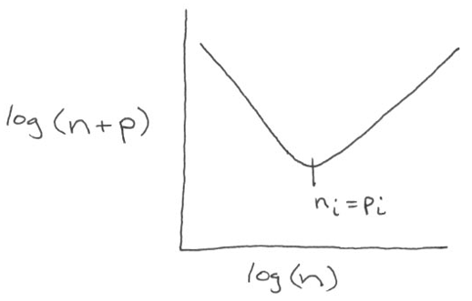
2. v (carrier velocity, cm/s):

In semiconductors, charge carriers move ballistically in well-defined wavefunctions about 0.1 μm before scattering off a lattice defect or vibration. Over larger distances, carriers move like gases.

• No electric field → motion like simple gas diffusion
• Electric field → viscous flow like in a pressure gradient

With a field, we find phenomenologically that:

v = μ E E = electric field (V/cm)

μ = mobility (cm²/V•s)

In general μ_{n} ≠ μ_{p} so that electron and hole velocities differ.

For a small field of 1 V/cm (like a battery), in Si μ_{n} = 1300

μ_{p} = 500
So v_{n} = 1300 cm/s

v_{p} = 500 cm/s These are small numbers compared with
the wavefunctions, which move at ∼ 1%
the speed of light, or 10⁸ cm/s.

3. Putting it all together,

j = q N v

= q n μ_{n} E + q p μ_{p} E = E / ρ

So ρ = 1 / q (n μ_{n} + p μ_{p}) This is Ohm’s Law.
ρ in Ω-cm

Now, μ decreases slowly as T rises (increased scattering)

A. Intrinsic semiconductors

But n and p increase exponentially and more than compensate the decrease in μ.

Thus, ρ decreases with T while σ = 1/ρ increases.

B. Doped semiconductors

Now n and p remain constant at N_{D} and N_{A} respectively (until n_{i} increases above the larger of N_{D} or N_{A}). Thus, ρ and σ are about constant.

Lecture End ––––

