Lecture 5

Semiconductor Devices: pn junctions

These junctions form the basis of many devices.

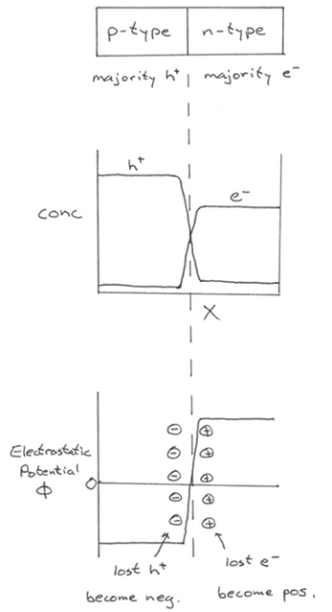
Simplest is a diode (rectifier): passes current in one direction, but not the other (an electrical “one-way valve”).
e– want to diffuse to p-side and holes to n-side.

But as they do, charge builds up to resist the diffusion.

Charge buildup continues until the electric field exactly balances the concentration gradient.

More rigorously, we know from thermodynamics that in equil, μ
must be consistent everywhere.

Now, μ has contributions from both concentration and electrostatic potential φ (for a positive test charge)

μ (referenced to E_{F}):

e– μ = kT ln(n/n_{i}) – eφ

holes: μ = kT ln(p/n_{i}) + eφ

Note:

p is high where φ is low (high potential repels + charges)
n is high where φ is high (high potential attracts e–).

Recall: $\underline{∇}φ=$ E E = electric field. Solve Poisson’s eq. ⇒ field is linearly with position in “depletion region.”

What is “depletion region”?

Recall: np = constant throughout sample.

Total carrier concentration N is n + p = n + C/n.
So N drops when n,p get closer to each other. Near interface, n drops below N_{D} and p drops below N_{A}

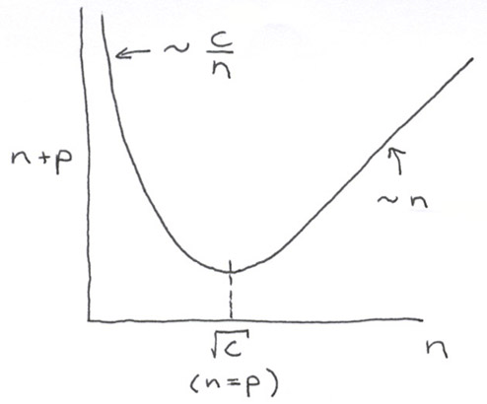

This zone is typically ~ 1 μm wide, but varies inversely (on each side) as N_{D}^{1/2} and N_{A}^{1/2}.

Electronic band behavior

We need to look at this to understand diode behavior.

It’s best to make diagrams in terms of potential energy E for e–, not electrostatic potential φ. Distinction is often not clarified in textbooks.

φ (for positive test charges): increases for applied positive voltages

E (for electrons): increases for applied negative voltages.

1. Equilibrium: no current flows
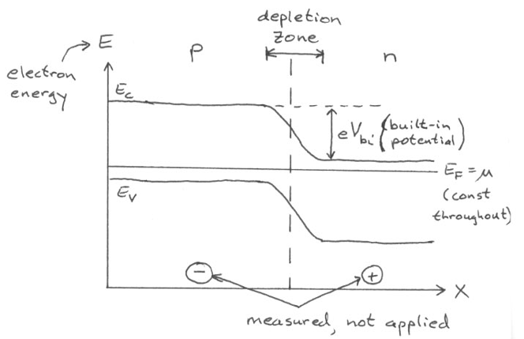

2. Reverse bias: no current flows
Note in drawing: depletion zone widens
make p side more negative
n-side more positive.
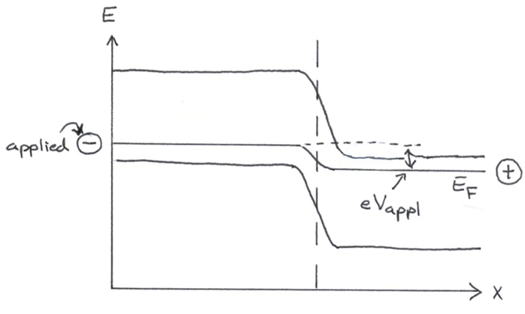
Hint: draw E_{F} first. Applying (–) voltage raises E_{F}.

Bulk Fermi level stays in same place relative to bands.

No current flows.

No current flows. Why? For significant current, we need to get more holes from n-side to p-side. Somehow we need to counteract the built-in potential that resists e– diffusion to p-side (and vice-versa for holes). But here we have increased the potential barrier for e– transfer!

3. Forward bias: current flows make: p side more positive
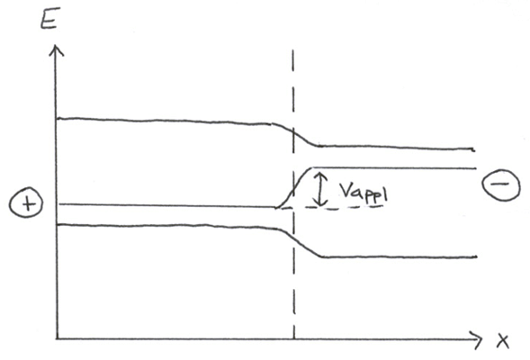
n side more negative
Current flows. Why? Now electrostatic potential barrier for e– motion to p-side is reduced, so majority carriers diffuse more freely.

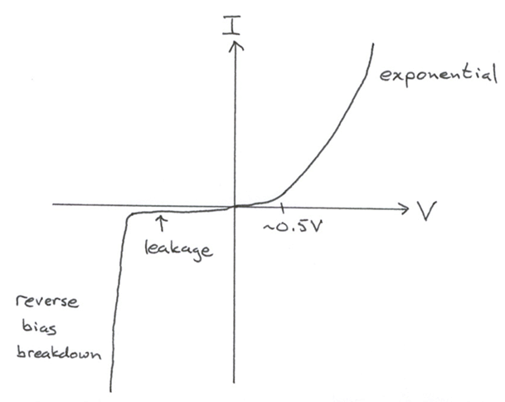
I-V Characteristics

Field effects on carrier density

Field effects govern behavior of CMOS transistors (in most IC’s)

Consider an n-type semiconductor.
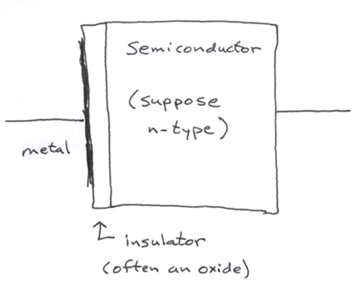
1. Accumulation condition

What happens when we put positive voltage on the metal electrode? No current can flow: insulator is present.

Charge is induced to reside at semiconductor-insulator interface in a narrow region. Charge is negative: e– are majority carrier: n + p increases.

2. Depletion condition

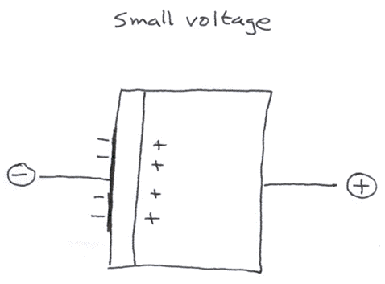
e– driven away from semiconductor-insulator interface, holes attracted. As long as e– remain majority carriers (n>p), n+p decreases and we have depletion of carriers near the interface.

3. Inversion condition
Same as depletion, but now so much induced change that p > n at semiconductor-insulator interface. Minority carriers in bulk are majority carriers at interface
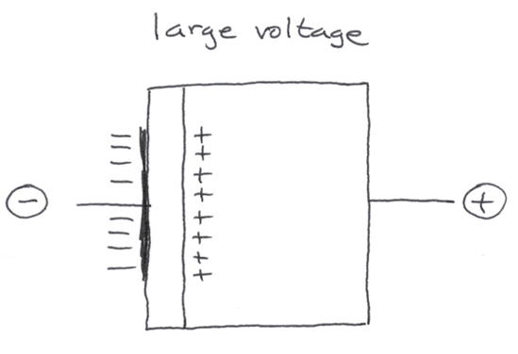
Lecture End ––––

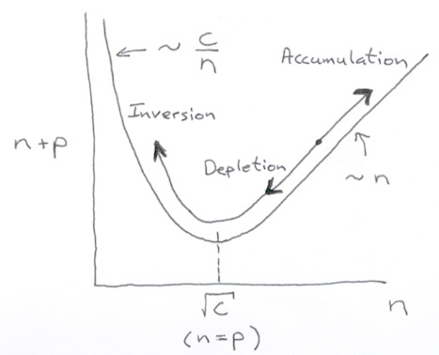
Accumulation, depletion and inversion can be understood with a diagram we’ve already seen:

If there’s time, describe how inversion

controls current in an FET channel.

