Lecture 7

Bring HeNe laser, handkercheif, penlight flashlight for demonstration.

Lithography (continued)

4. Resist contrast

Resists do not change their properties discontinuously; breakdown or crosslinking is a continuous, not discrete, process.

Contrast measures the sharpness of transition from nonexposure to exposure.

Let E_{i} = amount of energy needed to initiate transformation

E_{f} = amount of energy needed to finish
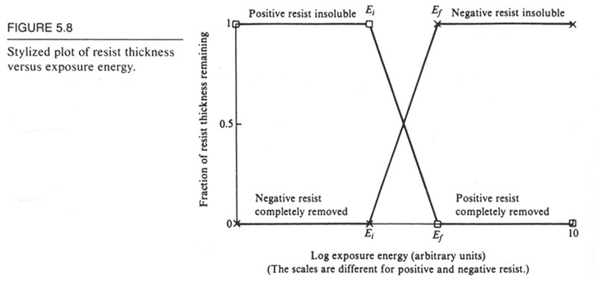

Then contrast γ ≡ 1/log(E_{f}/E_{i}) See Handout 4: Fig. 5.10 for
graph. For typical positive resist, γ ≈ 2-4

See Handout 4: Fig. 5.9 shows more typical response: E_{i} and E_{f} are not well-defined, but we can draw tangents to find them.

Higher contrast is better because it puts less burden on the optical system. Let’s see how.

See Handout 4: Fig. 5.11 shows ideal light pattern, and then minimum intensity swing needed for a resist with γ = 3. This is the swing our optical system has to provide.

(Note: intensity I is shown instead of energy E because I ∝ E for a given exposure time.)

A more detailed view of printing

Things we want to avoid

See Handout 4: Fig. 5.21 shows examples of unfaithful reproduction

Masking systems are subject to the following problems:

1. Feature overlay error (all masking systems)

System reproduces a faithful pattern, but in the wrong place or at the wrong angle

2. Distortion (projection, e⁻ systems)

System produces a distorted image. For optical lenses (or mirrors), we can get the following problems (and others):

• Spherical aberration: use of a spherical lens to approximate a perfect parabolic shape. Thus, focal length varies from center to edge of lens.

• Coma: image of a point source brought into a comet shape

• Astigmatism: Focal length of lens changes as one moves from x to y direction.

• Chromatic aberration: Focal length varies with wavelength

3. Magnification error (projection)

System produces right shape but wrong size.

Light sources

(Ask question: what is λ for visible light? Ans: 400 – 700 nm)

1. Arc lamps: put electrical discharge through a gas

• Hg: output down to 300 nm, major lines at 365, 405, 435 nm

• Xe: output down to 250 nm, major lines at 256, 280, 290 nm

• Deuterium: output down to 200 nm, but very low power

All these sources produce incoherent light: no relation between phases at different points in space and time.

2. Excimer lasers

Produce high-power, short wavelengths (but pulsed, not continuous). Most advanced applications use these.

“Excimer” = “Excited dimer”: a noble gas and a halogen form a well-defined molecule in the excited state that lives briefly before it decays into the largely repulsive ground state.

Electronic diagram:

Examples:

XeF: 351 nm

XeCl: 308 Many commercial systems currently use this.

KrF: 248 Now used for the most advanced circuits

ArF: 193

F₂ 157 For 0.1 μm or less. High-power lasers just
recently developed. Need CaF₂ optics of high
quality, now just developed.

As we saw before, lasers produce coherent light: phase is correlated for different points in space and time. This has big consequences for imaging.

Do projection experiment with HeNe laser and handkercheif, then with penlight flashlight, to demonstrate diffraction pattern with coherent light and lack thereof with incoherent.

Modulation transfer functions

We saw in our description of resists that for a given resist contrast γ, the optical system must deliver a sufficient modulation between the minimum light intensity I_{i} and maximum I_{f}.

See Handout 4: Fig. 5.11 for definitions of I_{i} and I_{f}

Definition: image modulation M = (half of intensity swing)/(avg intensity)

= I_{m}/I_{o} See Handout 4 Fig. 5.11 for
definitions

Note: M = 1 corresponds to ideal black/white contrast

Image just starts to transfer when M = 2I_{m}/2I_{o} = (I_{f} – I_{i})/(I_{f} + I_{i})

See Handout 4: Fig. 5.12 shows how the required value of M depends upon γ of the resist.

When the optical system’s modulation transfer function (MTF) equals M, we can get proper exposure.

MTF depends on spatial frequency of the object (i.e., how many lines/mm), photon wavelength, numerical aperture (or f-number) of lens, and the light’s coherence.

Coherent and incoherent light give very different MTFs

See Handout 4: Fig. 5.18 (assumes a sinusoidal object, but the square-wave we use in lithography is about the same)

Here the “cutoff frequency” is defined as λ/f-number

where f-number = focal length/diameter of lens

Note that coherent light gives good contrast until the frequency reaches 0.5 (normalized units), then drops to 0. Incoherent light has a slowly decreasing MTF.

Actual picture of I:

Lecture End ––––

