Lecture 8

Wet Etching

Current uses: • remove damage from whole wafer slices

• delineate crystal defects

• planarization by chemical mechanical polishing

• not for fine features

Advantages: • little substrate damage

• often highly selective

Disadvantages: • Isotropic (usually) → undercutting

• Difficult to control

• Particle contamination (sometimes)

• Susceptibility to scum poisoning

Isotropic etch Anisotropic etch (plasma)
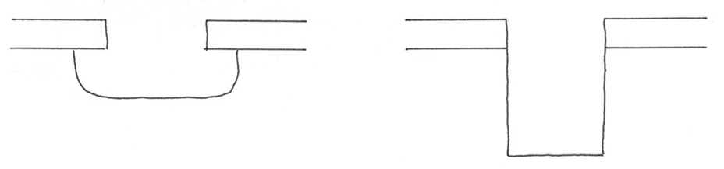

See Handout 5 (Fig. 6.3) for general setup

General chemical features
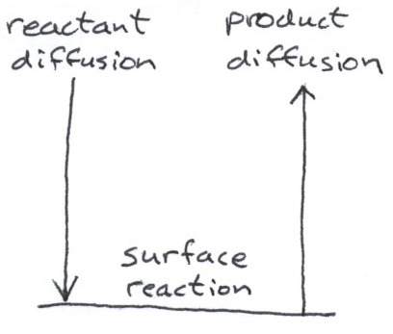
Any step can be rate limiting. Stirring/agitation can reduce (but not remove diffusion limitation.

Tests for diffusion limitation: • weak T dependence of rate
• more agitation increases rate

See Handout 5 (Fig. 6.5) for example of rxn/diffusion regimes

Mechanisms: General Features

- Often incompletely understood

- May involve intermediates not given in overall stoichiometry

- Reported etch rates for a system may differ substantially (factors of >2) because of

- difficulty of measuring surface T for fast exothermic rxn
- bubbling
- sensitivity to contaminants/minor products
- sensitivity to surface defects

Examples:

1. Si
or CH₃COOH, reduces surface tension → better wetting, smoother surface
Most based on HF – HNO₃ – H₂O

2 steps: • Si oxidized to SiO₂ (natively or by HNO₃)

• SiO₂ removed by HF

Overall rxn:

18HF + 4HNO₃ + 3Si → 3H₂SiF₆ + 4NO_{(g)} + 8H₂O
$↑$
soluble

Notes: • intermediate SiO₂ not listed!

• like all etching, this is a redox rxn

$\text{Si}$ is oxidized to SiF₆⁻² (0 to +4)

NO₃– is reduced to NO (+5 to +2)

formal oxidation state

Rates often shown on a ternary diagram: See Handout 5 (Fig. 6.4)

Too little HNO₃ → Si not oxidized to SiO₂

Too little HF → SiO₂ not dissolved

Can be either rxn or diffusion limited → See Handout 5 (Fig. 6.5)

Anisotropic etches

• Used for Si micromachines (MEMS)

• Large, electrically isolated devices for high-voltage or radiation-hard applications

Example: Si + 2KOH + H₂O → K₂SiO₃ + 2H₂

Etches [111] directions slower than others because of double
layer: See Handout 5 (Fig. 6.6).

On Si(100) wafers, get instead of
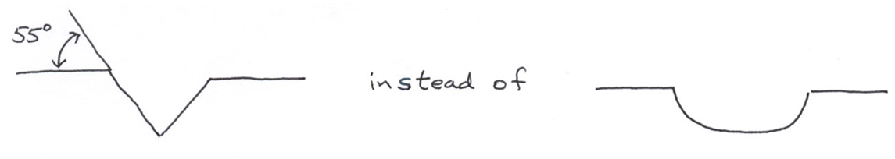

Resistivity effects

Heavy n or p doping increases rate for conventional
HF – HNO₃ – CH₃COOH solution by factor of ~15.

• Needed for accurate rate predictions

• Can help delineate heavily doped regions for characterization

• Can help make very thin films by etching underlying substrate

2. SiO₂

Most based on HF–H₂O

Overall rxn: SiO₂ + 6HF → H₂SiF₆ + 2H₂O No change
in formal
oxid. state.
Mechanism : very complex

Dilute soln : 3HF → F– + HF₂– + 2H⁺
active

not active

Concentrated soln : also get H₃F₄– or H₄F₅– complexes

Solutions often buffered with NH₄F.

Lecture End ––––

