Lecture 9

Review of buffers: Intended mainly to keep pH constant in response to adding acids or bases

Employ weak acids & conjugate bases

HA  H⁺ + A–
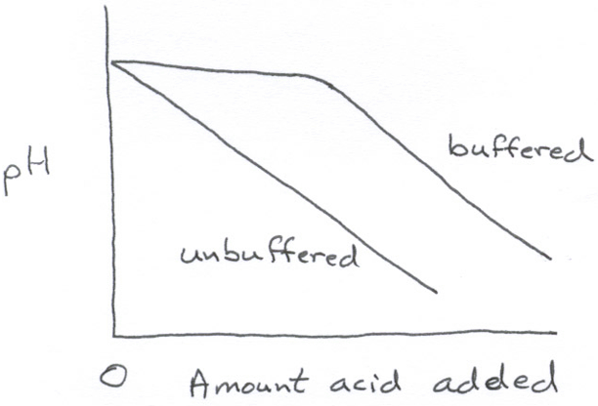

H₃O⁺

K_{a} = $\frac{\left[H^{+}\right] \left[A^{−}\right]}{\left[\text{HA}\right]}$

dissociation constant

K_{a} is small for a weak acid

Note: $\text{pH}=−{\text{log}}_{\text{10}}\left[H^{+}\right]$
e.g., HF, 25°C $K_{a}=7\text{.}2x{\text{10}}^{−4}M=$ $\frac{\left[H^{+}\right] \left[F^{−}\right] }{\left[\text{HF}\right]}$

K_{a} is large for a strong acid

e.g. HCl: K_{a} >> 1

Quantitative analysis

1. What is H⁺ in a weak acid solution of formal concentration C_{A}?

$\text{HA}$ $H^{+}+A^{−}$ → $\left[H^{+}\right] ≈ \left[A^{−}\right]$

not = because of H₂O dissociation

Also, $C_{A}=$ $\left[\text{HA}\right] + \left[H^{+}\right]$
$$⇒K_{a}=\frac{\left[H^{+}\right] \left[A^{−}\right]}{\left[\text{HA}\right]}=\frac{{\left[H^{+}\right]}^{2}}{C_{A}−\left[H^{+}\right]}⇒{\left[H^{+}\right]}^{2}+K_{a}\left[H^{+}\right]−K_{a}C_{A}=0$$

For weak acid, C_{A} is fairly large, $\left[H^{+}\right]$ $\text{<<}C_{A}$

→ ${\left[H^{+}\right]}^{2}$$−K_{a}C_{A}=0$ →
$$\left[H^{+}\right]=\sqrt{K_{a}C_{A}}$$

2. Calculate pH change when 100 ml of 0.05M HCl is added to 400 ml of a buffer that is 0.2M in HF and 0.3 M in NH₄F

$K_{a}=$ $\frac{\left[H^{+}\right] \left[F^{−}\right] }{\left[\text{HF}\right]}$= $7\text{.}2x{\text{10}}^{−4}M$

Starting pH: assume $\left[F^{−}\right]$ $C_{{{\text{NH}}_{4}}_{F}}$ $= 0\text{.}3M$

$\left[\text{HF}\right]$ $C_{\text{HF}}$ $=0\text{.}2M$

→ $\frac{\left[H^{+}\right] 0\text{.}3M }{0\text{.}2M}$= $7\text{.}2x{\text{10}}^{−4}M$ → $\left[H^{+}\right]$ $=4\text{.}8x{\text{10}}^{−4}M$

→ $\text{pH}$ $=3\text{.}\text{32}$

Ending $\text{pH}: H^{+}+F^{−}→\text{HF}$

$C_{\text{HF}}=\frac{\text{400}(0\text{.}2M)+\text{100}(0\text{.}\text{05}M)}{\text{500}}=0\text{.}\text{170}M$
Note: Both decrease due to distribution

$C_{{\text{NH}}_{4}F}=\frac{\text{400}(0\text{.}3M)−\text{100}(0\text{.}\text{05}M)}{\text{500}}=0\text{.}\text{230}M$

→ $\frac{\left[H^{+}\right] 0\text{.}\text{23}M }{0\text{.}\text{17}M}$= $7\text{.}2x{\text{10}}^{−4}M$ → $\left[H^{+}\right]$ $=5\text{.}3x{\text{10}}^{−4}M$

→ $\text{pH}$ $=3\text{.}\text{27}$

$$Δ\text{pH}=−0\text{.}\text{05}$$
→ Small

In HF / NH₄F buffer, however, the purpose is not just to keep pH constand during rxn. Adding NH₄F also affects, $\left[{\text{HF}}_{2}^{−}\right]$ etc. This is more complex. See Handout 5

3. Metals

Need for removing metallization, leftover metal from silicidation. Often either acids or bases work.
bubbles

e.g. Al: $2\text{Al}+6\text{NaOH}$ $→$ $2{\text{NaAlO}}_{3}+3H_{2}$

$2\text{Al}+6\text{HCl}$ $→$ $2{\text{AlCl}}_{3}+3H_{2}$

(even H₂O would etch Al, except for passivating oxide)

$H_{2}+\text{Al}{\left(\text{OH}\right)}_{3}$

Typical etch is an acid (since base attacks SiO₂)

20 parts by vol CH₃COOH

3 HNO₃

77 H₃PO₄

Problems: - Metals polycrystalline $→$ ragged edges

- Remove alloying compounds in Al (e.g. Si)
(leave precipitates behind)

- Undercutting in multimetal etch with Au or other passive metal on top

See Handout 5: this is all redox.
don’t change V for 2e–

$2\text{Au}$  $2{\text{Au}}^{+}+2e^{−}$ $−1\text{.}5 V$

$2H^{+}+2e^{−}$  $H_{2}$ $0 V$
____________________________________

$2\text{Au}+2H^{+}$  $2{\text{Au}}^{+}+H_{2}$ $−1\text{.}5 V$
doesn’t go, must be (+)

Similar analysis for Al, Cr, Co, Ni gives (+) voltage

→ will etch in pure acid.

Lecture End ––––

