Lecture 10

Plasma Etching

Uses: • very fine lines
• deep trenches

Advantages: • can be very anisotropic
• easy to control

Disadvantages: • selectivity lower than wet etch
• mechanism very complicated
• difficult to predict behavior a priori
• more complex equipment
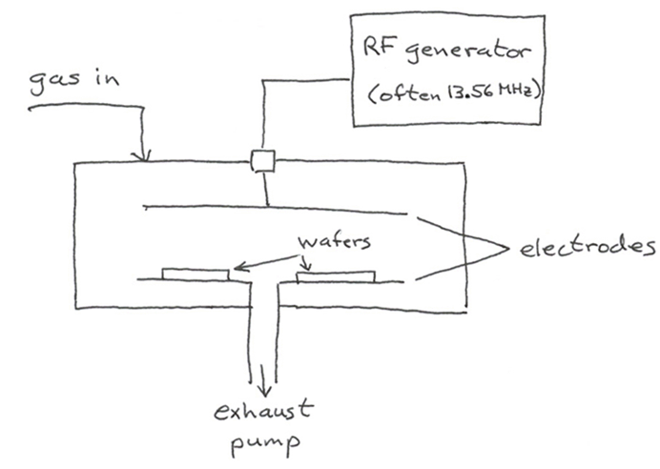
P=10^{–4} – 10 torr
Fraction ionized ~10^{–6}
Modes of Operation

- Ion milling (relatively uncommon)

- Use inert gas (Ar) at low P (<10^{–3} torr), high V
- Etching by physical erosion only
- Anisotropic, poor selectivity
- Considerable damage to substrate

- Reactive ion etching (very common)

- Use reactive F or Cl – containing gas at modest P (10^{–3} – 10^{–1} torr), modest V (70 – 300V)
- Etching by nonlinear combination of sputtering and rxn
- Fairly anisotropic, decent selectivity (~25)
- Some damage

- Free radical plasma

- Use reactive F or Cl – containing gas at “hi” P (10^{–1}–10 torr), low V (< 70V)
- Etching by free radical rxns
- Usually isotropic (without sidewall passivation), selectivity good, especially to photoresist, relatively low rate
- Little damage

Gas Selection

For Si, SiO₂, Si₃N₄, many silicides many metals

→ F-based etchants CF₄, C₂F₆, SF₆

e.g.: Si + 4F• → SiF_{4(g)}
3SiO₂ + 4CF₃• → 2CO + 2CO₂ + 3SiF_{4(g)}
SiO₂ + 2CHF₂ → 2CO + H₂ + SiF_{4(g)}
Si₃N₄ + 12F• → 3SiF₄ + 2N₂
Ti + 4F• → TiF_{4(g)}

For Al (no volatile fluoride → passivation)

→ Cl-based etchants CCl₄, BCl₃ + Cl₂ + CHCl₃ + N₂, BCl₃ + Cl₂

e.g.: Al + 3Cl• → AlCl_{3(g)}

Problems: • cold spots → AlCl₃ condenses
• expose to H₂O → form HCl (corrosion)
Al₂O₃ (particles)
• residual surface Cl → corrosion of Al
(flush with F species at end)

For photoresist stripping

→ O₂ – based etchant

Often multiple gases used because:
• some byproducts deposit passivating layers
(e.g., Photoresist scum) → add a little O₂

• etchant may react with main substrate but not its surface oxide covering

A Closer Look at RIE

1. Physics: ungrounded plates become negative w.r.t. plasma because e⁻ move further per rf cycle and are depleted from gas phase.

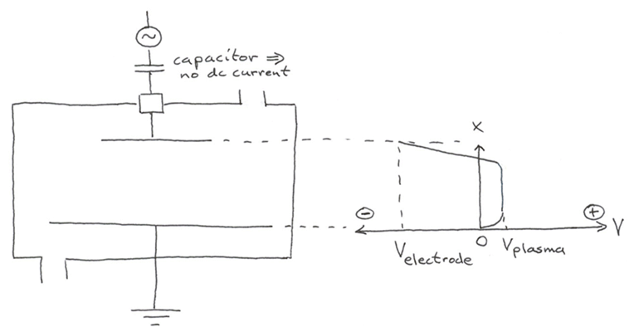
Effect more pronounced when floating (or hot) electrode is smaller than grounded one.
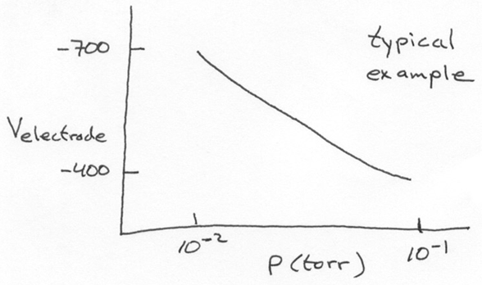

Voltage makes ions impinge
at near-normal incidence
(although collisions deflect some)

Plasma Temperature

Normally T in a gas is characterized by a Boltzmann dist. in velocity u:

$$f\left(u\right)=4{πu}^{2}{\left(\frac{m}{2{πk}_{B}T}\right)}^{\text{3/2}}\text{exp}\left(−{\text{mu}}^{2}{\text{/2k}}_{B}T\right)$$
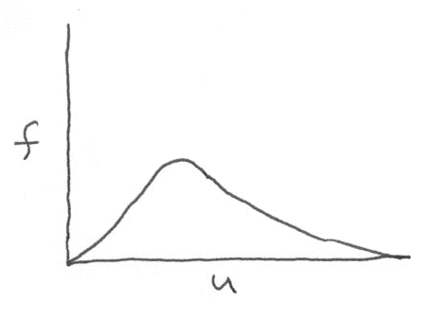

In plasmas, there are several distributions:

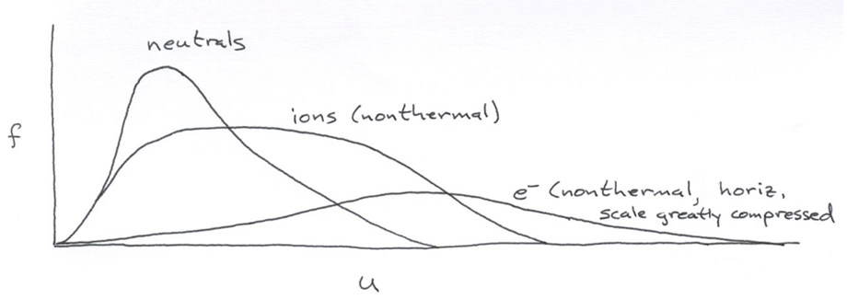

Ions, e–, neutrals are different, and ions/e– are not Boltzmann! To get an idea of T, consider a definition based on mean velocity ū:

$$T=\frac{πm{\bar{u}}^{2}}{{\text{8k}}_{B}}$$

On this basis, T_{ion} ~ 400 – 500K
T_{e-} ~ 10,000K (like sun’s surface!)

However, since T is not well defined, standard theories for thermal chemistry don’t apply.

Lecture End _____

