Lecture 11

Plasma Etching (continued)

Last time we started to examine RIE, and saw how principles of typical thermal chemistry did not apply. Let’s examine such effects some more.

Example: Threshold effects in sputtering

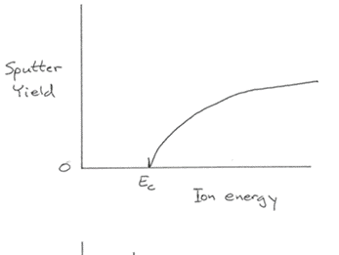
Yield = 0 up to E_{c}

Typically E_{c} ≤ 20eV

Example: Angular effects in sputtering
Most effective near 60°

Scoop atoms out of surface

Glancing incidence does little.

Example: Cooperative effects: XeF₂/Ar⁺ on Si
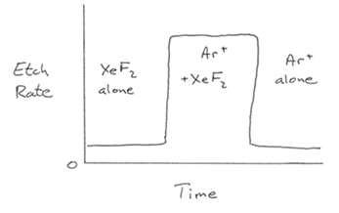

Need both Ar⁺ and
XeF₂ to etch!

Voltage makes most ions impinge at near-normal incidence (although gas collisions deflect some)

2. Chemistry

Etching occurs from: • free radicals (minor effect)
• ion-surface reactions (at lover V)
• ion sputtering (at higher V)

nonlinear interaction → • ion stimulated surface rxns
↑
e.g. Cl₂ + Ar⁺ on Si

Rate expressions: • very complicated
• difficult to make predictions
• affected by - gas composition
- total P
- rf power
- surface T
- electrode voltage
- loading
- gas flowrate
- electrode composition

(We’ll examine the effects of each
of these in a minute)

General (though not universal) form for a given active species i.

Pressure of neutral species i
↓
r_{i}=k_{i}[e–]P_{i}
↑
e– concentration

More e⁻ give more ions/radicals from neutral i.

However, collision effectiveness of e– varies with P.
At very low P, plasma not self sustaining

At modest P, P ↑ gives more collisions before e– loss ⇒ r ↑

At high P, P ↑ reduces mean free path, no e⁻ don’t pick up enough energy between collisions ⇒ r ↓
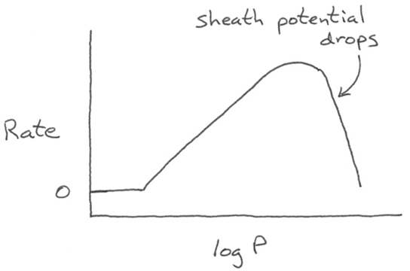
Thus

Other process variables:

- rf power → increases make [e–] rise ⇒ higher r

- surface T → increasing T often increases r weakly with Arrhenius dependence

- loading (increasing number of wafers)

system-dependent constants
Usually $r=\frac{k_{1}}{1+k_{2}A}$
exposed area for etching

This is a common kinetic form for surface reactions of any kind.

• gas flow rate → affects loading constants k₁, k₂

• electrode material → may be sputtered/redeposited (e.g. Al)
or yield extra gas products (e.g. SiF₄ in
F plasmas over Si or SiO₂)

Damage effects – difficult to avoid

- structural defects
- foreign ion implantation
- rough surface (especially when etching only part way through a layer → trenches)
- unwanted residues

Reduce effect by clever choice of

- etchant
- electrode materia/design
- sacrificial layer of oxide

Can also do a subsequent annealing/cleaning step

Always tradeoffs!

Lecture End _____

