Lecture 12

Physical Vapor Deposition

No chemical reactions here: contrasted with chemical vapor deposition

Good for:

- Single-element layers (esp. metals)

- ultra-high purity applications

- non-crystalline layers

Two methods: evaporation and sputtering

1. Evaporation

Idea: raise vapor pressure of source by heating → evaporate (or sublimate) and deposit

Do in vacuum for • cleanliness
• long mean free path

Heating methods:

A. Resistive: wrap crucible in wire and pass current

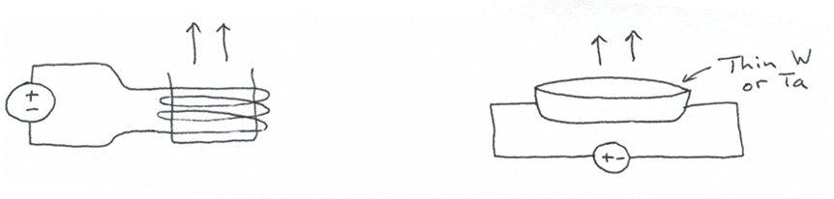

- Simple

- Energy-inefficient • point thermal contacts with wire

• poor efficiency of resistive heating with low resistance

- E-beam heating:
bias source with respect to hot filament
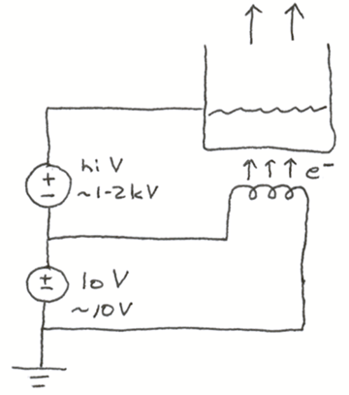

- More complicated

- More efficient

2. Sputtering:
blast material off a target with ions so it deposits on wafers

Ions come from a biased plasma
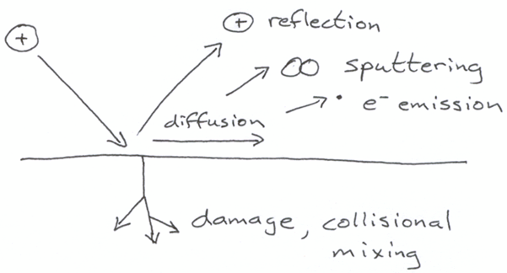
Physics of sputtering –
schematic diagram:

Sputtered atoms:• Almost all reflected species are neutrals if electron-phonon coupling is weak, as with metals/noble gases.

• sputtered atoms appear above a threshold of about 20 – 30 eV

• Atoms/clusters come off with energies of 10 – 50eV, which heats surface of wafer or directly enhances surface diffusion

Comparison of evaporation, sputter deposition

Evaporation: • Relatively simple

• Generally poorer step coverage

• Difficult to control rates: vary exponentially with T

Sputtering: • More complex

• Better step coverage

• Easier to control rates: vary linearly with plasma power

• Better for making alloys, compound materials for this reason

Problems in PVD

1. Step coverage

Line-of-sight techniques give poor conformality on sidewalls

Improve by: • Rotating wafers during deposition

• Increasing surface diffusion D = D_{o} exp (–E_{diff}/kT)
by heating wafers with lamp

2. Stress in film: causes wafer bowing or film peeling

Usually caused by deposition at high temperature:

- Thermal expansion mismatch with substrate

- Intrinsic stress from recyrstallization

- Compressive stress: wafer becomes
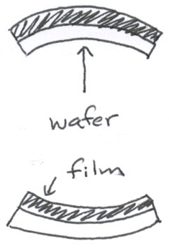
convex

- Tensile stress: wafer becomes concave

Lecture End _______

