Lecture 14

Chemical Vapor Deposition (CVD)

Chemical reactions take place: gas-phase “source gases” or “precursors” react with hot wafer surface

Examples:

- Si (amorphous, epitaxial or poly) from SiH₄ or Si₂H₆

- GaAs from (C₂H₅)Ga and AsH₃

- InP from (CH₃)₃In and PH₃

Can take advantage of surface chemistry to get:

- selectivity: growth on some wafer areas not others

Examples: • Epi-Si on Si (but not SiO₂) from SiH₂Cl₂

• TiSi₂ on Si (but not SiO₂) from TiCl₄, SiH₄

• W on Si (but not SiO₂) from WF₆, H₂

- very close stoichometry: like GaAs is exactly 1:1 regardless of source gas ratio

CVD especially good for:

- semiconductors, insulators

- crystalline layers, especially epitaxial (define) → “vapor phase epitaxy,” VPE (because everything is hot → surface diffusion)

Potential problem: very hazardous (poisonous, pyrophoric) source gases

Several methods: depend on pressure, mode of heating, other enhancements

1. Atmospheric-pressure CVD (APCVD)

Done at atmospheric pressure, sometimes in continuous mode
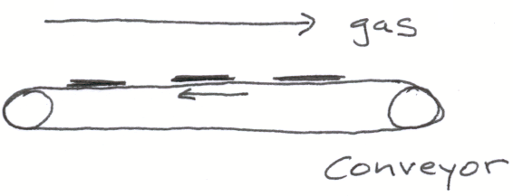
Schematic:

Good for undemanding applications: control not great because of large gradients in heat, concentration; takes nontrivial time to start and stop reactor.

2. Low-pressure CVD (LPCVD)

Done below room temperature, usually 10^{–3} to 10 torr (lower than 10^{–3} demands more than mechanical pumps)

- Generally done in batch, with single or multiple wafers

- Since gas diffusivities 1/P, growth rates can be faster than APCVD

- Fewer fluid mechanic effects → better uniformity

A. Conventional furnace

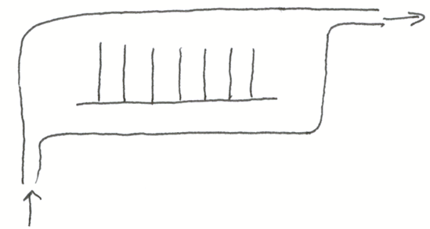
Schematic:

Hot wall gives more uniform wafer T, fewer convection effects

B. Rapid thermal (RTCVD)

Schematic: (usually part of a cluster tool)
B. Single-wafer (Rapid-thermal CVD, or RTCVD)

Schematic: (usually part of a cluster tool)

- Get kinetic advantages from fast (~100ºC/s) heating: less bulk diffusion

- Cold wall → few particulates, other contamination
3. Plasma-enhanced CVD (PECVD)

Use plasma to: • predissociate gas precursor (most common) for low-T growth

• get surface resputtering onto sidewalls for better uniformity

Examples: • Si₃N₄ from SiH₄ and (N₂ or NH₃)

• SiO₂ from TEOS (tetraethoxysilane, Si(OC₂H₅)₄)

Problem: get less control over composition than pure surface chemistry gives → results closer to PVD

Elementary Steps in CVD

Can be controlled by several factors, any of which can be rate-limiting

Schematic:
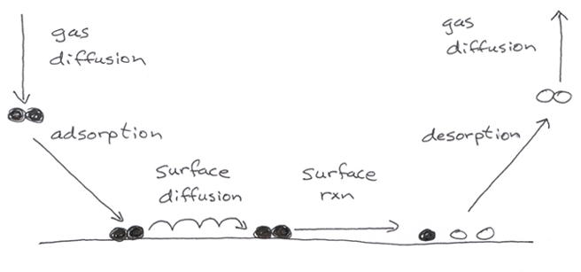

A typical rate plot in Arrhenius form (log(r) vs. 1/T)

Since surface rates vary exponentially with T, while gas transport varies much more weakly (polynomial, typically T^{1/2} to T^{7/4}), at sufficiently high T we always are mass-transport limited.

Next time we’ll look more closely at surface effects first, then later at gas transport.

Lecture End _______

