Lecture 15

Chemical Vapor Deposition (continued)

Last time we saw where CVD is used and showed schematically the physical processes that control deposition rates:

Schematic:
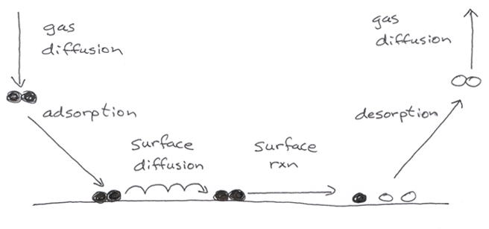

Let’s look more closely at surface effects first, then later gas transport.

1. Surface kinetics

A. Adsorption

We envision a surface as a regular array of discrete adsorption sites of density n (cm⁻²)

Typically the maximum (or “saturation”) density n_{sat} is 10¹⁴ to 10¹⁵ cm^{–2}. For Si it’s 6 to 7 × 10¹⁴ cm^{–2}, depending on cryst. face.

We can define a coverage $θ$ = n/n_{sat}, with 0 $θ≤$ 1

In simplest models, rate incident flux f ( pressure P)

× “sticking probability” S (typically a function of θ)

Thus, r_{a} = Sf = S($θ$)P / (2$π$mkT_{g})^{1/2}

where: m = molecular mass (g)

k = Boltzmann’s constant

T_{g} = gas temperature

In real units,

f (molec/cm²-s) = 3.816×10²⁰ [300/T_{g} × 28/M]^{1/2} P (torr)

where M = molecular weight (e.g., 28 for N₂)

So dependence on T_{g} and M is weak

These fluxes are really big: at room temp, get 1/2 mol/cm² every second impacting! We’d all be buried in a couple of minutes except that S becomes very low. At 10^{–6} torr, it take about 1 s to saturate a surface with S = 1.

In the simplest models, S = S_{o} (1 – $θ$)^{N}

where usually N = 1 (first-order, non-dissociative: e.g., H₂O on Si)

= 2 (second-order, dissociative: e.g., H₂ on a metal)

Typically S_{o} has a weak T dependence (on both T_{surf} and T_{g})

So how does surface concentration vary with time? This is a simple problem to illustrate how to use adsorption kinetics

Do mass balance on atoms or molecules: “control volume” is the surface.

In words,

accumulation = in – out + generation – consumption

Let’s assume for the moment: • no reaction (gen, cons = 0)

• no desorption (out = 0)

Then accumulation = in

or (for a molecule that doesn’t dissociate):

dn/dt r_{a} = Sf = S(n)P/(2$π$mkT_{g})^{1/2}

For dissociation: dn/dt = 2r_{a} = 2Sf

Note: the stoichiometric coefficient often, but not always equals N in S(θ).

Integrate:

∫dt’ = t = (2$π$mkT_{g})^{1/2}/P ∫dn’/S(n’)

Expression gives relation between $θ$ and t. Note that we get

θ ∝ P×t This product of P and t is called the “exposure.”
B. Desorption

In contrast to adsorption (where bonds form but do not break), desorption rates usually have a strong T dependence.

Usually, r_{d} = k_{d}n^{N} = ν_{d}exp(–E_{d}/RT)n^{N}

where R = 1.987 cal/mol-K

8.62 × 10^{–5} eV/K

Again, N is typically 1 or 2

So how does surface concentration vary with time?

Do mass balance on atoms or molecules: “control volume” is the surface.

In words,

accumulation = in – out + generation – consumption

Let’s assume for the moment: • no reaction (gen, cons = 0)

• no adsorption (in = 0)

Then accumulation = – out

or (for a molecule that doesn’t dissociate):

dn/dt = –r_{d} = –k_{d}n^{N}

or (using n = n_{sat} $θ$) n_{sat}d$θ$/dt = –k_{d}n_{sat}^{N}$θ$^{N}

or d$θ$/dt = –k_{d} n_{sat}^{N–1}$θ$^{N}

If associative desorption like H₂, dn/dt = –2r_{d}

Integrate:

∫dt’ = t = –1/k_{d}n_{sat}^{N–1} ∫dθ’/θ’^{N}

Gives $θ$ vs. t.

Note: at steady state, r_{a} = r_{d} (with suitable stoichiometric
coefficients)

This relation is important for the homework.

C. Surface reaction

Generally the reaction rate has the form:

r_{R} = k_{R} n^{N} = $ν_{R}$exp(-E_{R}/RT)n^{N} (eqn in molec/cm²-s)

D. Surface diffusion

Usually the diffusion rate is buried into the surface reaction rate constant.

If reaction is surface-diffusion limited, can’t get a universal closed-form expression for reaction rate constant in two dimensions.

If coverage is low ($θ$ < 0.1 or so) for A + A → A₂:

r_{R} = k_{R} n² (eqn in molec/cm²-s)

where

k_{r} = 2$π$D/ln$\sqrt{1/θ}$

and where the (hopping) diffusion coefficient

D = D_{o} exp(–E_{diff}/RT)

Lecture End ______

