Lecture 16

Chemical Vapor Deposition (continued again)

Last time we looked at how surface processes controlled deposition rate. Now let’s examine transport effects in the gas phase.

2. Gas transport

Treatment depends on pressure regime:

• Molecular flow, P < 10^{–2} torr or so (much LPCVD)

Mean free path at least comparable to chamber dimensions

Treat reactor as well mixed

• Viscous flow, P > 10^{–2} torr or so (APCVD, some LPCVD)

Mean free path much smaller than chamber dimensions

Need more complicated fluid mechanics: boundary layers

A. Molecular flow

Mass balance for a well-mixed reactor:

accumulation = in – out + generation – consumption

This equation works for total mass or for any individual species.

Converting into quantitative form is easier with a diagram showing control volume and all streams:

Diagram:
Define: • $\overset{˙}{N}$ = flowrate (mole/s or molec/s)

• C = concentration in reactor (mole/cm³)

• A = area of reaction (cm²)

This is a classical continuous-flow stirred tank reactor (CSTR).

Assume:

• steady flowrates N_{in} and N_{out}

• no gradients in temperature or concentration within reactor (low pressure ensures good mixing even without stirrer)

• outlet composition reflects overall reactor composition

Thus, C_{out} = C

• discontinuity in temperature and/or composition at reactor inlet

Do balance on control volume of reactor itself:

For any species i,

dN_{i}/dt = v_{in}C_{in} – v_{out}C_{out} + αAr_{R} (eqn in units of molec/s)

where • v = flowrate (cm³/s)

• C = concentration (mole/cm³)

• α is a stoichometric coefficient depending on exactly how reaction rate is defined. It’s (+) for products and (–) for reactants. But α is best not to treat by formula: think about what is happening.

Example: SiH₄(g) → Si(s) + 2H₂(g)
give different $α$
2SiH₄(g) → 2Si(s) + 4H₂(g)

Note that N_{i} = C_{i}V = PV/RT_{g} by the ideal gas law (which always works in this regime of low pressure).

To obtain v_{out}, we need another balance on the total number of moles (including reactants and products):

dN/dt = ${\overset{˙}{N}}_{\text{in}}−{\overset{˙}{N}}_{\text{out}}$ + ΔαAr_{R} (eqn in mole/s)

where $Δα$ refers to the mole number changes of gas species in the reaction. This comes from the stoichiometric coefficients $α$.

Example: SiH₄(g) → Si(s) + 2H₂(g)

One gaseous mole becomes two

$Δα$ = 2 – 1 = 1

An important special case:

Steady state → accumulation = 0 → dN/dt = dN_{i}/dt = 0

if also no change in mole number (Δα = 0), then v_{in} = v_{out} ( = v_{o})

A common characteristic property:

Residence time τ ≡ V/v_{o} = [cm³/(cm³/s)] = [s]

This is the average amount of time a molecule stays in the reactor.

* Longer residence times mean

- higher conversion of reactants

- more possible loading effects (C → 0). This is OK for production on a well-characterized tool.

* Shorter residence times mean

• lower conversion of reactants

- more wasted source gas (C → C_{in}).

- Good opportunity for measuring kinetics that must be generalized to other tools, since C in the rate expression is near C_{in} and there are few product promotion or inhibition effects. Should keep conversion below 10% or so.

Confusion in literature:

• intrinsic kinetics confused with reactor (conversion) effects.

• deposition rates published as a function of flowrates v_{o} (sccm).
With high conversion, apparent rate tends to vary linearly with v_{o}:
0
Ar_{R} = v_{o}C_{in} – v_{o}C_{out}

but otherwise not. These are not true kinetics!

B. Viscous flow

Called “viscous” because fluid viscosity now plays a key role. Fluid velocity and temperature profiles vary with position even over a flat plate:

Velocity profile: Temperature profile:
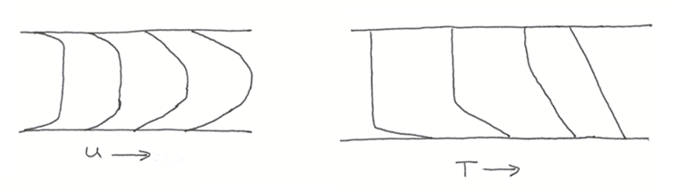

Fully-developed: parabolic Fully-developed: linear

* A key dimensionless number that characterizes flow:

Reynolds number Re ρud/μ

where • $ρ$ = density (g/cm³)

• u = bulk velocity far from wall (cm/s)

• d = a characteristic length (e.g., a tube radius or diameter)

• $μ$ = viscosity (g/cm-s)

In pipes, Re > 2100 gives turbulent flow: never used in CVD. Flow is always laminar: streamlines are smooth, fluid “sheets” slip over each other and don’t mix.

Turbulent flow should be avoided: gives uniformity problems and stirs up particles.

* Another important quantity: the “entrance length” of a reactor.

For a rectangular channel, width d and height H, length for fully developed profile is

l_{u} = 0.04 H Re for velocity

l_{T} = 0.28 H Re for temperature (7 times longer!)

If T is too large, buoyancy makes flow become unstable, nonlaminar. Most incorporate T-dependence of physical properties to be quantitative.

Lecture End _________

