Lecture 18

Thermal Oxidation

Dry oxidation Si_{(s)} + O_{2 (g)} → SiO_{2 (s)}

Wet oxidation Si_{(s)} + 2H₂O_{(g)} → SiO_{2 (g)} + 2H_{2 (g)}

Some processes use O₂ and H₂O

Used for gate dielectric in MOSFETS and field oxide between devices.

Simplified Deal-Grove Model

3 possible rate-limiting steps:

- diffusion through gas film
- diffusion through oxide
- reaction at interface

In principle all 3 can contribute.
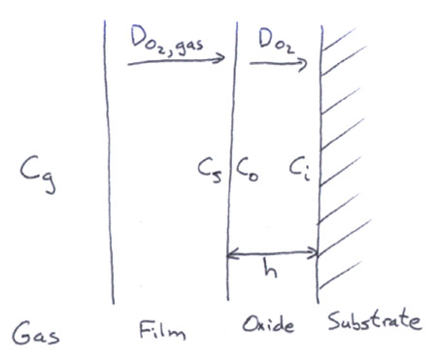

In Si oxidation, gas diffusion is always very fast compared to the other steps: gas diffusivities are very high.

1. Diffusion across oxide limits:
$\begin{aligned}J_{o_{2}}=−D\frac{\text{dc}}{\text{dx}} ≈−D\frac{Δc}{Δx} \\ =−D\frac{C_{o}−C_{i}}{h}\end{aligned}$

(in molec/cm²-s)

Linearizes derivative over entire film. This is an approximation.

Use Henry’s law (dilute solution in solid) to get C_{o}:

$C_{o}=k_{h}C_{s}={\text{HP}}_{o_{2}}$
$­$
conventional notation.

This implies diffusion is not so fast to destroy equilibrium at interface.

$$J_{o_{2}}=D\frac{{\text{HP}}_{o_{2}}−C_{i}}{h}$$

- Reaction at interface limits: r (molec/cm²-s) = kC_{i}

Put together: $r=J_{o_{2}}$ $⇒$ $D\frac{{\text{HP}}_{o_{2}}−C_{i}}{h}={\text{kC}}_{i}$

to get C_{i}

$⇒$ ${\text{DHP}}_{o_{2}}−{\text{DC}}_{i}={\text{hkC}}_{i}$

$⇒{\text{DHP}}_{o_{2}}=\left(\text{hk}+D\right)C_{i}$ $⇒$ $C_{i}=\frac{{\text{DHP}}_{o_{2}}}{\text{hk}+D}=\frac{{\text{HP}}_{o_{2}}}{1+\frac{\text{hk}}{D}}$
Thus, $r=\frac{{\text{kHP}}_{o_{2}}}{1+\frac{\text{hk}}{D}}=N_{1}\frac{\text{dh}}{\text{dt}}$
$­$
molecules O₂ /unit vol. SiO₂

IC: h(0) = h_{o}
Then solution is: $h^{2}+\frac{2D}{k}h=\frac{2{\text{DHP}}_{o_{2}}}{N_{1}}\left(t+τ\right)$
$τ=\frac{h_{o}^{2}+\frac{2D}{k}h_{o}}{2{{\text{DHP}}_{o_{2}}}/{N_{1}}}$

Let $A=\frac{2D}{k}$ $B=\frac{2{\text{DHP}}_{o_{2}}}{N_{1}}$

Then $τ=\frac{h_{o}^{2}+{\text{Ah}}_{o}}{B}$

Two regimes:

- Linear, $h→0⇒h≈\frac{B}{A}\left(t+τ\right)$ Rxn and diffusion matter

- Parabolic, $h→∞⇒h≈\sqrt{B\left(t+τ\right)}$ Diffusion dominates

Note: Both A and B have activation energies:

$B ∝ \text{exp}\left({−E_{\text{diff}}}/{\text{RT}}\right)$

$A ∝  \text{exp}\left(−(E_{\text{diff}}−E_{R})/{\text{RT}}\right)$

Thus, for h → 0, E_{A} ≈ E_{R}

h → ∞, E_{A} ≈ E_{diff} / 2

For very small total thicknesses (<30 nm), Deal-Grove model breaks down: rate is faster than expected.

Nobody knows why. Campbell’s book shows a “scotch tape” parameterization of $t$ to make the data fit.

Effects of Dopants:

All dopants increase rate. Some prefer to segregate into oxide. Campbell’s Fig. 4-16 misleading – has mass balance problems.

impurity in Si
Define segregation coeff. m = ––––––––––––
impurity in SiO₂

m < 1 (Segregate to oxide)
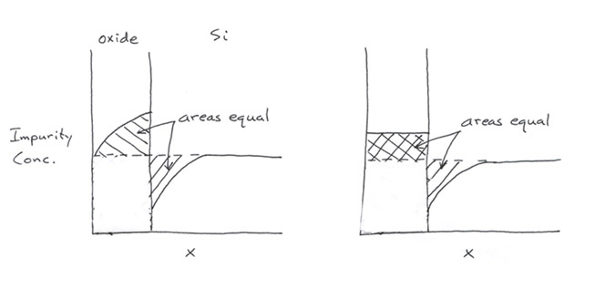

m > 1 (Segregate to Si)

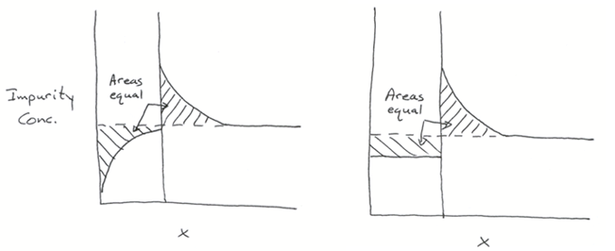

Slow diffusion in oxide Fast diffusion in oxide

Lecture End _________

