Lecture 19

Si Production

Process flow: (From H. Lee’s book, Fundamentals of Microelectronic Processing)

HCl

Arc Furnace (molten)
Fluidized bed
Sand
Metallurgical grade Si
~ 0.3% Fe
~ 0.1% Al
~ 0.1% Ca
many others

SiH₄,
SiH_{x}Cl_{4-x}

Purified
SiH₄, SiH_{x}Cl_{4-x}

Polycrystalline
Separator
Fluidized bed or decomp. chamber
electronic grade
Si

1. Molten furnace

Reduce SiO₂ (as sand or quartzite) with carbon

CO, SiO, H₂O SiO₂, coal, wood chips

 | Carbon  Electrode |  | 1600ºC
Condense most SiO  SiO_{(g)} + CO_{(g)} $→$SiO₂ + C | Carbon  Electrode |  | 1600ºC
Form SiC | Carbon  Electrode | SiO_{(g)}+2C$→$SiC+CO_{(g)} | 1780^{O}C
SiO₂ + 2SiC $→$ 3Si + 2CO_{(g)}
2SiO₂ SiC $→$ 3SiO(g) + CO_{(g)}
Si (~2% total O, Fe, Al, Ti)

2. Fluidized bed

Principal reaction is: Si + 3HCl $→$ SiHCl₃ + H₂

But there are others.

3. Separation & purification

Done by distillation. It’s easier to purify gases than liquids or
solids.
4. Electronic grade Si production

Most is made in a Siemens reactor

SiHCl₃ + H₂ $\vec{{\text{1000}}^{o}C}$ Si + mostly HCl ( + some SiCl₄)
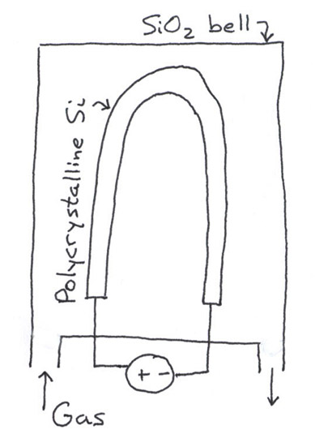

But: 1. Slow batch process (low
rate, not continuous)

2. High loss of SiCl₄

3. High power consumption

Hemlock Semiconductors Corp. calls this deposition “CVD”

They break up Si into uniform size by hand with Ti hammers!

Some work is in fluidized beds now, as in next example.

Quantitative Treatment of Fluidized Bed Reactor

This example is a fairly sophisticated use of mass balances.

Provides experience with:

• Distribution functions
• Converting difference equations into differential equations
Let p(r) be a distribution
fxn describing probability
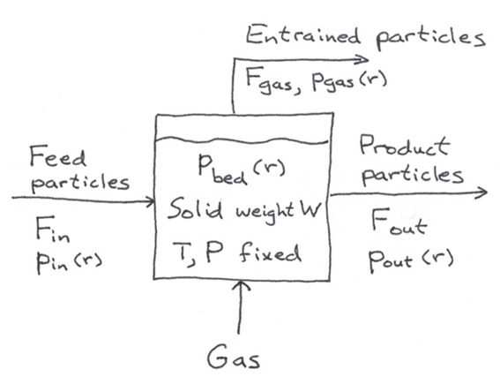
of having size r

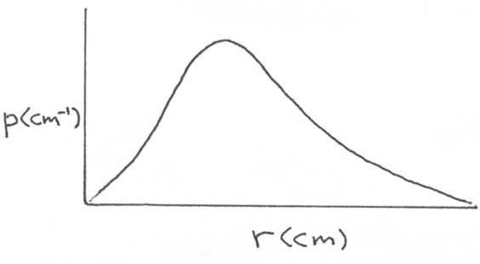

Assume: • well-mixed CSTR $→$ p_{out} = p_{bed}
• constant solid density $ρ_{s}$
• no attrition
• constant deposition rate $\overset{˙}{r}$(cm/s)
• steady state

Physical picture: T & P of reactor set $\overset{˙}{r}$. Solid feed picks up mass from gas phase before exiting.

Question: Given F_{in} and p_{in}(r), what is F_{out} and p_{out}(r)?

(To get an answer simply, we have to assume there is some parameterization for p_{gas} in terms of p_{out}.)

Approach: Since we need the size distribution as a function of r, we need a differential mass balance on particles between r and r + Δr.

Up to now we have done only integral balances, yielding algebraic equations, because we haven’t needed to know what’s going on inside the control volume.

Now we need knowledge about the size distribution inside the control volume. This leads to differential equations.

Our control volume will not be fixed in space, but will be a size range within the distribution between r and r + Δr.

General form: accum = in – out + gen – cons Do for particles between r and r + Δr
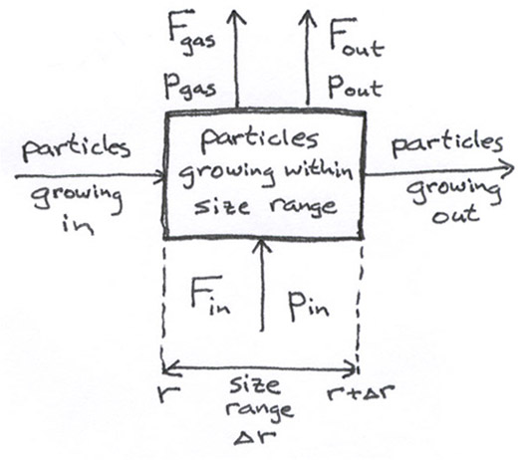

solid product gas stream
So 0 = solid inflow – outflow – outflow

steady
state entrance by exit by growth growth of particles
+ growth at r – at r + Δr + staying within $Δr$

(all in g/s)

$=\underset{g/s}{\overset{F_{\text{in}}}{↑}}\underset{{\text{cm}}^{−1}}{\overset{p_{\text{in}}\left(r\right)}{↑}}\underset{\text{cm}}{\overset{Δr}{↑}} −F_{\text{out}}p_{\text{out}}\left(r\right)Δr−F_{\text{gas}}p_{\text{gas}}\left(r\right)Δr$

$+\underset{g}{\overset{W}{↑}}\underset{{\text{cm}}^{−1}}{\overset{p_{\text{bed}}\left(r\right)}{↑}}\underset{{\text{cm}}/s}{\overset{\overset{˙}{r}}{↑}}−{\text{Wp}}_{\text{bed}}\left(r+Δr\right)\overset{˙}{}r +\text{gen}$ (1)

another view of this term:
Let $\overset{˙}{r}=\frac{\text{dr}}{\text{dt}}$ Then Wρ_{bed}dr gives the weight at r.
Dividing by dt gives the rate of change

What about the generation term? Let N(r) = number of particles between r and r + Δr

Then gen = $N\left(r\right)ρ_{s}\overset{˙}{V}$ where $\overset{˙}{V}=\frac{4}{3}π\left(r^{\overset{˙}{3}}\right)=4{πr}^{2}\overset{˙}{r}$
$\frac{{\text{cm}}^{3}}{\text{particle}⋅s}$

cm³/particle

and N(r) comes from $\underset{{\text{wt}}/{\text{particle}}}{\underbrace{ ρ_{s}V\left(r\right) }}N\left(r\right)={\text{Wp}}_{\text{bed}}\left(r\right)Δr$

$⇒N\left(r\right)=\frac{{\text{Wp}}_{\text{bed}}\left(r\right)Δr}{ρ_{s}\frac{4}{3}{πr}^{3}}$

So gen $=\frac{{\text{WP}}_{\text{bed}}Δr}{ρ_{s}\frac{4}{3}{πr}^{3}}ρ_{s}4{πr}^{2}\overset{˙}{r}=\frac{3}{r}{\text{WP}}_{\text{out}}\overset{˙}{r}Δr$ since p_{out} = p_{bed}.

Substituting into (1) and dividing by Δr,

$$0=F_{\text{in}}p_{\text{in}}−F_{\text{out}}p_{\text{out}}−F_{\text{gas}}p_{\text{gas}}−W\overset{˙}{r}\frac{P_{\text{out}}\left(r+Δr\right)−p_{\text{out}}\left(r\right)}{Δr}+\frac{3W}{r}\overset{˙}{r} p_{\text{out}}$$

Let Δr → 0, ignore F_{gas} (assume no entrainment), divide by $W\overset{˙}{r}$

⇒ $\frac{{\text{dp}}_{\text{out}}}{\text{dr}}+\left(\frac{F_{\text{out}}}{W\overset{˙}{r}}−\frac{3}{r}\right)p_{\text{out}}=\frac{F_{\text{in}}p_{\text{in}}}{W\overset{˙}{r}}$

We’ll solve this equation next time.

Lecture End ––––

