Lecture 20

Bring Czochralski boules to pass around.

Quantitative treatment of fluidized bed rxtr (continued)

We saw last time that:

$\frac{{\text{dp}}_{\text{out}}}{\text{dr}}+\left(\frac{F_{\text{out}}}{W\overset{˙}{r}}−\frac{3}{r}\right)p_{\text{out}}=\frac{F_{\text{in}}p_{\text{in}}}{W\overset{˙}{r}}$

This has the form $y^{'}+P(x)y=Q\left(x\right)$

Use integrating factor $e^{\int{\text{Pdx}}}$ = $\text{exp}\left(\int{\left(\frac{F_{\text{out}}}{W\overset{˙}{r}}−\frac{3}{r}\right)\text{dr}}\right)$

=$\text{exp}\left(\frac{F_{\text{out}}r}{W\overset{˙}{r}}−3\text{ln}(r)\right)=\frac{1}{r^{3}}e^{F_{\text{out}}r/W\overset{˙}{r}}$

Multiply both sides by this $⇒$

$\frac{d}{\text{dr}}\left[p_{\text{out}}\frac{1}{r^{3}}e^{F_{\text{out}}r/W\overset{˙}{r}}\right]=\frac{F_{\text{in}}p_{\text{in}}\left(r\right)}{W\overset{˙}{r}}\frac{1}{r^{3}\text{exp}}F_{\text{out}}r/W\overset{˙}{r}$

⇒ $p_{\text{out}}\frac{1}{r^{3}}e^{F_{\text{out}}r/W\overset{˙}{r}}=\frac{F_{\text{in}}}{W\overset{˙}{r}}\int{\frac{p_{\text{in}}\left(ρ\right)}{ρ^{3}}}\text{exp}\left(F_{\text{out}}ρ/W\overset{˙}{r}\right)dρ+C$
dummy
variable

Now let’s assume that all inflowing particles have radius r_{in}

So that F_{in}p_{in}(r) = F_{in}δ(r – r_{in}) where δ(r – r_{in}) = 0 for all r ≠ r_{in}

$⇒\frac{F_{\text{in}}}{W\overset{˙}{r}}\int{\frac{δ\left(ρ−r_{\text{in}}\right)}{ρ^{3}}}\text{exp}\left(F_{\text{out}}ρ/W\overset{˙}{r}\right)dρ$$=\frac{F_{\text{in}}}{W\overset{˙}{r}}\frac{1}{r_{\text{in}}^{3}}\text{exp}\left(F_{\text{out}}{r_{\text{in}}}/W\overset{˙}{r}\right)$

$⇒p_{\text{out}}\frac{1}{r^{{}_{3}}}e^{F_{\text{out}}r/W\overset{˙}{r}}=\frac{F_{\text{in}}}{W\overset{˙}{r}}\frac{1}{r_{\text{in}}^{3}}e^{F_{\text{out}}{r_{\text{in}}}/W\overset{˙}{r}}+C$ (2)

BC: With perfectly mixed behavior, some inlet particles at r_{in} immediately appear throughout bed.

Inlet amount: F_{in} dt

These all appear in bed: ${\text{Wp}}_{\text{bed}}\left(r_{\text{in}}\right)\text{dr}={\text{Wp}}_{\text{out}}\left(r_{\text{in}}\right)\text{dr}$

$⇒p_{\text{out}}\left(r_{i}\right)=\frac{F_{\text{in}}}{W}\frac{\text{dt}}{\text{dr}}=\frac{F_{\text{in}}}{W\overset{˙}{r}}$

Putting this into (2) gives C = 0

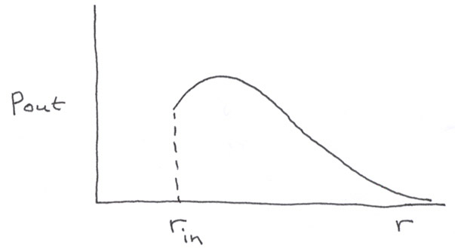

$⇒$$p_{\text{out}}\left(r\right)=\frac{F_{\text{in}}}{W\overset{˙}{r}}\frac{r^{3}}{r_{\text{in}}^{3}}\text{exp}\left[−\frac{F_{\text{out}}}{W\overset{˙}{r}}\left(r−r_{\text{in}}\right)\right]$
Also, since $\int{p_{\text{out}}\left(r\right)}\text{dr}=1$, we get

$\frac{W}{F_{\text{in}}}=\int{\frac{1}{\overset{˙}{r}}}\frac{r^{3}}{r_{\text{in}}^{3}}\text{exp} \left[−\frac{F_{\text{out}}}{W\overset{˙}{r}}\left(r−r_{\text{in}}\right)\right]$ (useful for homework)

Crystal growth (3 methods)

1. Bridgeman (simplest)

• Melt polycrystalline Si in carbon-coated boat within a tube

• Insert seed XL of desired orientation

• Cool from seed end.

Eg. GaAs

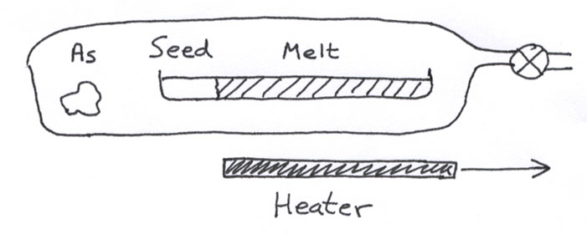

Try to reduce wall wetting to get:

• less contamination

• fewer cracks, dislocations when semiconductors expand
upon freezing

So roughen carbon walls to get hills and valleys for less contact area and wetting.

2. Floating zone

Can get better contamination control: no contact with a crucible at all.

This is a version of zone refining.

Melt a small, moving area on a vertical rod.

Molten area held by viscosity, surface tension.
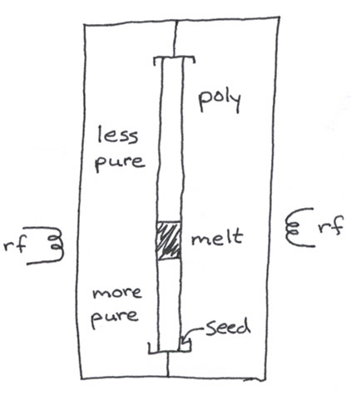

Problem: High cost of fabricating the initial rod. Used only for high
performance devices.

3. Czochralski pulling

Most common for Si, GaAs growth: avoid wall contact with liquid

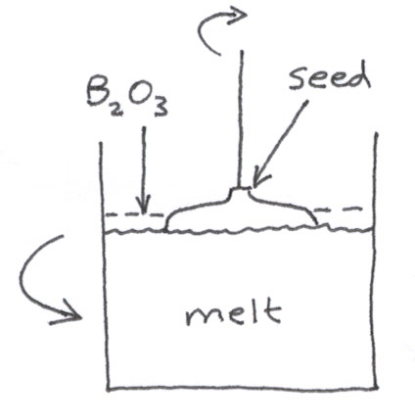
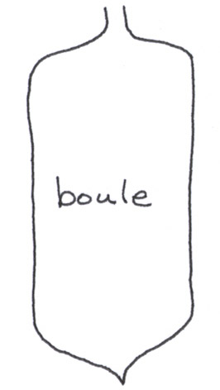

No walls$→$ very low defect production.

But lots of O₂ gets in if silica (cheap) crucible is employed

Vary boule diameter by varying pulling rate. Slower → wider.

We’ll examine this process quantitatively next lecture

Final Wafer Formation

- Large crystal shaped by grinding. Ends cut off.
- Flats ground in for orientation
- Crystal sawn into wafers
- Wafers mechanically polished
- Contaminants chemically etched off with mixtures of
HF, HNO₃, acetic acid

- Final polishing with 10nm SiO₂ powder in NaOH

Usually polish only one side because:

• It’s cheaper.

• Impurities are “gettered” on unpolished side during high-T processing. Impurities migrate faster along defects in bulk material, and are attracted to them on a surface. This effect pulls impurities away from the clean, polished surface.

Lecture End ––––

