Lecture 21

Hand out HOMEWORK 5: Explain …

Heat Transfer in Czochralski Growth
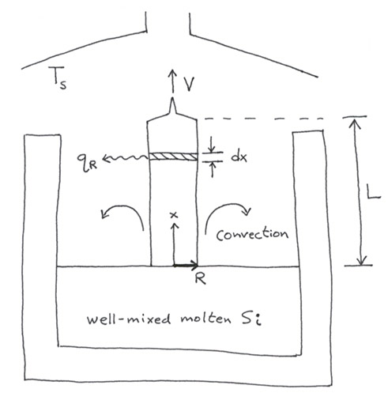
Physical
picture

Assume constant physical properties (not correct), steady state

Full equation in solid: (differential energy balance)

accum = in – out + gen – cons

${ρC}_{p}\frac{∂T}{∂t}=−{ρC}_{p}\underline{υ}⋅\underline{∇}T+k_{s}∇^{2}T+q_{\text{gen}}$
0 0

accum. in-out in-out
(flow) (diffusion)

If we assume radial symmetry, and convective/radiative heat transfer on the circumference, we can integrate out the radial dependence to get

${ρC}_{p}V\frac{\text{dT}}{\text{dx}}=k_{s}\frac{d^{2}T}{{\text{dx}}^{2}}−\frac{2h}{R}\left(T−T_{s}\right)−\frac{2}{R}q_{r}$ (1)

radiative heat flux

Stefan-Boltzmann const.

Now q_{r} has the general form $A_{\text{rad}}\text{εσ}\left(T^{4}−T_{s}^{4}\right)$

emissivity

where A_{rad} is a complex function of crucible geometry, temperatures, emittances.

Eq (1) needs two BC’s:

melt

1. At x=0, T = T_{m}

solid–liquid interface

2. At x=L, $−k_{S}\frac{\text{dT}}{\text{dx}}=\text{εσ} \left(T^{4}−T_{s}^{4}\right)+h \left(T−T_{s}\right)$
top end heat flux

Now, • pull velocity V tends to be low

• most cooling is by radiation

There are various approaches to solution. What we really want is the maximum pull rate V_{max}.

This we can get by an energy balance at the interface where solidification takes place:
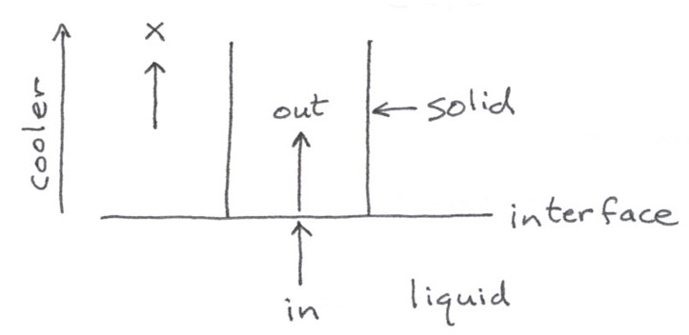
Diagram:

${ΔH}_{m}\overset{˙}{M}=−k_{s}{\left(\frac{{\text{dT}}_{s}}{\text{dx}}\right)}_{x=0}A−\left(−k_{L}\underset{}{\underbrace{{\left(\frac{{\text{dT}}_{L}}{\text{dx}}\right)}_{x=0}}}A\right)$

mass freezing 0 (with
rate, g/s perfect mixing)

gen out into solid in from liquid

accum = in – out + gen ⇒ gen = out – in
Now $\overset{˙}{M}=ρ_{s}\text{VA}$ where the cross section area A = πR²

⇒ for max V, get $V_{\text{max}}=\frac{−k_{s}}{ρ_{s}{ΔH}_{m}}{\left(\frac{{\text{dT}}_{s}}{\text{dx}}\right)}_{x=0}$

The solution to (1) (on p. 2) gives [dT_{s}/dx]_{x=0}. If pull any faster than this, the heat of fusion can’t be conducted away into the solid fast enough.

So let’s estimate the maximum pull rate using real numbers:

Let ⎜dT_{s}/dx ⎜≈ 100°C/cm ΔH_{m} = 1810 J/g

k_{s} = 0.216 W/cm•K ρ_{s} = 2.29 g/cm³

$\begin{aligned}⇒V\text{max}≈\frac{0\text{.}\text{216} J/s⋅\text{cm}⋅k}{\left(2\text{.}\text{29} g/{{\text{cm}}^{3}}\right)\left(\text{1810} J/g\right)}\text{100} K/{\text{cm}}=0\text{.}\text{0052} {\text{cm}}/s \\ \end{aligned}$
= 0.31 cm/min

The actual pull rate is always lower than the ideal.

Why? (1) Usually [dT_{L}/dx]_{x=0} < 0 instead of = 0, because of cooling of free liquid interface. This means extra heat is pumped into solid from liquid $\left(k_{L}\frac{{\text{dT}}_{L}}{\text{dx}}A<0\right)$, so freezing rate must drop to compensate.

Can fix this by dropping melt interface deeper into crucible so it won’t cool as much, but need to replenish molten Si during growth.

(2) Fast pulling means fast cooling, and closed loop T control can’t follow fast enough → entire melt starts to freeze.

(3) Radial T is not uniform. Coolest on solid surface → strains.

(4) Impurity (e.g., dopant) pileup at liquid interface decreases melting temp.

If temperature boundary layer extends further into melt then concentration boundary layer, T_{m} rises faster than T going into melt → unwanted nucleation in melt near interface.

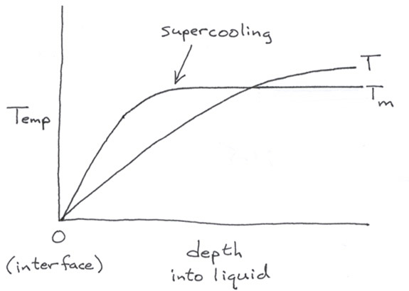
Diagram:

Lecture End ––––

