Lecture 22

Methods for Diffusional Doping

This method is used for noncritical applications because need extended annealing times at high T. Main doping method for critical applications is ion implantation (which we discuss next lecture)

An experimental method is PGILD (projection gas immersion laser doping) Idea:

• melt thin surface region with laser
• dopant goes from gas into liquid
• it redistributes evenly (diffusion a factor of 10⁸ faster than in solid)

Idea behind diffusional doping:

• deposit a layer of dopant oxide
• “drive in” dopant at elevated T by solid diffusion

Four oxide deposition methods (Campbell says little about this):

1. Spin-on
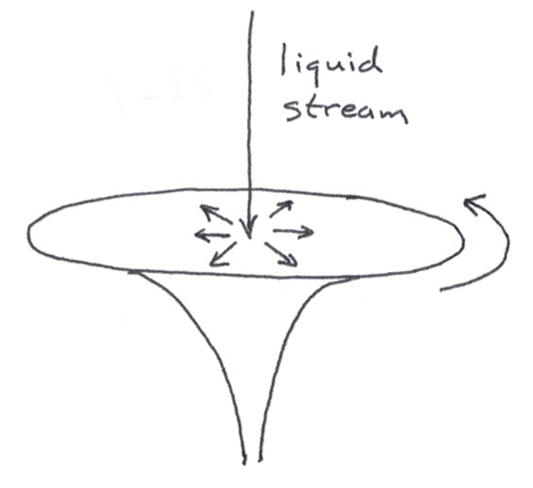

Deposit oxide (e.g., B₂O₃) of
dopant in a slurry and spin
over wafer

vacuum chuck: forms thin layer

Advantages: • simple
• applies to almost any dopant

Disadvantages: • poor uniformity (worst of any technique)

Uses: • non-critical doping applications where good
control not needed

2. Solid source

quartz, Si poly, or SiC tube

Heat up boat yielding vapor
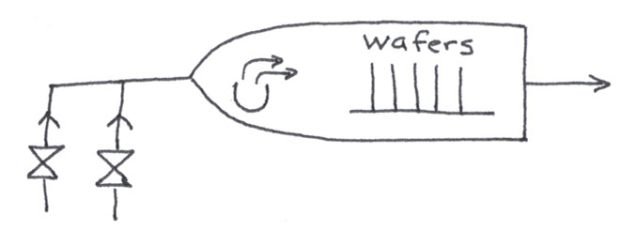
of dopant oxide (e.g., B₂O₃,
As₂O₃, or Sb₂O₃ in Pt, SiO₂, Si, or SiC boat)

Doping level controlled by T
carrier source of source (sublimation
gases pressure)
(N₂/O₂)

Advantage: • good for large–area wafers
• can be used when wafers are stacked close

Disadvantage: • on/off control poorer than for liquid/gas source
because of slow source heating/cooling
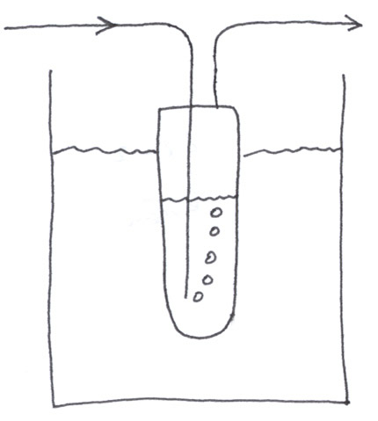
3. Liquid source
Like solid source except
bubble carrier gas through T–
controlled liquid (e.g., BBr₃,
POCl₃: phosphorous
oxychloride)

Doping level set by vapor pressure of liquid: permit equilibration for control.

Advantages/Disadvantages: • like solid source, except on/off control
by valves is faster, better

• ES&H problems: hazardous gases,
halogen disposal
4. Gas source

Like liquid source except need no bubbler: source gases have high vapor pressure. (e.g., BCl₃, B₂H₆, PH₃, AsH₃, SbH₃)

Add O₂ to carrier (like N₂) to ensure oxide formation.

Advantages/Disadvantages: • like liquid source, except more
pronounced

Solid Diffusion Physics

Unlike diffusion in liquids/gases, solid diffusion involves breaking chemical bonds, so there is a large T dependence.

Thus, D = D_{o} exp(–E_{diff}/kT)

Simplified diffusion mechanisms:

1. “Direct” diffusion by interstitial hopping

Occurs in semiconductors or other solids with an open structure, not metals (which are close packed)

Basically self– or heteroatoms squeeze between the host atoms on their sites. The squeezing stretches chemical bonds among the host atoms and yields a barrier.
Examples: H, metals (Fe, Cu, Ni) in Si
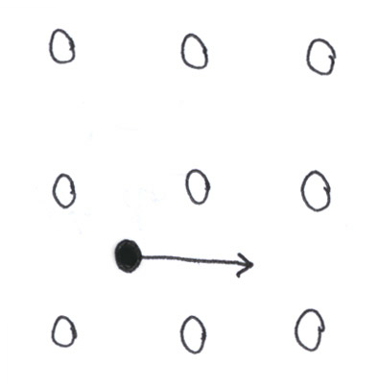

E_{diff} ≈ 0.5 – 1 eV
Larger values are for
bigger atoms

2. “Indirect” diffusion mediated by a point defect

Kinds of defects:
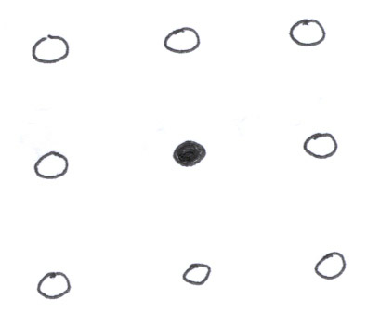
A. Substitutional

These atoms are largely
immobile

B. Interstitial
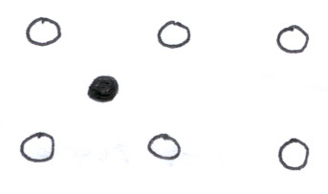

These atoms move
rapidly as we saw above

C. Vacancy

These “holes” can
also move, though
more slowly (since bonds
are broken, not strained)

At 0º K for typical dopants of Groups III and V, interstitial and vacancy defects are unstable with respect to substitutional (since these elements can form 4 bonds)

At higher temperatures, vacancies and interstitials can form with probability :

exp(–ΔG_{f,int}/kT) where ΔG_{f} is the free energy of
formation for the defect

or exp(–ΔG_{f,vac}/kT)

These defects eventually equilibrate with the surface (which is a source and sink for interstitials and vacancies)

Vacancies and/or interstitials can also be created or destroyed in nonequilibrium concentrations through various processing steps.

Example: TiSi₂ formation requires updiffusion of Si through the silicide, which takes Si from the bulk and injects vacancies into it.

Dopants move in ways mediated by the defects.

A. Vacancy mechanism

Self– or heteroatom moves
by hopping into a neighboring vacancy
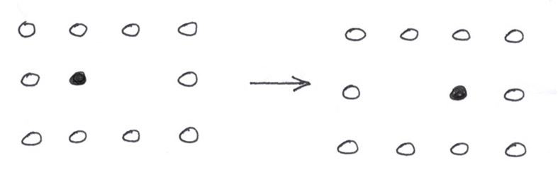

E_{diff} ≈ 3.5 – 4 eV

B. Interstitial mechanism

The exact name of mechanism depends on how interstitial atoms are created and destroyed. Campbell is fuzzy on this point.

1. “Kick-out” or “interstitialcy”
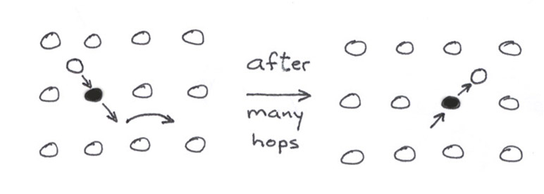
An interstitial atom (host or
foreign) kicks out an
atom on a lattice site.

E_{diff} ≈ 3 eV

2. “Dissociation” or “Frank–Turnbull”

A vacancy forms with creation of
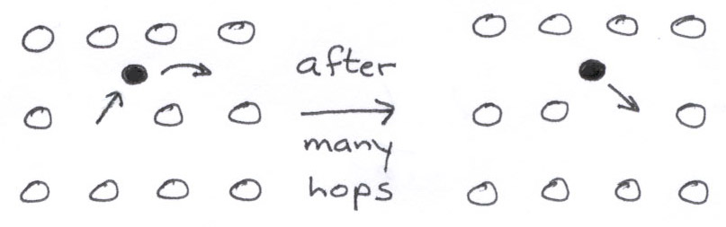
and interstitial, or is annihilated
by an interstitial

E_{diff} ≈ 3.5 – 4 eV

Note: an interstitial can be created by kick-out and destroyed by recombination with a vacancy or vice–versa, although one particular mechanism usually dominates in a given situation.

Lecture End ––––

