Lecture 23

Effects of Defect Charge

Vacancies and interstitials in Si can be charged. For example, the Si vacancy can carry charges, of +2, 0, –1, or –2. These charge states have deep energy levels within the bandgap:
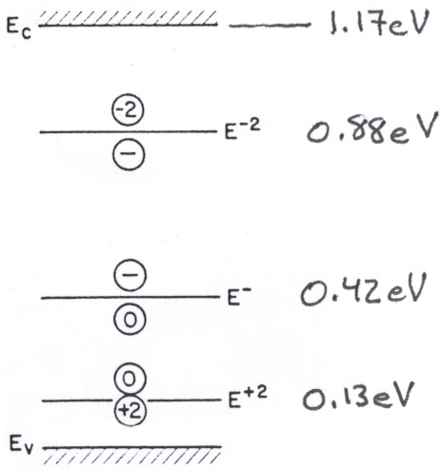

Si at 0ºK

To create a charged vacancy or interstitial, charge must be taken from near the Fermi level (on average) and transferred to the energy level of the defect. This is easier when E_{f} and the defect state are close.

Thus, in n-type Si V^{1–} and V^{2–} predominate, for example.

Charge affects the overall diffusivity two ways:

• Hopping diffusivity D^{i} for each charge state differs due to atomic
size and other effects
• Concentration of each species depends on E_{F}

The “total diffusivity” is given by (neglecting degeneracy factors):

D_{tot} = D²⁺[V²⁺]/n_{site} + D⁰[V⁰]/n_{site} + D–[V–]/n_{site} + D^{2–}[V^{2–}]/n_{site}

where n_{site} is the total concentration of lattice sites in the crystal.

It can be shown that this expression reduces to:

D_{tot} = D²⁺(p/n_{i})² + D⁰ + D–(n/n_{i}) + D^{2–}(n/n_{i})²

Uncharged vacancies are unaffected by doping.

These effects complicate the calculation of diffusion profiles where background carrier concentrations vary in space, as near junctions.

Diffusion Profiles

We can take two approaches to determining diffusion distances (which would set a junction depth, for example)

1. Simple, back of the envelope

In 3-dimensions, the random diffusive motion of a single atom is governed by:

x² = 6Dt

This is useful for estimating roughly how far a dopant goes in a given time.

2. Exact analytical solution of diffusion equations

Diffusion really takes place in response to a gradient in chemical potential. The system wants to reach a state where chemical potential is the same everywhere.

Under most conditions, chemical potential scales with concentration, so that it’s the concentration gradient that matters.

In full 3-dimensional form:

Fick’s First Law: J = – D ∇C

This is an empirical relation. Under ideal conditions (where there are no long-range attractive or repulsive interactions between dopant atoms), D is constant.

However, sometimes there are interactions or other complex effects that cause this equation to break down. Such complications are often treated by making D an empirical function of C.

Fick’s Second Law (involves a differential mass balance):

∂C/∂t = – ∇ • J = D∇²C

(assuming D is constant)

To solve the equation for C(x, y, z, t), we need an initial condition for t and 2 boundary conditions for each of x, y, z.

In many microelectronics applications, we are concerned only with 1-D diffusion into the wafer.

It’s almost always true that we have the following conditions:

IC: C(x,0) = 0

BC: C(x → ∞, t) = 0

For the other BC, we have two typical cases:

A. Constant source

This is a good approximation when we have a very thick layer of dopant oxide (for example) and short diffusion times, so that the layer is not significantly depleted.

Then, BC: C(0, t) = C_{o}

Solution: we use a so-called “similarity solution” to obtain

C(x, t) = C_{o} erfc(x/$\sqrt{\text{4D}t}$)

where erfc(y) = 1 – erf(y)

and $\text{erf}(y)=\frac{2}{\sqrt{π}}\int{\text{exp}(−z^{2})\text{dz}}$ (1)

The integral is not analytical: need to look up in a table or have suitable software.
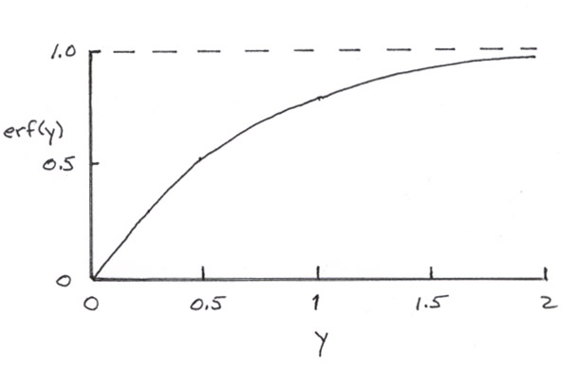

erf(0) = 0

erf(∞) = 1

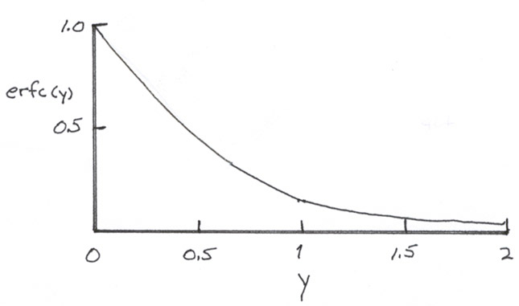
erfc(0) = 1

erfc(0) = 1

erfc(∞) = 0

Note: erf(y) is sometimes defined in terms of the area under a
standard normal curve. We can define two kinds of error
functions:

Eq (1): ${\text{erf}}_{\text{conc}}(y)=\frac{2}{\sqrt{π}}\int{\text{exp}(−z^{2})\text{dz}}$

Eq (2): ${\text{erf}}_{\text{norm}}(y)=\frac{1}{\sqrt{2π}}\int{\text{exp}(−{z^{2}}/2)\text{dz}}$

Then: erf_{conc}(y) = 2 erf_{norm}(y$\sqrt{2}$) – 1

Sketch of profiles:
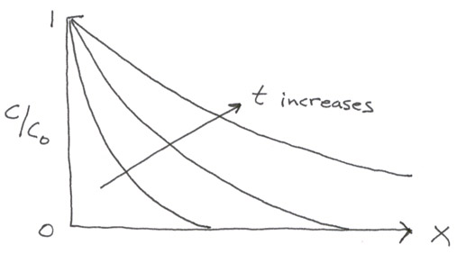

Compare to “back-of-envelope” estimate: x² = 6Dt ⇒ x = $\sqrt{6Dt}$

⇒ C/C_{o} = erfc(x/$\sqrt{\text{4D}t}$) = erfc($\sqrt{6Dt}$/$\sqrt{\text{4D}t}$) = erfc$\left(\sqrt{2/3}\right)$ = 0.248

Thus, the simple estimate calculates the value of x at which the concentration reaches about 1/4 of its maximum value.
B. Depletable source

This is a good approximation when we have a very thin layer of dopant oxide (for example) and long diffusion times, so that the layer looks like a delta function and is significantly depleted.

BC: dC(0, t)/dx = 0

(because there can be no flux through the surface)

Solution uses a “Green’s function” approach with the condition that the total amount of dopant is constant:

$\int{C(\text{x, t})\text{ dx }={\text{ Q}}_{o}}$
Solution:
C(x, t) = Q_{o}/(πDt)^{1/2} exp(–x²/4Dt)

A Gaussian shape:
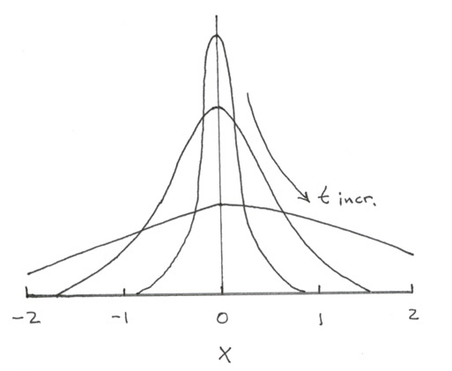

constant
area Q_{o}

Lecture End ––––

