Lecture 25

Bring and show chips with part of package removed.

Packaging

This is so-called “back-end” processing. Describes what happens after wafers are cut up into individual chips called “dice.”

Main purposes of package:

• Provide electrical contact between chip and outside world

• Remove excess heat

• Keep out contamination

Rough process outline:

• Bond back of die to mounting medium

See Handout 7 (Fig. 11-1 and 11.2)

Generally use hard solder (e.g., Au with 2%Si) or a polymer (e.g., Ag-filled epoxy or polyimide). Need high thermal and electrical conductivity.

• Connect bond pads on circuit side of chip to package leads

See Handout 7 (Fig. 11-5 and 11-4)

Leads are usually Kovar (Fe-Ni-Co alloy). Several methods exist: “wire bonding,” “tape-automated bonding,” “flip-chip.” Flip chip is now most common.
• Mold package into final form (& maybe encapsulate/seal)

See Handout 7 (Fig 11-6)

Package body is either plastic (cheap) or ceramic (more expensive but more robust, hermetic sealing). A new trend: multiple layers of metal in chip and multiple chips in package. Distinction between chip-level and package-level functions is becoming blurred.

There are many variations on these ideas, most of them proprietary.

Corrosion Issues

Problem: Electrochemical corrosion (oxidation) of metal leads by environment

Origins:

1. Direct acid attack

e.g. Fe + 2H⁺ → Fe⁺²
Ni + 2H⁺ → Ni⁺²
Co + 2H⁺ → Co⁺²

Kovar (Fe-Ni-Co alloy) is a common lead material for ceramic packages. These rxns solublize the metal.

2. Redox with other metals

e.g., Fe + Pb⁺² → Fe⁺² + Pb

The Pb comes from the low-T glass (PbO / ZnO / B₂O₃) used to seal a Cerdip package.

3. Stress in package

Metals oxidize more readily under stress. This is also a problem on metal bridges in winter.

Solution: Keep out worst contaminators.

A direct O₂ attack is not problematic because products are not soluble.

The worst actors are:

1. H₂O • donates H⁺ for acid attack.

• provides electrolytic medium, even at monolayer levels (2-D solution)

• dissolves redox products like NiCl₂

2. Na •Increases ionic strength of electrolyte, providing salt bridge component

Standard electrochemical cell (e.g. Ni)
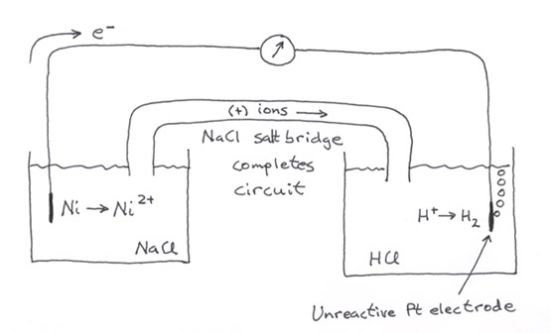

Inside the package with an inclusion of H₂O:
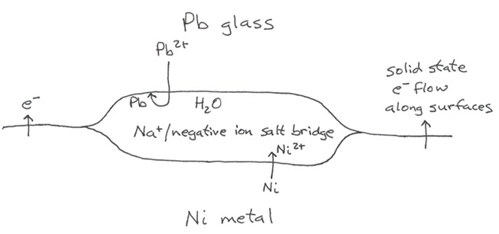

• exchanges readily with other (+) ions on oxide surfaces (ion exchange), so they can do electrochemistry.

3. Cl • Salt bridge electrolyte like Na

• Provides counterions for soluble metal redox ions (e.g. FeCl₂, NiCl₂, etc.) Other counterions (SO₄^{–2}) might precipitate.

• In (rare) zero-valent form is a potent oxidizer, e⁻ + Cl → Cl–. This can happen after plasma processing

Since H₂O, Na, and Cl are so ubiquitous, package processes and seals must be very effective at keeping them out.

Steady-State Heat Conduction

Need to remove heat. Mechanisms: • solid conduction
• natural or forced convection

See Handout 7 (Figure 11-9)

Radiation not important (as in Czocholski growth) because T is low, and q_{r} ∝ T⁴. Instead,

q = – k∇T

Conduction → use high thermal conductivity materials for package body, especially in multilayer ceramic (MLC) technology

e.g., Materials k (W / cm-°C)

most common → Al₂O₃ 0.34
toxic → BeO 1.84
plastic 0.002 (typical)

(Note: also need low dielectric constant to avoid RC propagation delays)

Convection → • At an interface, q = h (T–T_{surr})

• natural: h lowest

• forced: h higher, especially for liquids vs. gases

The heat transfer is pretty complicated in general. A simple configuration is treated in the homework.

Transient Heat Conduction - Thermocycling

Key parameter: expansion coefficient α

For liquids, we usually use coefficient of volume expansion. This is what you saw in ChE 370.

α_{v} = $\frac{\text{dV/dT}}{V}$ = $\frac{\text{dlnV}}{\text{dT}}$

For solids, it’s more useful to use coefficient of linear expansion:

α_{v} = $\frac{\text{dL/dT}}{L}$.

The relation between the two coefficients is:

α_{v} = $\frac{d(L)\text{/dT}}{L}=3\frac{\text{dL/dT}}{L}=3$α_{L}

Typical value for α_{L}: Metal: 1.5 × 10^{–5} °C^{–1}
Ceramic: 0.5 × 10^{–6} °C^{–1} (three times smaller)

So expansion ΔL of a given material is given by

ΔL = α_{L}LΔT

e.g. for Ni, α_{L} = 13.1 × 10^{–6} °C^{–1}, 0.2 cm long, 15°C thermocycle

ΔL = (13.1 × 10^{–6}) (0.2) (15) = 3.9 × 10^{–5} cm = 0.39 μm (small)

The problem is, this exerts huge forces. Consider the strain E = fractional change in length = ΔL/L, (here 3.9 × 10^{–5}/0.2 = 2 × 10^{–4})

Hooke’s Law: strain is linear in stress S: S = μE, where μ = elastic (or Young’s) modules (This law appears in different form for springs).

For Ni, μ = 45 × 10⁹ N/m² (units of pressure)

- S = (45 × 10⁹ N/m²) (2 × 10^{–4}) = 9 × 10⁹ N/m² = 90 atm!

There forces can rupture joints

(When the stress is uniaxial over area A, the force is F = SA)

When stress becomes too high, we get plastic deformation (Hooke’s Law breaks down).

Can also get slow deformation over time (creep)

Strain E

Plastic
deformation

Stress S

In general, the number of cycles a lead can undergo before failing from repeated plastic deformation scales as 1/E².

Lecture End ––––

