Lecture 26

Issues in Factory Design and Construction

• A fab is in many respects a chemical plant.

* costs $2 billion
* takes ~2-3 years to build
* process time is several weeks from start to finish
* throughput now at 20K wafer starts/month (WSM)
* in near future, throughput will be 30-40K WSM
* process steps will double in 10 yrs

• Recent hiring data from Intel and IBM indicates that a typical fab hires 25-30% ChE’s – fraction not exceeded by any other discipline.

Some context for fab construction: comparative industry features

• Bulk petrochemicals

Example: BP-Amoco

ROI goal ~6%, was 3% in mid-90s

Key features: * debottlenecking, optimization are crucial

* few process innovations

* profitability significantly impacted by mergers

• Consumer products

Example: Kraft:

ROI ~ 8%, was 3% a decade or so ago

Key features: * short product life cycle

* broad arrays of new products, heavily marketed

* technical sophistication often modest compared to
electronic device processing

• Microelectronics

Example: Intel

ROI in double digits

Key features: * high technological sophistication

* rapid introduction of improved technologies

* for microprocessors, price remains roughly flat
while performance increases according to
steep power law

* symbiotic relationship with software industry

Main point: Combination of rapid technology advance and high capital costs require detailed planning and coordination at a variety of levels.

See Handout, first page

Note: • The “zero” year is usually defined as the time at which the
first million units have been shipped.

• There are well-defined timelines for a variety of activities

• There are significant overlaps (and coordination) among the
various activities.

Fab-level construction issues

Siting Issues:

- access to good workforce (e.g., problems at Micron in Boise)
- government incentives
- environmental regulations
- access to water
- proximity to other parts of industry (San Jose, Research Triangle Park, Boston Rt. 301, Austin)
- cost of land

Design issues:

- ability to add/modify for future generations
- keep chemical handling (esp. gases) separate (~25% of space)
- const. T in critical areas (T ~1°C)
- anti vibration for lithography (~20% of building cost)
- air handling in clean rooms

Optimizing plant assets

A. Tools

- Tools used to be 30% of fab cost. Now >80%.
- Implanters, steppers, furnaces, etc, are $100K to $10M apiece.
- Requires lots of environmentally controlled floor space
- Yield levels are now near 90% – can’t improve much more. More attention to debottlenecking

e.g. Equipment is used only 30% of the time in production!

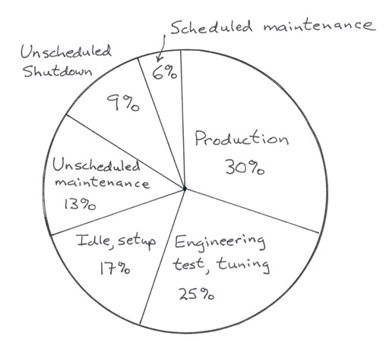

Unsch. shutdown →

• cancelled orders

• late materials

• operators quit

• software failures
(80% of total
shutdowns in
new equipment)

B. Consumables

- Substrate wafers
- Process chemicals

Minimizing costs requires that inventory levels be optimized:

- too much → excessive floor space, expiration of products with limited shelf life

- too little → shortages

C. Subcontractor relationships

Subcontracted services (due to high cost-of-ownership, COO)

• wafer growth
• assembly
• electrical test
• die preparation
• final test
• packaging
• sometimes implant (complex)

- must deliver promised work to subcontractor
- not put in erratic requirements
- include required paperwork

D. Data management

Increases productivity of process engineer → don’t want to spend time getting data

Types: − standard (good at job level: yield variance)
− ad hoc (equipment/process specific)
− analysis (piece of equipment or entire shift)

Software exists to help with this (manufacturing execution system)

Lecture End ––––

