


An Introduction to Design and Discovery

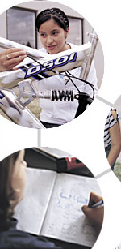
Experiencing Engineering
Through Design

An Introduction to Design and Discovery
Experiencing Engineering Through Design

The Intel® Innovation in Education Institutes Web resources contain all the materials you need to present a successful presentation including:
- This document
- Participant handouts
- Workshop slides

These presentation materials assume that you:
- Have education experience in the classroom
- Have taken the workshop
- Have thoroughly reviewed and are familiar with the workshop resources
- Are familiar with the Intel® Innovation in Education Web site
- Are familiar with using the Internet
- Have a high-speed Internet connection to use during the workshop

Technical Requirements
To give the presentation, you’ll need:
- Presenter's workstation equipped with:
- Windows Media Player* and a high-speed Internet connection
- Screen
- Computer projector
- Speakers (or speakers on the computer projector)
- Wireless mike (depending on room size and acoustics)

For more information, on the computer requirements, see Site Recommendations www.intel.com/education/site_support/recommendations.htm

Preparation
Make sure you have spent time going over the Design and Discovery resource before your presentation so you are familiar with its layout and content.

Prepare for any video viewing from the Design and Discovery Web pages: For optimal viewing, download the introductory video from the Web site or transfer the file from the CD to the presentation workstation desktop.

Also download one of the project example video clips (in Resources) and the rolling toy example (Session 5A). Test and adjust viewing screen size on the media player. Test and adjust audio.

If you have a longer session and will be doing the optional activity, Build a Better Paper Clip, be sure to prepare the materials. At a minimum, you will need
sample paper clips, wire, wire cutters, and needle-nose pliers. See Session 1A for details.

Day of the Presentation
Open two browser windows on the presenter’s workstation. During the presentation, you will use one browser for the presentation slides and the other for the Intel® Innovation in Education Web site. You’ll toggle between these browser windows during the presentation.

An Introduction to Design and Discovery
Experiencing Engineering Through Design

Goals
- Introduce youth to the principles of engineering and design
- Build problem-solving skills through a hands-on experience
- Prepare students for Intel ISEF-affiliated fairs or other engineering and science fairs
- Create awareness of engineering as a career option

Agenda

Total Estimated Time: 1–2 hours (includes optional experience)
Topic | Estimated Time | Slide Numbers
- Welcome | 5 minutes | Slides 1–3
- Overview and Goals | 5 minutes | Slides 4–5
- How Do We Learn About Engineering? | 10 minutes | Slides 6–10
- Explore the Resource | 5 minutes | Slides 11–13
- Visit the Curriculum | 15 minutes | Slides 14–19
- Optional: A Design and Discovery Experience | 45 minutes | Slides 20–24
- Program Implementation | 5 minutes | Slides 25–26
- Resources | 5–10 minutes | Slides 27–28
- Design and Discovery in Your Community | 5–10 minutes | Slides 29–30
- Wrap Up | 5 minutes | Slide 31

Facilitator Tips During the Workshop

Slide 1




Key Points Notes
Time: 5 min. Slides 1–3

Display this slide as participants enter the room.

If appropriate, introduce yourself and have participants introduce themselves.

Slide 2
About Intel in Education
The Intel® Innovation in Education initiative:
- Has invested more than $700 million worldwide in education efforts through 2003
- Collaborates with leaders from education, governments, industry, academia, and research organizations
- Designs and delivers programs in more than 50 countries on six continents
- Gives teachers tools, strategies, and resources, free-of-charge, that they can use to make a difference in the classroom
This long-term, sustained initiative consists of several programs:
- Intel® Innovation in Education Web site
- Intel® Teach to the Future
- Intel Computer Clubhouse Network
- Intel sponsored science competitions
  - Intel Science Talent Search (Intel STS)
  - Intel International Science and Engineering Fair (Intel ISEF)
Key Points Notes
Time: 5 min. Slides 1–3

Provide an overview of Intel’s efforts in and commitment to education worldwide.

Slide 3
Intel® Innovation in Education Web Site
Intel® Innovation in Education home page
www.intel.com/education
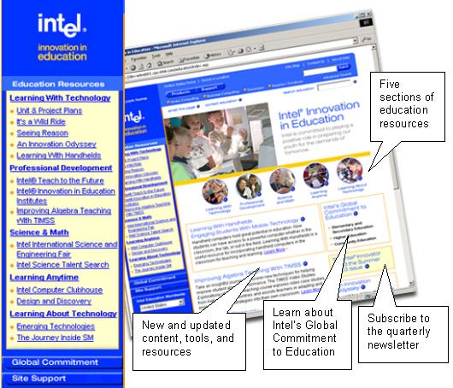
Key Points Notes
Time: 5 min. Slides 1–3

Display the Intel® Innovation in Education Web site home page to make participants familiar with it as a source of Intel resources for educators.

Point out the location of Design and Discovery on the Intel® Innovation in Education home page (in the left navigation bar under “Learning Anytime”).

Slide 4
Overview and Goals
Design and Discovery is a free curriculum and supporting resources for implementing an extended learning experience to interest youth in design and engineering.
In this presentation, you will learn about the complete Web-based resource to help you implement a Design and Discovery program in your area.
Design and Discovery Program Goals:
- Introduce youth to the principles of engineering and design
- Build problem-solving skills through a hands-on experience
- Prepare students for Intel ISEF-affiliated fairs or other engineering and science fairs
- Create awareness of engineering as a career option

Key Points Notes
Time: 5 min. Slides 4–5

Share the presentation and Design and Discovery program goals.

Point out the following:
- The curriculum is a free Web-delivered resource. It is not an online course.
- Design and Discovery was created for the facilitator—students do not go to the resource to “take the course.”

Slide 5
Agenda

How Do We Learn About Engineering?
Explore the Resource
- Introductory video
- Design and Discovery Web Resource

Curriculum
- Navigation, activities, and printable curriculum

Optional: Design and Discovery Experience
- Build a Better Paper Clip
- The Design Process

Implementation
Resources
Design and Discovery in Your Community
Wrap Up
Key Points Notes
Time: 5 min. Slides 4–5

Briefly present the agenda.

Point out whether you will be doing the optional Design and Discovery experience.

Slide 6
How Do We Learn About Engineering?
Use the handout to answer the following questions, then share your answers with a partner.
- Do you know an engineer?
- Did you ever want to become an engineer?
- What experiences introduced you to engineering?
- What experiences introduce young people to engineering?
- How do we interest young people in engineering?
Key Points Notes
Time: 10 min. Slides 6–10

Have participants answer the engineering questions on their handout, "How Do We Learn About Engineering," and then share with a partner.

Facilitate a discussion around these questions. Discuss:
- What engineering is
- Why engineering is important (engineers create)
- What characteristics engineers share (creative, synthesizers, problem-solvers…)

Slide 7
Understand and Create
"A scientist discovers that which exists; an engineer discovers that which never was."
— Dr.Theodore von Karman, Aerospace Engineer (1881-1963)
Key Points Notes
Time: 10 min. Slides 6–10

Discuss this quote. Have participants share ideas about the differences and similarities between engineers and scientists. (For example: scientists discover the “laws of nature,” while engineers design useful things.)

Slide 8
Design Opportunities
Look around the room or walk through your day and begin to take notice of design opportunities.

Everything outside of the natural world has been designed and engineered.

- What things, services, or processes could be improved?

- What improvements would you make?

Key Points Notes
Time: 10 min. Slides 6–10

Begin a discussion about all the designed and engineered products in our everyday life. Call out a few items…chairs, bicycles, razors… and talk about the different designs for each and how the designs are dependent on user needs.

Discuss the above questions and have participants write a list of design opportunities on their handout and share them with a partner.

Slide 9
The Design Process
The design process guides the development of an idea to a working prototype. See Session 1B Handout. The steps in the design process are cyclical and include:
- Identify a design opportunity.
- Research the design opportunity.
- Brainstorm possible solutions to the problem.
- Write a design brief.
- Research your solution.
- Refine your solution.
- Prepare design requirements and conceptual drawings.
- Build models and component parts.
- Build the prototype.
- Improve your solution. Test, evaluate, and revise.

Key Points Notes
Time: 10 min. Slides 6–10

Introduce the design process by having participants look at the Session 1B sheet in their handout.

Explain that these are the steps that students follow to come up with an idea and ultimately create a working prototype. Emphasize that they are cyclical and are revisited throughout the design process.

Point out that participants just began step 1 of the design process.

Slide 10
The Design and Discovery Approach
Design and Discovery is an inquiry-based, hands-on design and engineering program for students in middle grades:
- Think carefully about everyday things in the designed world
- Identify problems and needs based on their interests
- Follow a design process to create and build working prototypes
- Share solutions with peers, family, and their community
Key Points Notes
Time: 10 min. Slides 6–10

Explain that the Design and Discovery approach is for students to look for design opportunities in the world around them. The Design and Discovery curriculum is unique because it encourages youth to identify and design solutions to problems that are significant in their lives.

Provide a few examples of students identifying a problem based on their interests (details in Project Examples):
- The student who played the bass and couldn’t keep her fingers together.
- The student who had a guinea pig, but didn’t know how to provide water for it when her family went out of town.

Slide 11
Explore the Resource: A Video Introduction
The short introductory video presents the Design and Discovery experience. It's available online (and on CD) and can be shared with others who are interested in the program.
As you watch the video consider:
- What do you want to know more about?
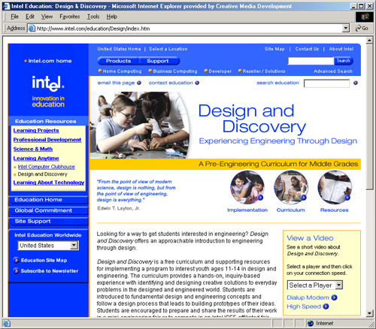
Key Points Notes
Time: 5 min. Slides 11–13

Introduce the video.

Tell participants to make notes of any questions, comments, or observations on their handout.

Play and project the video from your computer (3 minutes).

NOTE: The video is available online for downloading, or on a CD.

Slide 12
Discuss the Video
- What stands out from the video?
- In what ways might the video be useful?
- What more do you want to know about Design and Discovery?
Key Points Notes
Time: 5 min. Slides 11–13

With the entire group, discuss the questions, comments, or observations that people made.

NOTE: You may answer some of their questions throughout the rest of your presentation.

Slide 13
Design and Discovery Web Resource
www.intel.com/education/design
Three main sections to the site:
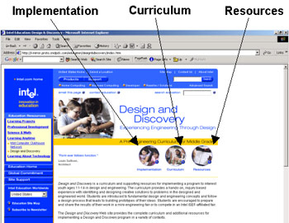
Key Points Notes
Time: 5 min. Slides 11–13

Point out how the Web pages are structured with three main sections: Implementation, Curriculum, and Resources. These sections can also be navigated from the blue strip on the top of each page.

Mention that there is also a link at the top of the page that takes you to the Design and Discovery main landing page.

Slide 14
Visit the Curriculum
The Curriculum consists of 18 sessions that are organized in six sections.
- Understanding the Design Process
Introduction to designed world and the design process

- Engineering Fundamentals
Background in electrical, mechanical, and materials engineering principles
- Thinking Creatively About Problems and Solutions
Identify interesting problems and possible solutions
- Making, Modeling, and Materializing
Build and test models, components, and materials
- Prototyping
Refine projects into working prototypes
- Final Presentations
Plan or participate in an event to showcase projects
Key Points Notes
Time: 15 min. Slides 14–19

View the Curriculum page. Explain how the Design and Discovery curriculum is organized.

Direct the participants to the Overview and Sequence sheet in their handout packet.

NOTE: You can toggle (ALT+TAB) between the Curriculum page that shows the “table of contents” (including the six curriculum sections and all the sessions) and your presentation.

Slide 15
Curriculum Navigation
The Web resource has a separate navigation area at the top of each page of the Curriculum section.
- All sessions can be navigated from any page within the curriculum
- A detailed session description appears when you roll your cursor over the session number.
Visit Curriculum to see how this works.
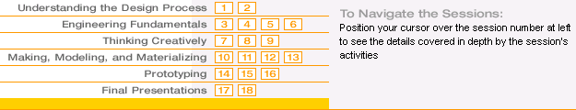
Key Points Notes
Time: 15 min. Slides 14–19

Using the Curriculum Web page, show how the navigation (“the calculator”) provides a quick link to all the sessions. (It gives a brief description of each session when the cursor is over the session number.) Click a session number to go directly to that session.

Slide 16
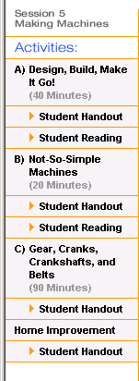
Curriculum Activities
Sessions: Each session typically begins with a warm-up discussion followed by two to four hands-on activities or explorations done in small groups.
Activities: Each activity includes directions for the facilitator and a student handout to document student ideas and results.
Readings: Some sessions include brief background reading, further research, or real-world examples of design and engineering professionals.
Home Improvement: Many sessions include additional investigations which are completed at home with input from family members.

Key Points Notes
Time: 15 min. Slides 14–19

Point out the structure of the navigation on the session and activity pages:
- Each activity has a facilitator page and a Student Handout.
- Many sessions have Student Readings.
- Some sessions include a Home Improvement activity, which are completed at home with input from family members.
- Supplies are listed for each session, as well as for each activity.

Slide 17
Supporting Successful Learning
Activity pages provide:
- Detailed step-by-step instructions
- Photos and diagrams
- Demonstration video clips for complex constructions
For example, Session 5A: Design, Build, Make it Go!
This construction of a rolling toy includes sequenced images of the process and a video clip that demonstrates construction steps.
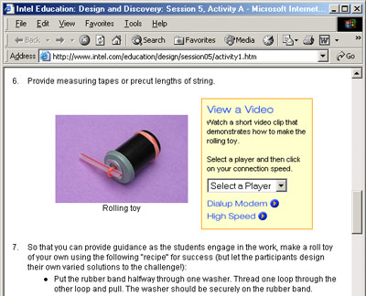
Key Points Notes
Time: 15 min. Slides 14–19

Explain that activity pages include photos, diagrams, and video clips to help facilitate the activity. For example: go to Session 5A to show the location of a demonstration video.

Explain that the video was made with the facilitator in mind—so they understand the construction and can then help guide the students.

Show the video (2 minutes), if time allows. (Play a downloaded version from your computer.)
NOTE: There are two more demo videos: “Light Emitting Diodes” (Session 4C) and “Crankshaft Toy” (Session 5C).

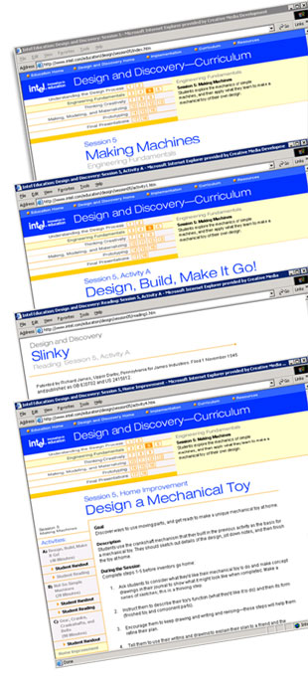
Slide 18
Let's Look at Learning Activities
Session 5: Making Machines
Session Activity
Session 5A: Design, Build, Make it Go!
Supplemental Reading
Session 5A: Slinky*
Home Improvement
Session 5: Design a Mechanical Toy
Key Points Notes
Time: 15 min. Slides 14–19

Show Session 5 and click through the session, activity, reading, and Home Improvement pages to explain the structure of each session.

Answer questions about the structure of the sessions and activities.

Slide 19
Printable Curriculum
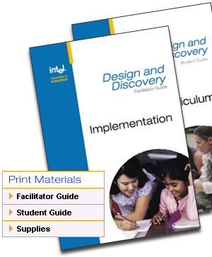
The Web resource provides a Facilitator and a Student Guide, each formatted with page numbers for easy printing.
The Facilitator Guide contains session and activity descriptions and all student handouts and readings, and Implementation and Resource materials.
The Student Guide contains all activity handouts, readings, and pages for notes.
The Supplies section lists all materials and tools for each activity.
Key Points Notes
Time: 15 min. Slides 14–19

Explain that the materials can be printed. On the Curriculum page, click Facilitator Guide under “Print Materials” to show that the curriculum can be printed by an individual session or as a whole unit.

Point out that the Implementation and Resource materials can also be printed from here.

Explain that each student gets a printed Student Guide.

NOTE: If you are going to do the optional activity, Build a Better Paper Clip, continue to the next slide. Otherwise go to slide 25 (Program Implementation).

Slide 20
Optional: A Design and Discovery Experience
Are you ready for a preliminary design experience with an everyday item?

Key Points Notes
Time: 45 min. Slides 20–24

Optional:
Engage participants in a hands-on design and engineering experience. (This is the first activity in the Design and Discovery curriculum.)

Be ready with these supplies for the activity:
- Examples of various paper clips
- Wire
- Wire cutters and needle-nose pliers
- Participant handouts

Slide 21
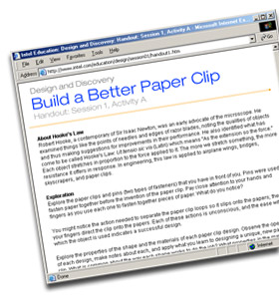
Activity 1A: Build a Better Paper Clip
For this activity, you'll work from a copy of the Student Handout for Build a Better Paper Clip.
Please read through the handout.
Key Points Notes
Time: 45 min. Slides 20–24

Distribute a variety of paper clips to participants so they can explore the design of each one.

Direct the participants to the student handout in their packet (Session 1, Activity A).
NOTE: You can use the link on the Web page to show the handout.

Slide 22
Activity 1A: Exploration
Examine the different paper clips carefully and begin to think about the following:
- Observe the action needed to separate the paper clips so they slip onto papers.
- Study the shape of the paper clip design. Think about the advantages and disadvantages of its form.
- Explore the material paper clips are made of and notice how freely the material bends and springs back, retaining the ability to "hold" items (evidence of Hooke's Law).
Key Points Notes
Time: 45 min. Slides 20–24

Have participants examine the paper clips carefully and make observations.

Slide 23
Activity 1A: Design Challenge
Build a Better Paper Clip: Use wire to design, engineer, and test a new paper clip prototype

Design Requirements:
- Must be unique
- No bigger than 2 inches
- Must hold 10 pieces of paper together
- Main material must be wire
- Must not be a hazard to small children

Key Points Notes
Time: 45 min. Slides 20–24

Distribute wire and needle-nose pliers.

Provide ample time for the participants to develop and test new paper clip designs.

Explain that activities typically conclude with whole group discussion or brief reports to share results of small group work. Time permitting, have participants show and demonstrate their paper clip designs.

Mention that there is a reading for 1A that can be done at home.

Slide 24
Activity 1B: The Design Process
Activities in the Design and Discovery curriculum build upon the work in previous sessions and activities.
The next activity in Session 1 builds upon students' experience with re-engineering a paper clip as a common reference point for introducing The Design Process.
Discuss:
- How does the paper clip experience provide a taste of the design process?
Key Points Notes
Time: 45 min. Slides 20–24

Direct the participants back to the Session 1B handout (The Design Process). (You can use the link on the slide to show the handout on the screen.)

Discuss as a whole group: How does the paper clip experience provide a taste of the design process?

NOTE: The next activity, 1B: Toothpaste Cap Innovations, is not performed in this workshop, but it should be mentioned:

Explain that in Toothpaste Cap Innovations students apply the design process to another everyday object—a toothpaste cap—and that all resources for the activity are available online.

Continue to the next slide to resume your explanation of the Design and Discovery Web resources.

Slide 25
Program Implementation

The Implementation section of the Web resource will help answer questions and provide the background needed to plan a program.
Organizing a Program
Helps you plan a program to fit your needs
- Formal Education
- Informal Education
- Mentors
- Publicity
Using the Curriculum
Assures that the student experience is well supported
- Curriculum Structure
- Scheduling Options
- Field Trips
- Supply Shopping List
Participating in Fairs
Provides information on how students can present their projects
- Intel ISEF
- Hosting a Fair
- Other Fairs
Key Points Notes
Time: 5 min. Slides 25–26

Explain each of the Implementation sections. View the pages on the Web as you explain them.

Slide 26
Sample Implementation Pages
Modify sample pages to assist in your implementation of the program.
- Sample Mentor Application
- Sample Press Release
- Sample Letter to Parents
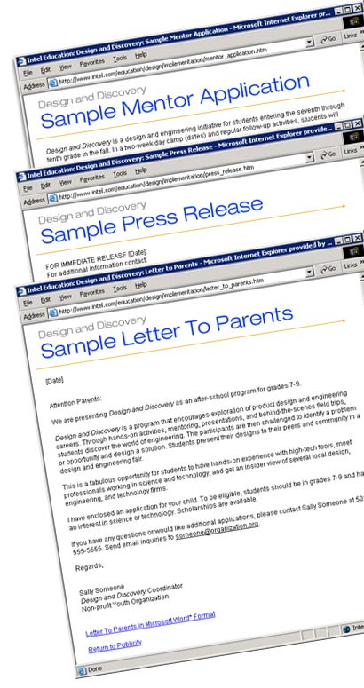
Key Points Notes
Time: 5 min. Slides 25–26

Use the Sample Mentor Application, Press Release, or Letter to Parents to show an example of the support materials offered in the Implementation section.

Explain that these are Microsoft Word documents that can be modified to meet the needs of a program.

Slide 27
Resources
The Resources section provides additional materials that may enhance your program.
- Research Resources
Annotated bibliography of Web sites and publications
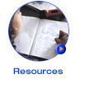
- What Do Engineers Do?
Supplemental readings about engineers' experiences
- Supplemental Design Investigations
Additional engineering and design opportunities
- Project Examples
Sample student projects with video clips of students
- Girls and Engineering
Research supporting the philosophy and approach used in Design and Discovery

Key Points Notes
Time: 5–10 min. Slides 27–28

Explain each of the Resources sections. View the pages on the Web as you explain them.

Slide 28
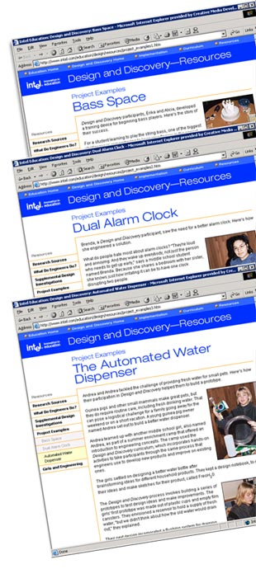
Project Examples
Project Examples in the Resources section give examples of students' designs.
- Bass Space
- Dual Alarm Clock
- Automated Water Dispenser

Key Points Notes
Time: 5–10 min. Slides 27–28

View the Project Examples in the Resources section.

Show the video clip called “Bass Space” (about 3 minutes), if time permits. (Play a downloaded version from your computer.)

Explain that this is an example of former Design and Discovery students.

Point out that participants have a copy of a project example in their handouts.

Slide 29
Design and Discovery in Your Community
Discuss:
- How could Design and Discovery be implemented in your community? What context (after-school club, inter-session, summer program)?
- What would you need to do in order to implement Design and Discovery?
- Who else could you tell about Design and Discovery?
Key Points Notes
Time: 5–10 min. Slides 29–30

Discuss:
- How could Design and Discovery be implemented in your community? What context (school, after-school program, summer camp)?
- What would you need to do in order to implement Design and Discovery?
- Who else could you tell about Design and Discovery?

If participants mention barriers to implementing a Design and Discovery program, discuss ways to overcome those barriers.

Slide 30
From a Facilitator
"It's fascinating to watch these girls progress through the steps of engineering. They have such a good time, making something tangible."
—Jill Barrett
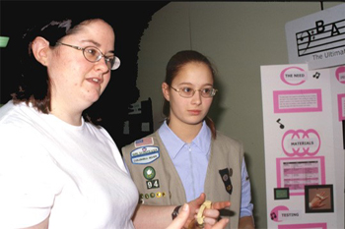
Key Points Notes
Time: 5–10 min. Slides 29–30

Emphasize the positive responses that facilitators have had after conducting a Design and Discovery workshop, Explain that many return the following year to facilitate another Design and Discovery program.

Slide 31
Wrap Up
Any questions?
- Where to find answers to your questions
- Next steps

Please complete the online session evaluation at:
www.inteleducation.com/institute
Key Points Notes
Time: 5 min. Slide 31

Ask if there are any questions.

Wrap up the workshop.

Thank participants for attending.

Have participants complete the online session evaluation.

