


 Emerging Technologies in Education
Understanding and Implementing New and Promising Technologies

Emerging Technologies in Education
Understanding and Implementing New and Promising Technologies

The Intel® Innovation in Education Institutes Web resources contain the materials you need to present a successful workshop including:
- This document
- Workshop slides

NOTE: There are no participant handouts for this workshop.

These workshop materials assume that you:
- Have education experience in the classroom
- Have taken the workshop
- Have thoroughly reviewed and are familiar with the workshop resources
- Are familiar with the Intel® Innovation in Education Web site
- Are familiar with using the Internet
- Have a high-speed Internet connection to use during the workshop
- Are comfortable using and explaining the technologies covered in the workshop (weblogs, handhelds, syndication, etc.) as well as facilitating discussions of how they might be used in education

Technical Requirements
To give the workshop, you’ll need a technology lab setting with high-speed Internet access and the following equipment:
- Presenter's computer equipped with:
- A computer with a high-speed Internet connection
- Screen
- Computer projector
- Wireless mike (depending on room size and acoustics)
- Computers with high-speed Internet connection for participants
(maximum of 2 participants per workstation)

For more information, on the computer requirements, see Site Recommendations www.intel.com/education/site_support/recommendations.htm

Preparation
Make sure you have spent time going over the Intel® Innovation in Education Web site before your presentation so you are familiar with its layout and content.

Set up a weblog to be used by participants during the workshop for them to post their comments, ideas, and thoughts.

Day of the Presentation
Open two browser windows: one to the workshop slides and another to the Intel® Innovation in Education Web site. You’ll toggle between these browser windows during the workshop.

Emerging Technologies in Education
Understanding and Implementing New and Promising Technologies

Goals
Learn how to identify emerging technologies and adapt them for education.
- Increase knowledge of important emerging technologies in education
- Learn about free resources for learning more about using emerging technologies in education
- Use a weblog to record activities, events, and strategies gleaned from the workshop

Agenda

Total Estimated Time: 2 hours 20 minutes

Topic | Estimated Time | Slide Numbers
- Welcome | 5 minutes | Slides 1–3
- Overview and Goals | 5 minutes | Slides 4–5
- Emerging Technologies | 10 minutes | Slides 6–7
- Explore Weblogs | 45 minutes | Slides 8–14
- Use Handhelds | 45 minutes | Slides 15–19
- Review Other Technologies  - Syndication  - Wireless connectivity  - Collaboration tools | 20 minutes | Slides 20–23
- Wrap Up | 10 minutes | Slide 24

Facilitator Tips During the Workshop


Slide 1





Key Points Notes
Time: 5 min. Slides 1–3

Display this slide as participants enter the room.

If appropriate, introduce yourself and have participants introduce themselves.

Slide 2
About Intel in Education
The Intel® Innovation in Education initiative:
- Has invested more than $700 million worldwide in education efforts through 2003
- Collaborates with leaders from education, governments, industry, academia, and research organizations
- Designs and delivers programs in more than 50 countries on six continents
- Gives teachers tools, strategies, and resources, free-of-charge, that they can use to make a difference in the classroom
This long-term, sustained initiative consists of several programs:
- Intel® Innovation in Education Web site
- Intel® Teach to the Future
- Intel Computer Clubhouse Network
- Intel sponsored science competitions
  - Intel Science Talent Search (Intel STS)
  - Intel International Science and Engineering Fair (Intel ISEF)
Key Points Notes
Time: 5 min. Slides 1–3

Introduce and review the purposes of the Intel® Innovation in Education initiative and its associated programs worldwide.

Slide 3
Intel® Innovation in Education Web Site
Intel® Innovation in Education home page
www.intel.com/education
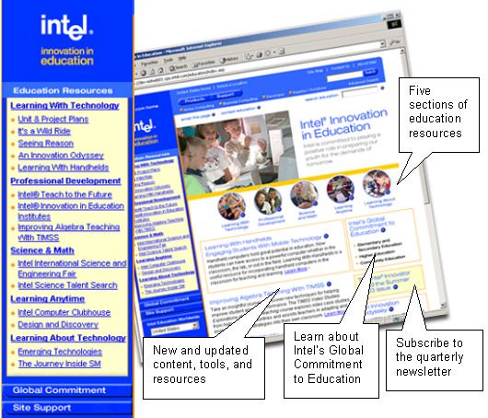
Key Points Notes
Time: 5 min. Slides 1–3

Display the Intel® Innovation in Education Web site home page to make participants familiar with it as a source of Intel resources for educators.

Point out the location of Emerging Technologies on the Intel Innovation in Education home page (in the left navigation under Learning With Technology).

Slide 4
Overview and Goals
Learn how to identify emerging technologies and adapt them for education.
- Increase knowledge of important emerging technologies in education
- Learn about free resources for learning more about using emerging technologies in education
- Use a weblog to record activities, events, and strategies gleaned from the workshop
Key Points Notes
Time: 5 min. Slides 4–5

Present the goals of the workshop to set the stage for the concepts and activities to follow.

Slide 5
Agenda

Emerging Technologies
- Adapting for education
Explore Weblogs
- Explore education-focused weblogs
- Begin using your own weblog
- Post your first weblog
Use Handhelds in Education
- Explore Learning With Handhelds Web resources
- Read online resources on your handheld
Review Other Technologies
- Syndication
- Wireless connectivity
Wrap Up
Key Points Notes
Time: 5 min. Slides 4–5

Briefly present the agenda to be covered in the workshop.

Slide 6
What Is an Emerging Technology?
An "emerging technology" is, in its simplest sense, one that is new to you, your school, or your district.
More broadly, emerging technology refers to cutting edge technologies that are not usually developed with education in mind.
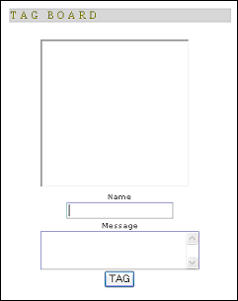
"Tag Board" is a weblog-based chat tool which allows users to post notes, comments, and responses. It is available for free at www.tag-board.com.*
Key Points Notes
Time: 10 min. Slides 6–7

Explain “emerging technology” using the points on the slide.

Ask participants about technologies that are new to their schools and have participants use the Tag-Board (or chat) to post or their responses.

Slide 7
Adapting Technologies for Education
IDENTIFY: What does this new technology allow a user to do?
ISOLATE: What are the most important features/functions?
ANALYZE: Where do these features/functions show up in education?
APPLY: Could this new technology be applied to improve/enhance that task?

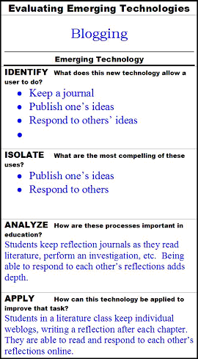
Key Points Notes
Time: 10 min. Slides 6–7
Explain the ways to adapt technologies for education: identify, isolate, analyze, and apply.
- Select one of the technologies from the responses to the question on the prior slide.

continued on next page

- Identify clearly what the selected technology is and what it does.
- List the important features of the selected technology.
- Explain the listed features in the context of current educational practices.
- Brainstorm how this technology might be used well in the classroom.

Slide 8
Explore Weblogs
What is a weblog, or simply, "blog"?
- Personal publishing
- Blog items are date-stamped and shown in reverse-chronological sequence
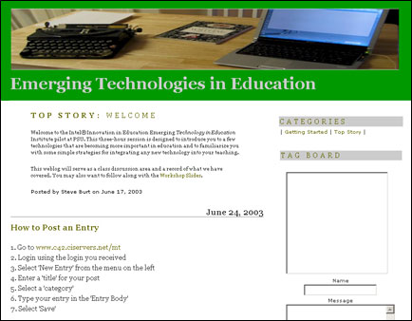
The companion Emerging Technology workshop weblog can be viewed at www.c42.ciservers.net/users/pilot*.

Key Points Notes
Time: 45 min. Slides 8–14

Explain the terms “weblog” and “blog.” Briefly explain how a weblog is used.

Ask participants if they have ever used a blog?

- Have participants view one of the Institutes’ weblogs at http://institutes.edweblogs.org.

- Use the Resources section (on the right column of the blog) to view other weblog sites.

Slide 9
Anatomy of a Post
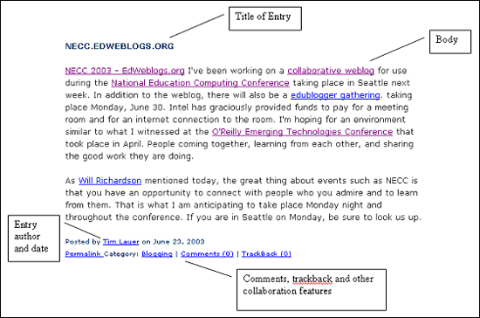
Key Points Notes
Time: 45 min. Slides 8–14

Using the example on the screen, or another example, show the main features of a weblog:
- Posting
- Time/date-stamped
- Links and blogrolls
- Commenting

Slide 10
Post to a Blog
We will be using a blog throughout this workshop.
- You can access the blog anytime from anywhere with Internet access.
- You will use the blog throughout the workshop to add posts and respond to other postings.
Post your answer to the following questions using a blog:
- What are the most effective technologies used in education?
- What are current technologies that could be adapted for use in education?
- What are my biggest fears of using technology in education?
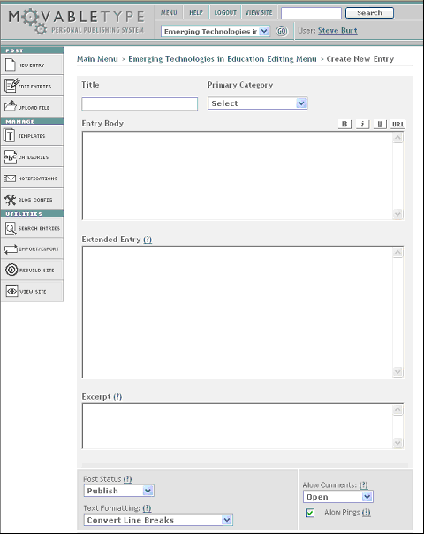

Key Points Notes
Time: 45 min. Slides 8–14

Explain how you will be using a blog throughout the workshop. Visit http://institutes.edweblogs.org/.

Have participants create a blog with their answers to the questions on the slide.


Slide 11
Use Blogs in Education

Why are blogs important?
- Distributed knowledge
- Frequently updated and current
- Social and fun
What do they do?
- Personal publishing
- Connect with disparate communities

Key Points Notes
Time: 45 min. Slides 8–14
Explain the value of blogs.

Provide examples of how blogs might be used in education,

View one of the following:
- The Intel® Innovator article about blogging (shown on the slide) www.intel.com/education/projects/news/vol_05/elementary2.htm
- An Innovation Odyssey stories about blogging (Story numbers 299 through 303).
www.intel.com/education/odyssey/Story.aspx?StoryID=299

Slide 12
View a Blog
Weblogs in Education
”Using Weblogs in Education” by Will Richardson
www.weblogg-ed.com*

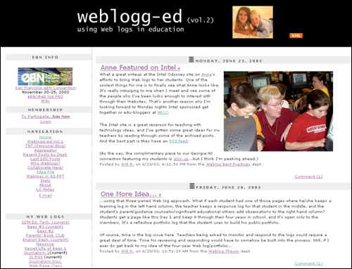

Key Points Notes
Time: 45 min. Slides 8–14

Examine the blog by Will Richardson.

NOTE: If you prefer, you may use any other education weblog listed in the right-hand column of any of the Institutes’ weblogs).

Slide 13
Personalize Your Blog
You can modify your blog:
- Use categories
- Add links/blogrolls
- Change the look-and-feel
- Use calendar, archives
- Add graphics
- Trackback

Key Points Notes
Time: 45 min. Slides 8–14

NOTE: This slide is optional—to be used if time permits.

Using a real blog, demonstrate its features (listed on the slide).

Slide 14
Set Up a Blog for Use in Education
Institute Blog
- Edweblogs is the clearinghouse for blogs accompanying each Institute hosted by Intel® Innovation in Education www.edweblogs.org*
General
- Blogger provides a basic introduction, support, and even hosting.
www.blogger.com*
Key Points Notes
Time: 45 min. Slides 8–14

Explain how to set up a blog for use in education.

Ask if there are any questions about using blogs.

Slide 15
Using Handhelds in Education
Handhelds, PDAs, and cell phones in the classroom:
- What is a handheld computer?
- How should schools deal with these technologies?
- How can they be used to positively effect learning?
Discuss the following questions. Post your answer on your blog.
- Which emerging technologies (devices) are you seeing students use? (One example is cell phones.)
- How should schools deal with these technologies?
- How can they be used to positively effect learning?
Key Points Notes
Time: 45 min. Slides 15–19

Mention that the workshop will cover another technology—the use of handhelds in education.

Discuss the questions on the slide as a large group, or in smaller groups.

Have participants post a blog with their answers to the questions on the slide.

Distribute handhelds for participants to use and become familiar with (if available).

Slide 16
Learning With Handhelds Web Resources
Learning With Handhelds Web Resources
www.intel.com/education/handhelds
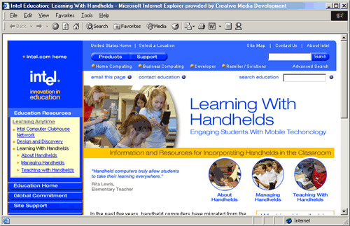 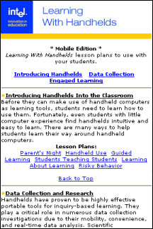

Key Points Notes
Time: 45 min. Slides 15–19

Explain about the Learning With Handhelds Web resources on the Intel® Innovation in Education Web site.

View the Learning With Handhelds Web pages.

Slide 17
Teaching With Handhelds
- How can handhelds extend learning?
- Power and mobility
- Findings from research
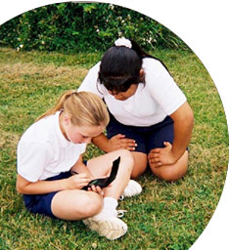
Key Points Notes
Time: 45 min. Slides 15–19

Discuss the questions on the slide.

Slide 18
Review Lesson Plans
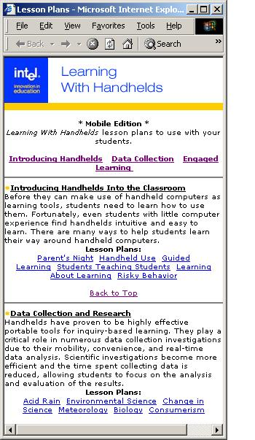
Key Points Notes
Time: 45 min. Slides 15–19

Explain that lesson plan ideas for using handhelds can be viewed on a handheld. This page shows how it appears to a mobile user.

If participants have handhelds with them, they might try accessing these resources.

Slide 19
Post Blog About Handhelds
Post a blog responding to one of the following questions:
- How does your school currently use handhelds?
- How do you envision handhelds being used by students in your school?
Key Points Notes
Time: 45 min. Slides 15–19

Determine whether participants have questions about using handhelds as a teaching resource.

Have participants post a blog with their answer to one of the questions on the slide.

Slide 20
Review Other Technologies
There are a wide variety of technologies in use and being developed.
- How to adapt them for education
- Additional value added

Key Points Notes
Time: 20 min. Slides 20–23

Discuss cell phones and any technologies identified by participants in response to questions on Slide 6.

Stress that the workshop has covered two technologies that might be used in education: weblogs and handhelds. There are other technologies, and the remainder of the workshop will cover a few.

Slide 21
What Is Syndication?
- Delivers updated content to your site
- One time setup
- A way to share information with staff and the community
How can syndication impact education?
- An Innovation Odyssey example
Setting it up
- HTML, Javascript, and XML, modified to your needs
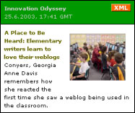

Key Points Notes
Time: 20 min. Slides 20–23
Explain what syndication is and how it works.

Show an example of how An Innovation Odyssey has been syndicated. Often, it is best to go to www.intel.com/education/syndication and walk through the syndication pages.

Explain the requirements (what it takes) to syndicate An Innovation Odyssey.

Slide 22
Wireless Connectivity
Types
- Wireless Fidelity (WiFi) - 802.11b
- Bluetooth
- Infrared
Impact on Education
- Mobility and portability of learning
- Remote access
Key Points Notes
Time: 20 min. Slides 20–23

NOTE: This and all of the remaining slides on other technologies are optional, depending on time.

Explain, briefly, the various types of wireless connectively and how they might impact education.

Discuss the primary benefits of wireless connectivity: mobility and portability of learning, as well as remote access.

Slide 23
Collaboration Tools
Integrating and Collaborating
- Identifying and adapting a technology
- Integrating technologies into the classroom for instructional purposes
- Expanding the reach of technology to improve learning
Blog Aggregation
- What is aggregation?
News aggregators (Newswire, NewzCrawler, etc.)
- Adapted for education
Enables a teacher to read, view, and comment on all of a group of students' blogs without viewing each one. "Brings the content to the user, not the user to the content."
Key Points Notes
Time: 20 min. Slides 20–23

Ask participants whether (and how) technology can help increase collaboration in education.

Briefly introduce collaboration tools.

Slide 24
Wrap Up
Questions?
Post an entry on personal blog.
Please complete the online session evaluation at:
www.inteleducation.com/institute
Key Points Notes
Time: 10 min. Slide 24
Ask if there are any questions.

Have participants post a blog entry on their overall reaction to the workshop.

Wrap up the workshop.

Thank participants for attending.

Have participants complete the online session evaluation.

