


Ideas Worth Borrowing


Developing
Technology-Supported Projects
Using Other Teachers’ Work

Ideas Worth Borrowing
Developing Technology-Supported Projects
Using Other Teachers’ Work

The Intel® Innovation in Education Institutes’ Web resources contain all the materials you need to present a successful workshop including:
- This document
- Participant handouts
- Workshop slides

These workshop materials assume that you:
- Have education experience in the classroom
- Have taken the workshop
- Have thoroughly reviewed and are familiar with the workshop resources
- Are familiar with the Intel® Innovation in Education Web site
- Are familiar with using the Internet
- Have a high-speed Internet connection to use during the workshop

Technical Requirements
To give the workshop, you’ll need a technology lab setting with high-speed
Internet access and the following equipment:
- Presenter's computer equipped with:
- A computer with a high-speed Internet connection
- Screen
- Computer projector
- Wireless mike (depending on room size and acoustics)
- Computers with high-speed Internet connection for participants
(maximum of 2 participants per workstation)

For more information, on the computer requirements, see Site Recommendations
www.intel.com/education/site_support/recommendations.htm

Preparation
Make sure you have spent time going over the following resources before the workshop:
- Unit and Project Plans: www.intel.com/education/unitplans
- An Innovation Odyssey: www.intel.com/education/odyssey

Participants may have questions about specific plans or stories and you will want to have some knowledge of the kinds of resources that are available.

Day of the Presentation
Open two browser windows on the presentation computer: one to the workshop slides and another to the Intel® Innovation in Education Web site. You’ll need to toggle between these browser windows during the workshop.

Ideas Worth Borrowing
Developing Projects Using Other Teachers’ Work

Goals
- Learn where to find and how to use collections of technology-supported projects
- Develop personal criteria for adapting others' project ideas
- Practice creating and adapting technology-supported projects

Agenda

Total estimated time: 2 hours

Topics | Estimated Time | Slide Numbers
- Welcome | 5 minutes | Slides 1–3
- Overview and Goals | 5 minutes | Slides 4–5
- Think About Planning Instruction | 20 minutes | Slides 6-9
- Unit and Project Plans | 20 minutes | Slides 10–15
- An Innovation Odyssey | 10 minutes | Slides 16–19
- Adapt-a-Plan Exercise | 15 minutes | Slide 20
- Work on a Plan | 20 minutes | Slide 21
- Tying Ideas Together | 10 minutes | Slide 22
- More Curriculum Resources | 5 minutes | Slide 23
- Wrap Up | 5 minutes | Slide 24

Facilitator Tips During the Workshop

Slide 1



Key Points Notes
Time: 5 min. Slides 1–3

Display this slide as participants enter the room.

If appropriate, introduce yourself and have participants introduce themselves.

Slide 2
About Intel in Education
The Intel® Innovation in Education initiative:
- Has invested more than $700 million worldwide in education efforts through 2003
- Collaborates with leaders from education, governments, industry, academia, and research organizations
- Designs and delivers programs in more than 50 countries on six continents
- Gives teachers tools, strategies, and resources, free-of-charge, that they can use to make a difference in the classroom
This long-term, sustained initiative consists of several programs:
- Intel® Innovation in Education Web site
- Intel® Teach to the Future
- Intel Computer Clubhouse Network
- Intel sponsored science competitions
  - Intel Science Talent Search (Intel STS)
  - Intel International Science and Engineering Fair (Intel ISEF)

Key Points Notes
Time: 5 min. Slides 1–3

Introduce and review the purposes of the Intel® Innovation in Education initiative and its associated programs worldwide.

Slide 3
Intel® Innovation in Education Web Site
Intel® Innovation in Education home page
www.intel.com/education
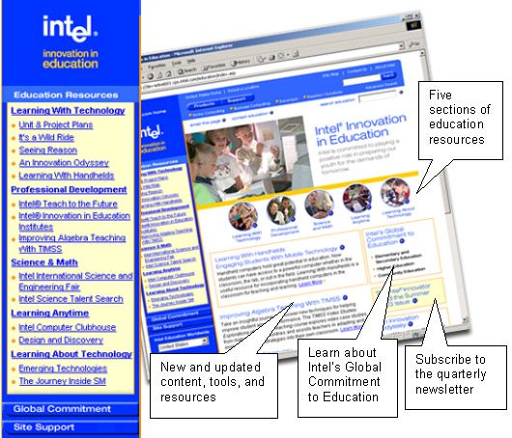
Key Points Notes
Time: 5 min. Slides 1–3

Display the Intel® Innovation in Education Web site home page to make participants familiar with it as a source of Intel resources for educators.

Slide 4
Overview and Goals
Ideas Worth Borrowing: Using other teachers' work to plan instruction
Designed to introduce Web resources, and help educators clarify personal criteria for selecting and customizing curriculum.
Goals
- Learn where to find and how to use collections of technology-supported projects.
- Develop personal criteria for adapting others' project ideas.
- Practice creating and adapting technology-supported projects.

Key Points Notes
Time: 5 min. Slides 4–5

Present the goals of the workshop to set the stage for the concepts and activities to follow.

Slide 5
Agenda
Think About Planning Instruction
- Where do your best curriculum ideas come from?
- How do you put them put into action?

Unit and Project Plans
- Examine online plans

An Innovation Odyssey
- 'Seed' ideas from other teachers

Adapt-a-Plan Exercise
Work on a Plan
Tying Ideas Together

More Curriculum Resources
Wrap-up
Key Points Notes
Time: 5 min. Slides 4–5

Briefly present the agenda to be covered.

Point out that the agenda items for the workshop are designed around the idea of adapting classroom teaching strategies and materials with and from other teachers.

Explain that it’s a hands-on session that alternates between:
- These slides and the live site
- Demonstration and discussion
- Guided and independent exploration
- Review of resources, including project examples
- A “Bird’s-of-a-Feather” session where participants will meet in groups based on subject-matter or students’ age-group

Slide 6
Think About Planning Instruction
Introduce yourself to your neighbor and discuss:
- How do you typically plan instruction?
- When looking beyond adopted curriculum, where do you go for new teaching ideas?
Report out. Share your experience:

- Describe a resource you turn to repeatedly when planning instruction. Explain why it is worthy of your attention.
Key Points Notes
Time: 20 min. Slides 6–9

Refer participants to the guided note-taking handout when introducing the activity on this slide.

Explain that the note-taking sheet is designed to collect thoughts and resources’ names during the workshop and will be a helpful reference during group discussions when “reporting out” from various workshop activities.

Slide 7
Curriculum Development Continuum
Consider how you develop curriculum: Do you build from scratch? Adapt? Use as is?
Where would you place yourself on the Continuum?

Build from  scratch | Adapt | Use existing  curriculum as is

Reflect: What kinds of curriculum resources might be most helpful for a consumer/developer like you?

Key Points Notes
Time: 20 min. Slides 6–9

Direct participants to reflect on the level of material development that best suits their teaching styles.

Ask for a show of hands to indicate where people place themselves.

Ask: “Did anyone have a hard time defining your place on the continuum?”

Explain that it is fine if their placement changes as the workshop progresses. The activity is intended as a starting point for consideration of curriculum development issues.

Slide 8
Curriculum Preferences
Think of the last time you taught something new: How did you go about it? With what did you start?
- Build-your-own materials: What did that entail?
- Easy-to-adapt materials: What did you look for?
- Ready-to-go materials: What makes a resource useful?

Key Points Notes
Time: 20 min. Slides 6–9

Have people work with a partner or in small groups to discuss the questions on the slide and share recent experiences teaching something new.

Ask a few groups to report out. Look for the following themes and patterns in the reports:
- Ready-to-go materials that are proven, failsafe, supplied, and duplicable.
- Easy-to-adapt materials that contain suggested adaptations or open-ended activities with the possibility of varied student outcomes.
- Build-your-own materials that go from idea through proof of concept with suggested resources or readings.

Slide 9
Explore Challenges

What are the real challenges teachers face when using teaching plans developed by others?
What are the challenges & benefits of using the Web to find teaching plans?
Share responses.
Key Points Notes
Time: 20 min. Slides 6–9

Explain that this section of the workshop examines an online environment for sharing ideas. Focus on the issues that teachers face when they look online for instructional plans.

Click on the link at the bottom of the page to open the document for recording this discussion. Save it locally if you want to be able to refer to it later.

Ask a participant or an assistant to record the discussion to enable you to lead it, if desired.

Some of the potential issues you might hear regarding using other teachers’ work include:
- It looks better than it really is
- Procedures are incomplete or unclear
- Lesson times that are incorrect
- Materials do not match procedures
- Out-of-date resources

continued on next page

Potential issues (continued)
- Overly ambitious or illogical plans
- Claim of outcome(s) that do/does not occur
- Lack of coherence
- Lack of continuity between goals, procedures, student activities, student outcomes, and assessment
- Too much effort to modify or implement

Web-specific resources have the following types of issues:
- Mining through the landfill to find a nugget that doesn’t pan out
- Investing time with minimal returns
- Sites that disappear (unstable resources)
- Materials that support outdated practices that are not best practices.

Potential benefits of using other teachers’ work include the following:
- Efficiencies
- Taking advantage of others’ efforts
- Finding approaches you may not have considered
- Using already-tried plans that have been adjusted by teachers who have “been there.”

Web-specific resources have the following types of benefits:
- Web is a huge hunting ground with constant additions and updates
- Links to primary source materials and access to experts
- Extended learning through collaborative projects and Web-based tools

Slide 10
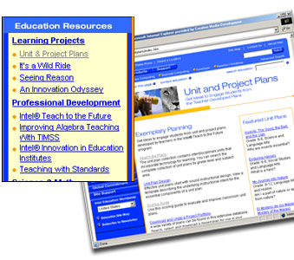
Unit and Project Plans
Unit and Project Plans
- Created by K-12 teachers who participated in the Intel® Teach to the Future program
- Many are multidisciplinary (categorized by dominant subject area)
- Feature technology integration in project-based learning
- Can be reproduced as-is or adapted to meet teachers' individual needs
From the home page, www.intel.com/education, select Unit and Project Plans in left navigation bar.

Key Points Notes
Time: 20 min. Slides 10–15

Introduce the unit and project plans that are on the Intel® Innovation in Education Web site.

Slide 11
Anatomy of a Plan
Look at the parts of a plan:
From Unit and Project Plans, select Sort the Plans.
Scroll down to Grade 3-5 section, and select "Float That Boat."
Notice some features these plans share:
- Curriculum framing questions
- Step-by-step procedures
- Background "From the Classroom" profile
- Assessment strategies
- Connections to standards
- Teaching materials, handouts, student work samples, rubrics
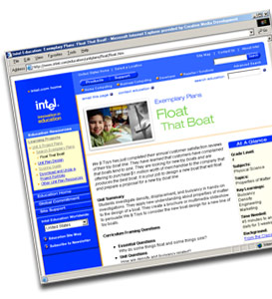
- Modifiable versions of associated files

Key Points Notes
Time: 20 min. Slides 10–15

Display the "Float the Boat" unit plan.
Point out the features of the unit plan:
- All resources are linked from the unit plan page.
- “From the Classroom” is a good place to find information about the teacher who created the plan.

Slide 12
Curriculum Framing Questions
Essential Questions
- Address broader themes than the unit, have no single right answer
- Can be addressed across disciplines
Example: How can we explain the things that happen around us?
Unit Questions
- Help students address the essential question
- Are specific to one discipline of study
Example: Are there rules that determine the ways things move?

Content Questions
- Direct students toward specific content knowledge
- Can have one right answer
Example: How are density, buoyancy, and displacement related?

Key Points Notes
Time: 20 min. Slides 10–15

Call attention to the three types of curriculum-framing questions presented on this slide. The examples are drawn from Float That Boat.

- Point out that Essential Questions are broad, interdisciplinary, and designed to appeal to a student’s sense of wonder and curiosity.

- Unit Questions are more focused on the goals for the unit’s inquiry. They often connect to benchmark standards.

- Content Questions are even narrower and more domain-specific. They often are linked to content standards.

Slide 13
What to Look for in a Plan
As Ready-to-go materials, the Unit Plans:
- Serve as complete, beginning-to-end guide for implementation
- Provide all supporting materials
As Easy-to-adapt materials, the Unit Plan materials:
- Are available as source files, easily customized
- Are open-ended, allow for varied student products, learning outcomes
- Include suggestions for adapting plans to meet different learners' needs
As Build-your-own materials, the Unit Plan materials:
- Serve as a model for good planning and technology integration as you plan your own exemplary units

Key Points Notes
Time: 20 min. Slides 10–15

Call attention to participants’ previous placements of themselves on the Curriculum Development Continuum.

Explain that this slide suggests different ways to use the Unit Plans.

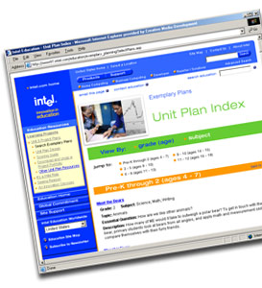
Slide 14
Select a Unit Plan
Unit Plan Index
Plans can be sorted by grade or subject.
Key Points Notes
Time: 20 min. Slides 10–15

View the Unit Plan Index. Sort the plans using a variety of criteria.

Show participants the ways that plans have been grouped on the Intel® Innovation in Education Web site.

Slide 15
Examine the Plans
Activity: Explore Unit Plans
As you examine plans look for:
- Plans you might use as-is
- Plans you might adapt. Determine what you would change (scope, rigor, technology, procedures).
- Elements you might use (a resource, instructional method, student activity, or technology)
Task: Find at least one plan that you want to work with later in the workshop.

Key Points Notes
Time: 20 min. Slides 10–15

Introduce the activity. Have participants work alone or in pairs.

Remind participants that they might find an adaptable story or plan that is not in their subject area or age-group.

Circulate through the room during the activity to answer questions and provide assistance.

Conduct a discussion about participants’ findings and any suggestions for adapting the new materials, and other prompts on the guided note-taking handout.

Summarize any adaptation patterns that emerge from the discussion.

Ask whether anyone found items that were useful as seed ideas but were not usable beyond that point.

Slide 16
An Innovation Odyssey
A resource designed for teachers who seek innovative project ideas, rather than fully-developed unit plans.
An Innovation Odyssey describes teachers' innovative project ideas.
- Updated frequently
- K-12 classrooms from 43 countries (and counting)
- Wide-ranging uses of technology
- Over 200 stories available
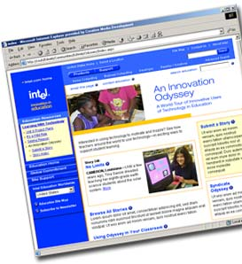
From the Intel Education home page, select An Innovation Odyssey in the left navigation bar.
Key Points Notes
Time: 10 min. Slides 16–19

Introduce An Innovation Odyssey as a teachers’ planning resource.

Slide 17
Odyssey Features
From the Innovation Odyssey landing page, you can access:
- Today's Story
- Submit a Project
- Story Index—Find Stories by Grade and Subject
- Syndicate Odyssey

Key Points Notes
Time: 10 min. Slides 16–19

Explore different aspects of An Innovation Odyssey from its main page.

Explain syndication:
- Web syndication automatically delivers each Odyssey story from the Intel® Innovation in Education Web site to any other Web site. With the one-time addition of a few lines of code by your Webmaster or site administrator, every time Odyssey is updated, your Web site is modified.

- To find more information about syndicating Odyssey, go to the syndication page in the Intel® Innovation in Education Web site: www.intel.com/education/syndication.

Slide 18
Anatomy of an Odyssey Story
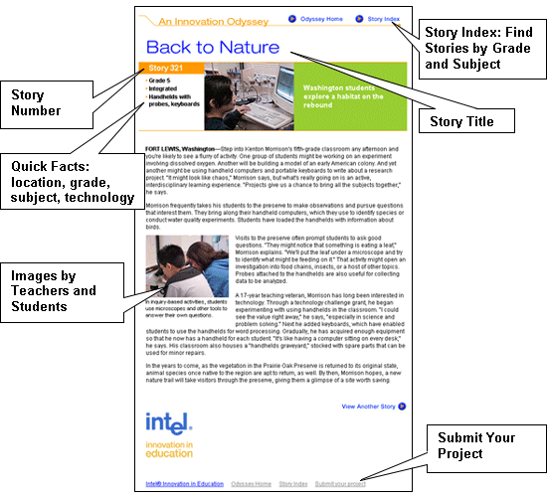
Key Points Notes
Time: 10 min. Slides 16–19

Point out how all Odyssey stories include common elements for ease-of-use for planning or adapting curriculum:
- Quick facts: grade, subject, technologies
- Project information in context
- Images by teachers and students
- Uses of technology

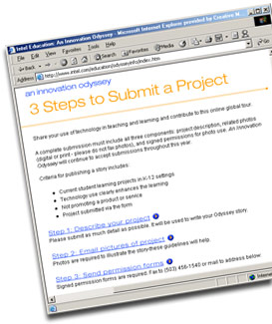
Slide 19
Submit a Story
Submit your story.
- Share a project showing how technology supports learning in your classroom
- Contribute to the pool of good teaching ideas
- Receive your choice of an erasable classroom calendar or a digital microscope as a thank-you
- To recognize your efforts in submitting a story, Intel will send you a thank-you gift

Key Points Notes
Time: 10 min. Slides 16–19

Explain that An Innovation Odyssey exists as a teachers’ resource because teachers submit their lesson plans, ideas, and experiences.

Invite workshop participants to join this online community and share their work with others.

Ask if there are any questions about An Innovation Odyssey.

Slide 20
Adapt-a-Plan Exercise

In small groups, examine a common project idea. Discuss its merits and adapt for your circumstances.
Discuss and record the following:
- What aspects of the project are interesting and worth borrowing? Why?
- Consider those elements that have potential: How would you adapt or develop them to meet your instructional aims?
- What are the new ideas and different approaches your group explored?
Be ready to report in 15 minutes.

Key Points Notes
Time: 15 min. Slide 20

Group participants based on grade level and/or subject. Groups should be small, 3–5 participants.

Assign one Innovation Odyssey story: Story (“day”) 331. (Story 102 may be a second option).

Explain that this exercise intentionally takes them outside the scope of their teaching assignment, and serves as an opportunity to work with peers while they engage in the analytical and creative process of adapting work.

Refer to the handout—groups can use the discussion questions and deeper prompts to guide their thinking, and use the note-taking space to record their ideas.

continued on next page

Go over the points on the slide. Ask them to consider:
- What aspects of the project are interesting and worth borrowing? Why?
- Are there elements that would be especially compelling for your students? In what way?
- Are there underlying concepts or content that is important and enduring?
- Are there engaging instructional strategies that give students authentic tasks? In what manner?

Consider those elements that have potential:
- How would you adapt or develop the topic, strategies, or use of technology to meet your instructional goals?

- What are the new ideas and different approaches your group explored?

- How did your different points of view contribute to the variety of ideas you came up with?

After 15 minutes, ask one person from each group to report out. Refer to the questions above to query groups for more information about unique processes and outcomes.

Restate big idea: The goal of this exercise is to recognize features of plans that can be used in other subjects and grades (big enduring concepts; engaging topics; effective strategies).

Note: If workshop time is limited this activity could be done as whole group. Ask all teachers to consider the questions and share responses in a discussion.

Slide 21
Work on a Plan

Alone or with a partner:
Return to a project idea that caught your interest during the browsing session.
Begin the same review and adaptation steps. Answer:
- What aspects of the project are interesting, and worth borrowing? Why?
- Consider those elements that have potential: How would you adapt or develop them to meet your instructional aims?

Key Points Notes
Time: 20 min. Slide 21

Explain that the goal is for each teacher to leave with initial work on an adapted plan, but more importantly, a broader view of instructional design and adaptation.

Circulate through the room during the activity to answer questions and provide assistance.

Slide 22
Tying Ideas Together

Consider the workshop goal—Participants develop personal criteria for adapting others' project ideas

Please reflect:
- What insights do you have into your own criteria and processes for using other teachers’ work?

Key Points Notes
Time: 10 min. Slide 22

Wrap up: Ask for a few volunteers to share their insights.

Explain that our intent has been to look at ways to find useful curriculum in other teachers’ work, even when there isn’t a perfect fit. Useful pieces may range from the inspiration of a seed idea to wholesale re-purposing of another strategy.

Slide 23
More Curriculum Resources
There are other parts of the Intel® Innovation in Education Web site that showcase teachers' innovative project ideas.
Related sections on the Web site:
- It's a Wild Ride
- Seeing Reason: Get a Clue and On the Road to Safety
- Design and Discovery
- Learning With Handhelds

Key Points Notes
Time: 5 min. Slide 23

Explore other parts of the Intel® Innovation in Education Web site to show participants the potential as a source of curriculum ideas, plans, and materials.

Slide 24
Wrap Up
Any questions?
Please consider submitting your own story to Odyssey.
Tell us what you think!
Please complete the online session evaluation at:
www.inteleducation.com/institute
Key Points Notes
Time: 5 min. Slide 24

Ask if there are any questions.

Wrap up the workshop.

Thank participants for attending.

Have each participant to complete the session’s online evaluation.

